Monthly report on livestock disease trends as informally reported by veterinarians belonging to
May 2022
the Ruminant Veterinary Association of South Africa (RuVASA), a group of the South African Veterinary Association

Previous disease reports can be seen on the RuVASA website www.ruvasa.co.za
These reports include data from individual practices
Click on Disease Reports
Click on the required dates of Disease Reports
The following practices and laboratories (141) submitted reports during May 2022:

Mpumalanga (12)
Bethal – Dr. Hardus Pieters
Delmas – Drs. Van der Merwe en Nolte
Grootvlei – Dr. Neels van Wyk
Hendrina – Dr. Anja Steinberg
Lydenburg – Drs. Trümpelmann and Steyn
Lydenburg – Dr. Marietjie Malan
Malalane – Drs. Van Sittert and Van Sittert
Malalane (Tonga)– Dr. Cate Holyoake
Middelburg – Dr. Neil Fourie
Nelspruit – Dr. André Beytel
Standerton – Dr. Kobie Kroon
Volksrust – Dr. Johan Blaauw

Gauteng (12)
Bapsfontein – Drs. Engelbrecht and Olivier
Bronkhorstspruit – Dr. De Bruin, De Bruin and Labuschagne
Hammanskraal – Dr. Hentie Engelbrecht
Irene (ARC) – Dr. Maggie Wepener
Krugersdorp (Veeartsnetwerk) – Dr. Danie Odendaal
Magaliesburg – Dr. Ryan Jeffery
Muldersdrift – Drs. Speedy and Enslin
Nigel – Dr. Cindy van der Westhuizen
Nigel – Dr. Henry Labuschagne
Onderstepoort Veterinary Academic Hospital – Proff. Holm and Leask and Drs. Fitte, Grobler, Hentzen, Koeppel, Magadu, Magagula, Marufu, Mokoele, O’Dell, Tagwirreyi, Tshuma, Van den Hurk and Van der Leek
Pretoria – Dr. Hanneke Pienaar
Vanderbijlpark – Dr. Kobus Kok

Limpopo (7)
Makhado (Louis Trichardt) – Drs. Harris, Klopper and Jacobs
Modimolle (Nylstroom)– Drs. Van Niekerk and Te Brugge
Mokopane (Potgietersburg) – Dr. Henk Visser
Polokwane (Pietersburg) – Drs. Watson, Viljoen, Jansen van Vuuren, Van Rooyen, Snyman and Cremona
Thabazimbi – Dr. Minette Nel
Tzaneen – ZZ2 Farm practice – Dr. Danie Odendaal
Vaalwater – Dr. Hampie van Staden

North West (12)
Beestekraal -Dr. Alwyn Venter
Bloemhof – Dr. Cizelle Naude
Brits – Dr. Boshoff and Coertze
Brits – Dr. Gerhardus Scheepers
Christiana – Dr. Pieter Nel
Leeudoringstad – Dr. Ian Jonker
Lichtenburg – Dr. Nelmarie-Krüger-Rall
Potchefstroom – Dr. Maartin Jordaan
Rustenburg – Drs. Grobler, Sparks, Stoffberg and Otterman
Schweizer-Reneke – Dr. Pieter Venter
Stella - Dr. Magdaleen Vosser
Zeerust – Dr. Lizahn Venter

Free State (27)
Bethlehem – Drs. Strydom and Strydom
Bloemfontein – Dr. Stephan Wessels
Bothaville – Dr. Gerrie Kemp
Bultfontein – Dr. Santjie Pieterse
Clocolan – Drs. Wasserman, Kleynhans and Boshoff
Dewetsdorp – Dr. Marike Badenhorst
Excelsior – Dr. Dedré Nel
Frankfort – Drs. Lessing, Cilliers and Janse van Rensburg
Harrismith – Dr. Wim Slabber
Hoopstad – Dr. Kobus Pretorius
Hoopstad – Dr. Cassie van der Walt
Koppies – Dr. Kobus Bester
Kroonstad – Drs. Daffue, Eksteen, Van Zyl and Van der Walt
Kroonstad – Dr. Maarten Wessels
Memel – Drs. Nixon and Nixon
Oranjeville - Dr. D’Wall Hauptfleish
Parys – Drs. Wessels and Wessels
Reitz – Dr. Murray Smith
Senekal – Dr. Jan Blignaut
Smithfield – Dr. Nienke van Hasselt
Viljoenskroon – Dr. Johan Kahts
Vrede – Drs. Bester-Cloete en Myburgh
Vrede – Dr. Daleen Roos
Warden – Dr. Paul Reynolds
Wesselsbron – Dr. Johan Jacobs
Winburg – Drs. Albertyn and Albertyn
Zastron – Drs. Troskie and Strauss

KwaZulu-Natal (13)
Bergville- Dr. Ariena Shepherd
Bergville -Dr. Jubie Müller
Camperdown – Dr. Anthony van Tonder
Eshowe – Drs. Pryke, Brits, Nel and Hoffman
Estcourt – Drs. Turner, Tedder, Taylor, Tratschler, Van Rooyen and Alwar
Kokstad – Drs. Clowes, Lees, Malan, Koekemoer, Cronje and Kilian
Mooi River – Drs. Fowler and Graver
Mtubatuba – Dr. Trevor Viljoen
Newcastle – Dr. Barry Rafferty
Pongola – Dr. Heinz Kohrs
Underberg – Drs. King, Delaney and Huysamer
Underberg – Dr. Tod Collins
Vryheid - Drs. Theron and Theron

Eastern Cape (15)
Adelaide – Dr. Steve Cockroft
Alexandria – Dr. Charlene Boy
Alexandria – Dr. Johan Olivier
Aliwal North – Drs. Troskie and Strauss
Bathurst – Dr. Jane Pistorius
Elliot - Drs. Clowes, Lees, Malan, Koekemoer, Cronje and Kilian
Graaff- Reinet - Dr. Roland Larson
Graaff-Reinet – Hobson, Strydom and Hennesy
Humansdorp – Drs. Van Niekerk, Jansen van Vuuren and Davis
Middelburg – Dr.Hoggie Viljoen
Queenstown – Dr. Clara Blaeser
Queenstown – Drs. Du Preez, Klopper, Jansen van Vuuren, De Klerk, Wentzel and Catherine
Steynsburg – Dr. Johan van Rooyen
Stutterheim – Dr. Dave Waterman
Uitenhage – Drs. Mulder and Krüger

Western Cape (24)
Beaufort West - Dr. Jaco Pienaar
Beaufort West – Dr. Bennie Grobler
Caledon – Drs. Louw and Viljoen
Caledon – Drs. Small, Greyling and Viljoen
Ceres – Drs. Pieterse, Wium, De Villiers and Scheepers
Darling – Drs. Van der Merwe, Adam, Jenkins and Lord
George – Drs. Strydom, Truter and Pettifer
George – Dr. Riaan Putter
Heidelberg – Dr. Albert van Zyl
Malmesbury – Dr. Otto Kriek
Malmesbury – Dr. Heyns and Zolner
Malmesbury – Drs. Bosman and Groenewald
Moorreesburg – Dr. Suenette Kotzé
Oudtshoorn – Dr. Glen Carlisle
Oudtshoorn -Dr. Adriaan Olivier
Paarl – Dr. Carla van der Merwe
Piketberg – Dr. André van der Merwe
Plettenberg Bay – Dr. André Reitz
Riversdale – Drs. Du Plessis, Taylor and De Bruyn
Stellenbosch – Dr. Alfred Kidd
Swellendam – Drs. Malan and Fourie
Swellendam – Drs. De Wet, Smit and Venter
Vredenburg – Dr. Izak Rust
Worcester – Drs. De Wet and Rabe

Northern Cape (8)
Calvinia – Dr. Bertus Nel
Colesberg – Drs. Rous and Rous
De Aar – Dr. Donald Anderson
Kathu – Dr. Jan Vorster
Kimberley – Drs. Smith and Van der Merwe
Kimberley – State Vet Group (De Aar, Kimberley, Kuruman, Upington, Kuruman, Kakamas, Koopmansfontein, Prieska) Drs. Terblanche, Moolman, Meyer, Nel, Meyer, Van den Berg, De Bruyn, Krause, Uys, Mmolawa, Solomon en Vermeulen

Postmasburg – Dr. Boeta van der Merwe
Upington – Drs. Vorster, Visser and Oosthuizen

Feedlots (2)
Dr. Eben Du Preez
Drs. Morris, Morris and Le Riche

Biosecurity consultant (1)
Bloemfontein - Dr. Theo Kotzé

Laboratory reports (8)
Dr. Marijke Henton - Vetdiagnostix, Johannesburg
Dr. Annelize Jonker, Veterinary Tropical Disease Bacterial Laboratory, University of Pretoria
Dr. Liza du Plessis – Idexx SA - Pretoria
Dr. Sophette Gers – Pathcare, Cape Town
Dr. Mark Chimes – Dairy Standards, George
Dr. Clara Blaeser, Queenstown Provincial Laboratory
Prof. Emily Mitchell – Wildlife, University of Pretoria
Me. Amanda McKenzie – Vryburg Veterinary Laboratory

Key message:
The key message for April is that if we want to control diseases in the production animal sector it will take the whole sector to work together. Starting with your own farm, your neighbours, your area, your province, doing the correct thing to prevent the spread of diseases.
Identification of every bovine (LITS or ICAR approved ID tag)
https://www.icar.org/
The International Committee for Animal Recording (ICAR) is an International Non-Governmental Organization (INGO) which was formed on March 9th, 1951, in Rome. Presently it is composed of 128 Members from 57 countries. ICAR strives to be the leading global provider of Guidelines, Standards and Certification for animal identification, animal recording and animal evaluation. ICAR wants to improve the profitability and sustainability of farm animal production by:
- Establishing and maintaining guidelines and standards for best practice in all aspects of animal identification and recording.
- Certifying equipment, and processes used in animal identification, recording and genetic evaluations.
- Stimulating and leading continuous improvement, innovation, research, knowledge development and knowledge exchange.
- Providing services essential to achieving international collaboration in key aspects of animal recording and animal breeding.

Movement control
Identification of clinical disease signs
Isolation of diseased animals
Demand a vendor’s declaration when animals are bought
Quarantine animals that are bought for 28 days
Strictly follow your herd management programme that is regularly updated in consultation with your veterinarian
The ultimate goal is to form a compartment of your farm
See what the pig farmers have achieved regarding African Swine Fever
https://www.woah.org/app/uploads/2021/10/asf-compartmentalisationguidelines-en.pdf

Foot and Mouth Disease outbreak
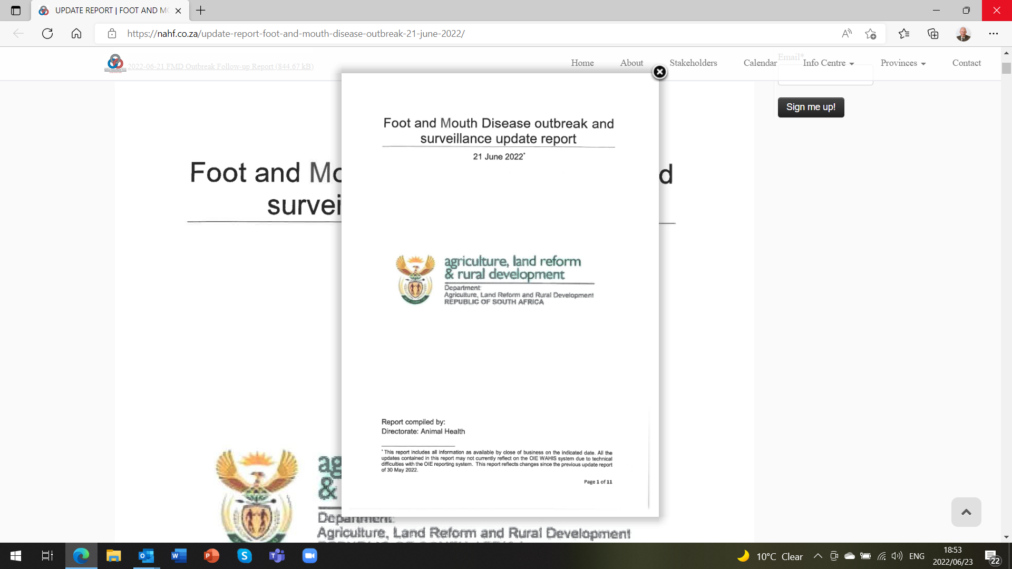
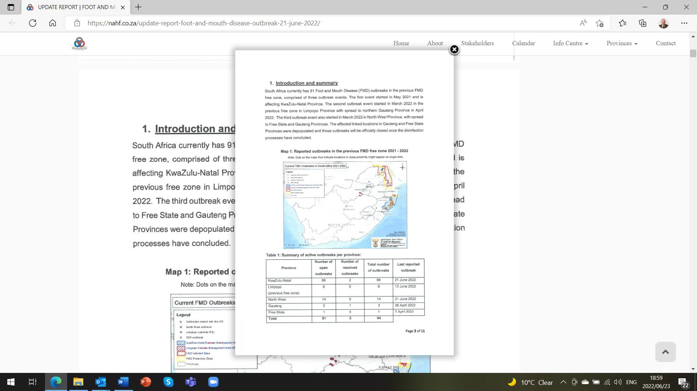
For the full report Control and click on the link below.
UPDATE REPORT | FOOT AND MOUTH DISEASE OUTBREAK | 21 June 2022 – National Animal Health Forum (nahf.co.za)

The reason for the foot and mouth outbreaks in South Africa all had to do with the illegal movement of cattle out of the FMD controlled zones in Limpopo.
Owners of motor vehicles are legally bound to have number plates on their vehicles, similarly all cattle have to be branded with a registered mark to prove ownership and in future cattle will be identified with a ICAR approved RFID ear tag.
Uitbreek van Bek en Klouseer in Suid-Afrika
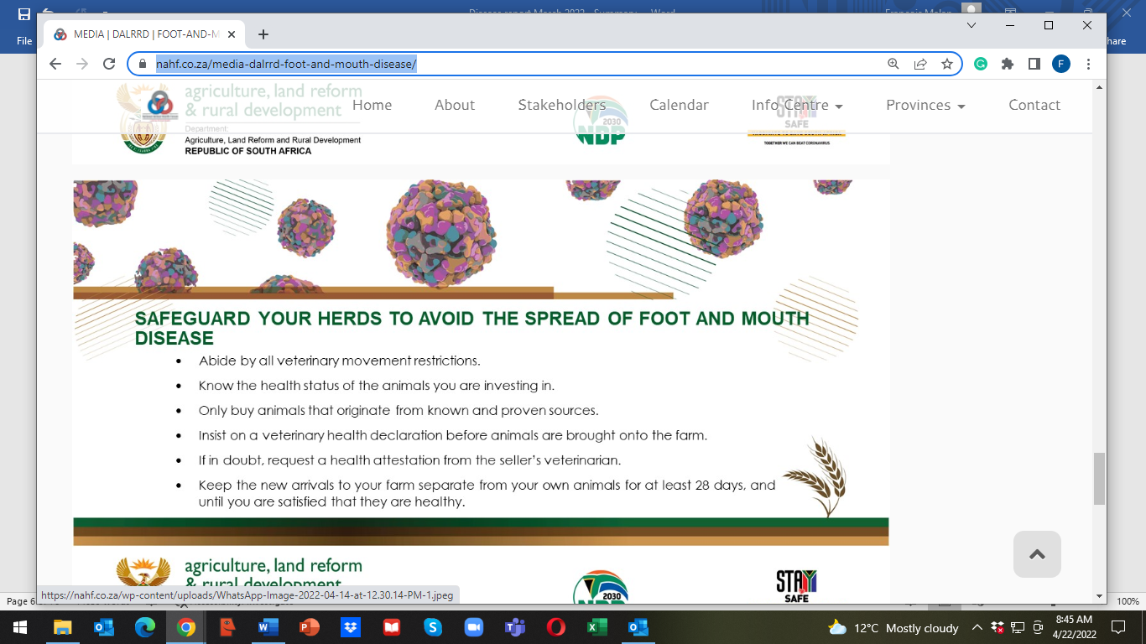
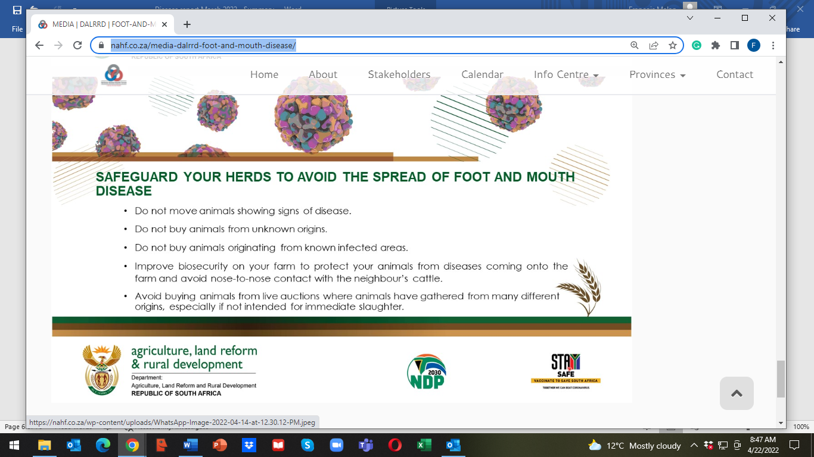
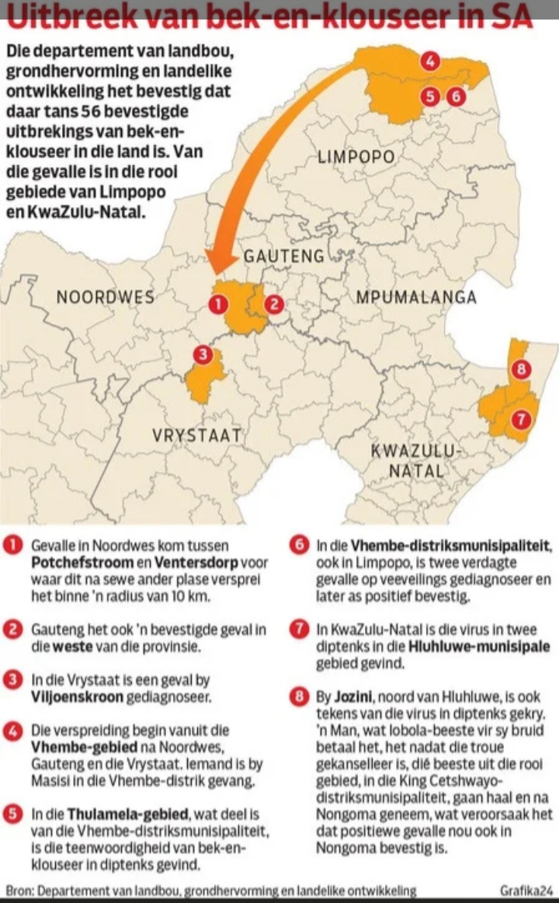
Important development in the beef industry
PRESS RELEASE
LIVESTOCK PRODUCERS DO GROUNDWORK FOR A TRACEABILITY
SYSTEM IN THE INDUSTRY
“International trade partners and consumers increasingly insist on a traceability system in the
livestock industries and it has also become necessary in terms of market access, whether
locally or internationally,” says Mr James Faber, chairman of the national RPO.
“The need for traceability systems has now become imperative because of the outbreak of
Foot and Mouth Disease (FMD),” Faber said.
The Department of Agriculture, Land Reform and Rural Development (DALRRD), in
cooperation with the livestock industries already made significant progress with the
development of a LITS system (Livestock Identification and Traceability system).
The CSIR developed the system and the testing phase is currently taking place in the FMD
endemic areas.
Although work is continuously being done in terms of the LITS system with the involvement
of the industries, it will take a long time to implement it comprehensively.
“The need to kickstart with a practical voluntary system has become of critical importance,”
according to Mr Faber.
On the initiative of the RPO, representatives of the livestock industries and private service
providers recently convened with the aim of commencing with a practical voluntary system.
The initiative will initially focus on individual animal identification with unique ear tag numbers
and will be urgently implemented in the cattle- and small stock industries. The numbers will
also be linked with the detail of the owner and the farm. Producers will make use of private
service providers who are already delivering services and will also pay for the services
themselves.
It is envisaged that commercial producers will participate on a voluntary basis and the state
will take responsibility for the implementation of a system in the developing sector. The
livestock industries will in collaboration with the private service providers establish criteria
which must be adhered to in order to render the system functional.
It will be imperative that the information systems of the private service providers be integrable
with the LITS system.
However, producers must ensure that service providers comply with ICAR (International
Centre of Animal Registration). Criteria which service providers will have to fulfil will soon be
finalised and announced.
“The implementing of the systems will pave the way for the establishment of a complete
traceability system in collaboration with the state in the future. Producers participating in the
system, should insist on a premium,” says Mr Faber.
The implementing of the system enjoys the full support of the state and will most likely lead
to a private/public partnership (PPP). The initiative will be driven by the primary red meat
cluster consisting of the RPO, NERPO, SA Feedlot Association and the Red Meat Abattoir
Association.
-  -
DATE : 21 April 2022
ENQUIRIES :
Mr Dewald Olivier Mr Gerhard Schutte
SA Feedlot Association Red Meat Producers’ Organisation
Cell: 082 800 3737 Cell: 082 556 7296
Email: exec@safeedlot.co.za Email: gerhard@rpo.co.za
Dr Gerhard Neethling Mr James Faber
Red Meat Abattoir Association Red Meat Producers’ Organisation
cell: 082 551 7232 Cell: 083 292 2556
Email: manager@rmaa.co.za Email: james@glenross.co.za
The May disease report recorded outbreaks of tick and insect transmitted diseases: Lumpy skin disease, African and Asiatic red water, Anaplasmosis and Heartwater. Three Day Stiff sickness and Blue Tongue outbreaks were less than the previous month. These diseases could have been prevented if animals were vaccinated according to a management program drawn up in conjunction with your veterinarian.
Plan now for the next rainy season!!!
For detailed reports and maps visit www.ruvasa.co.za and on the toolbar click on Disease reporting

Maps of disease outbreaks transmitted by ticks, and insects for May 2022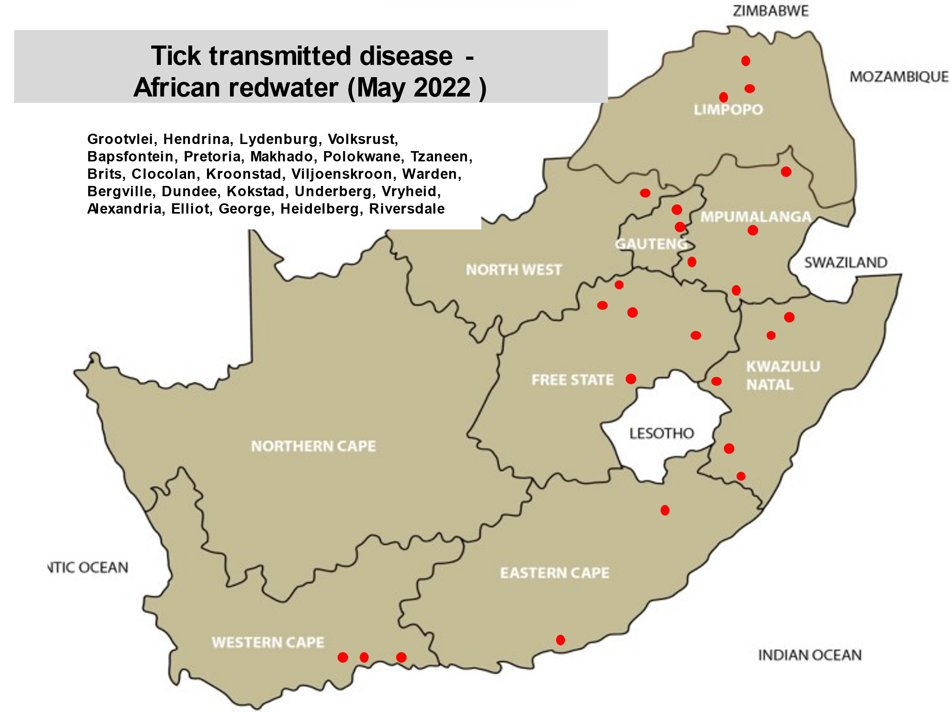

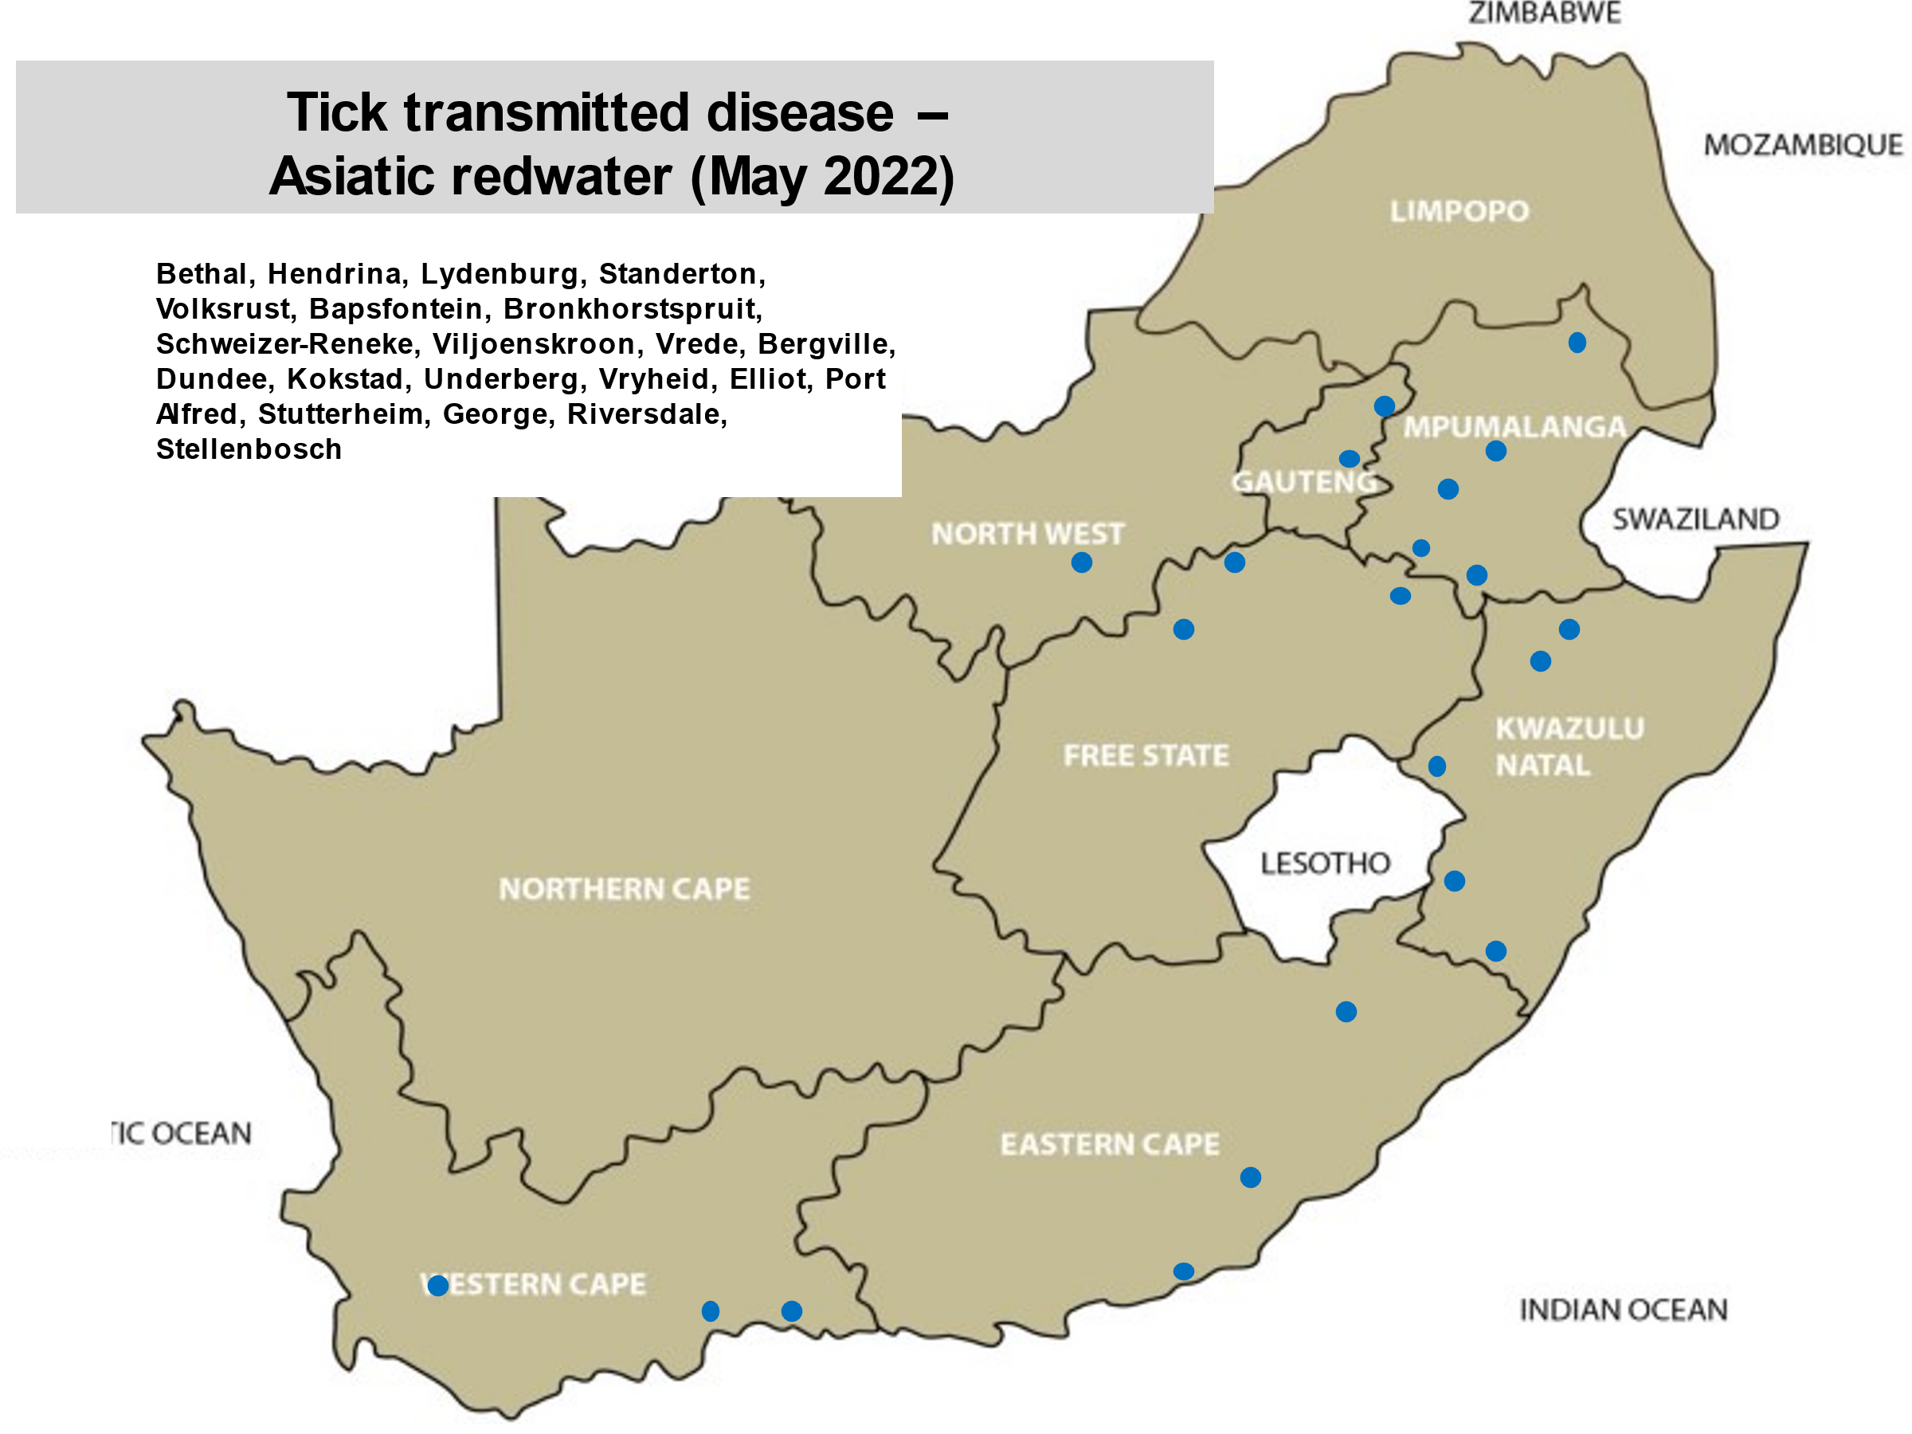
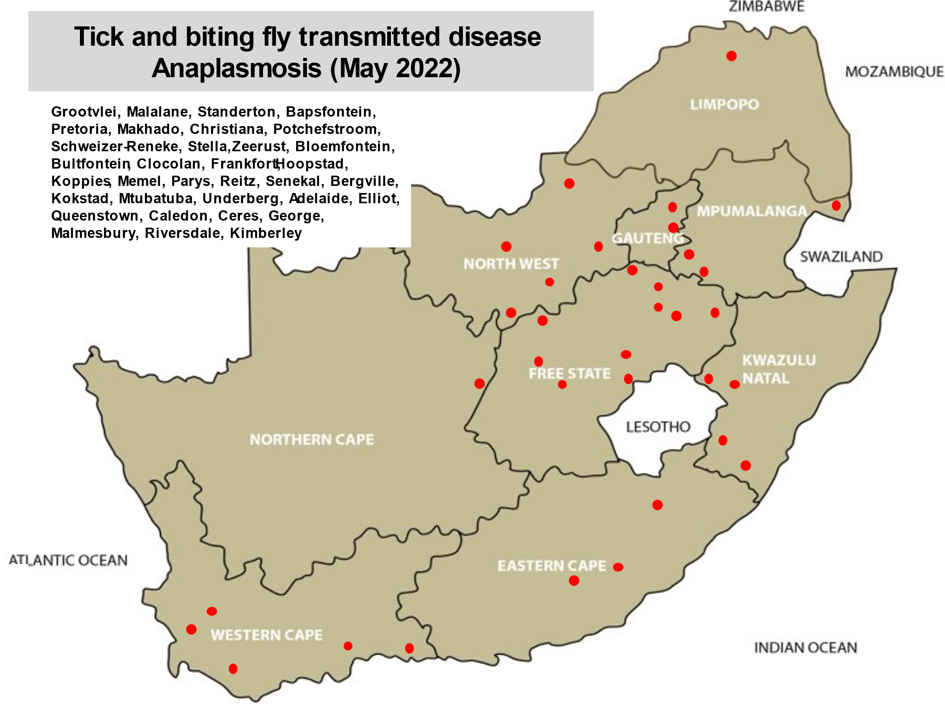

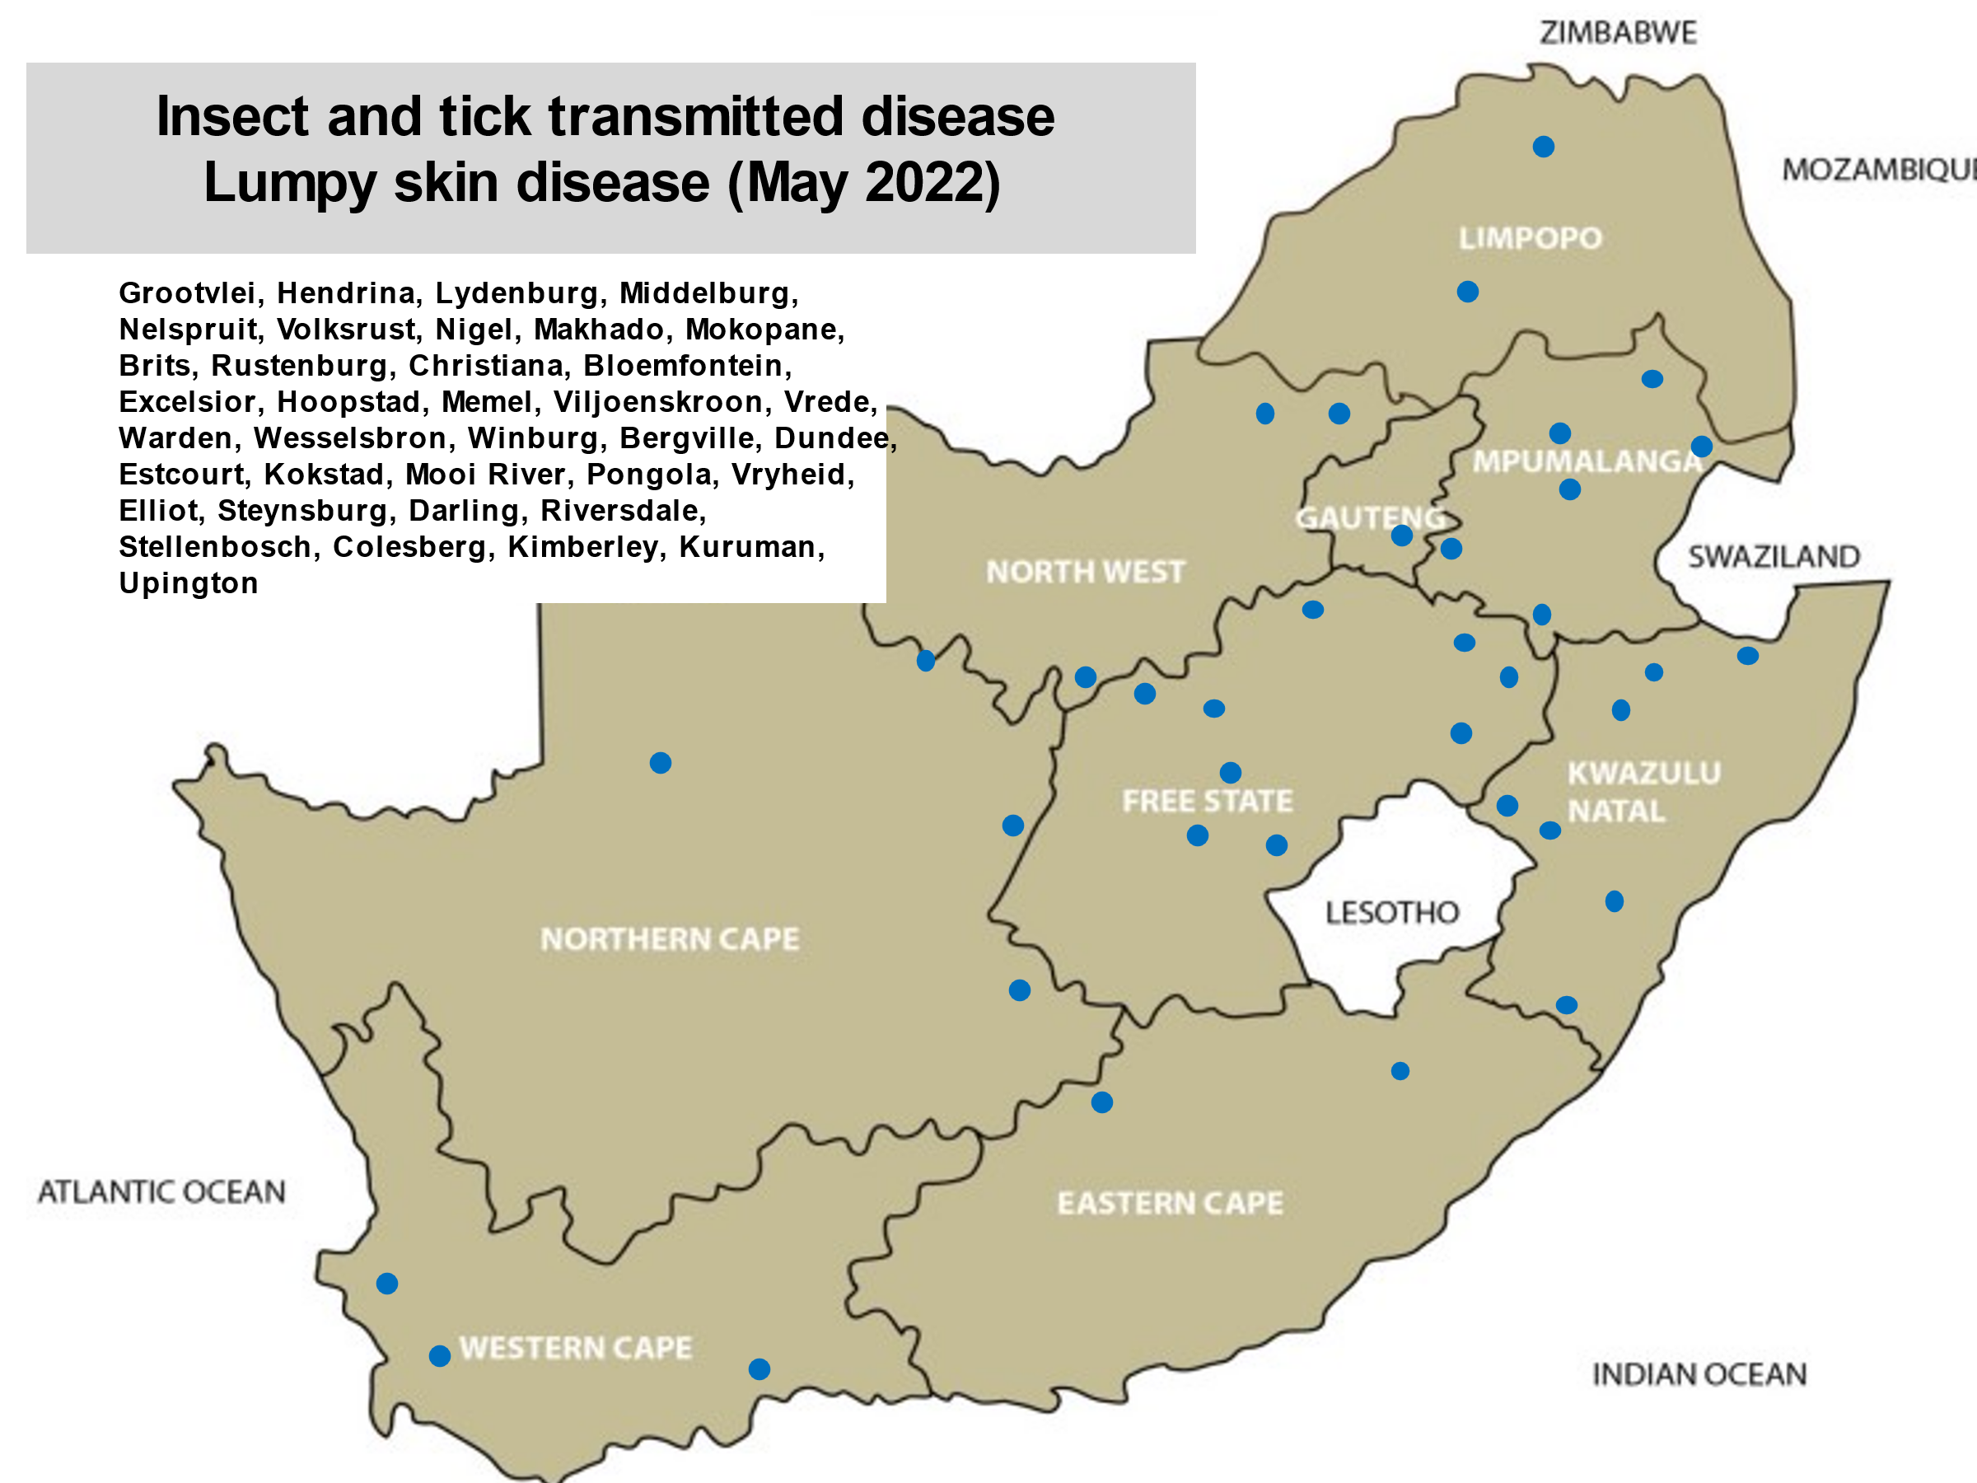

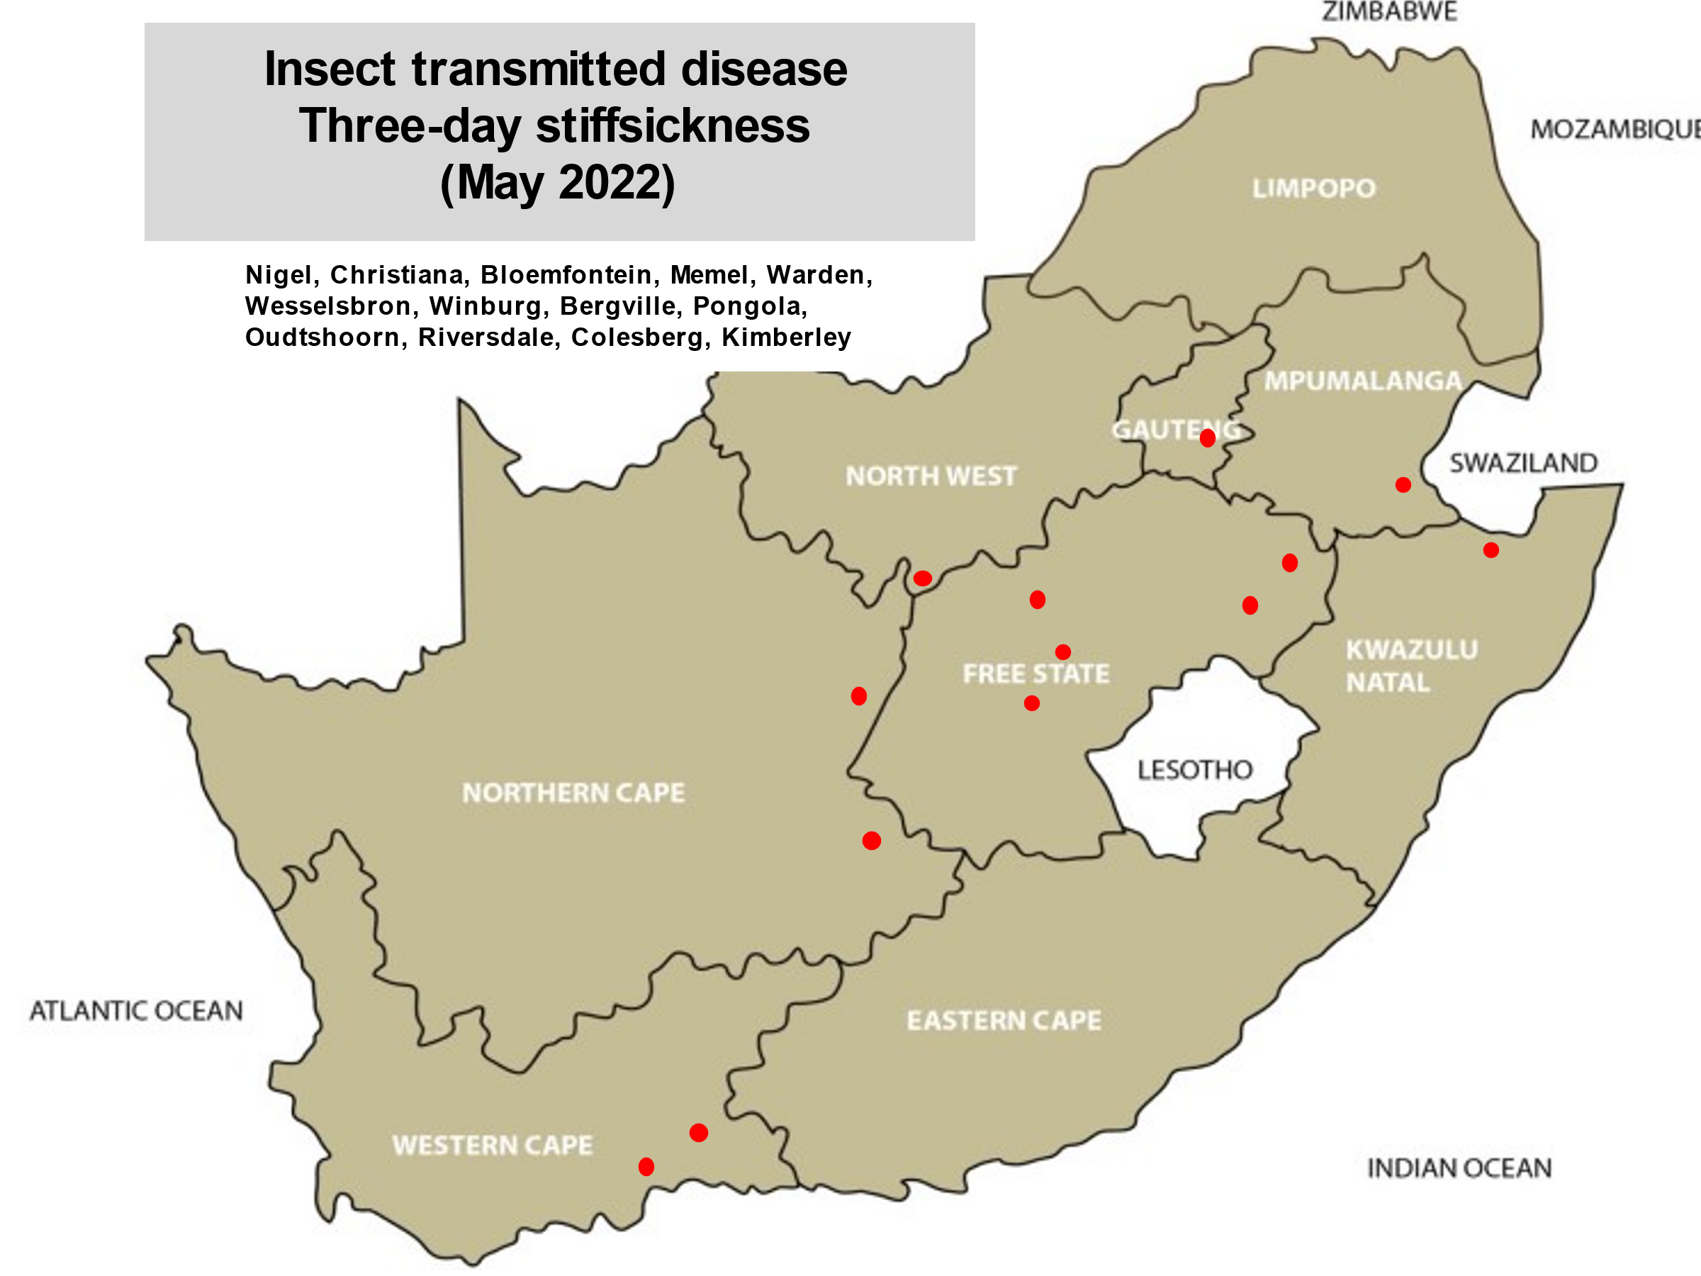
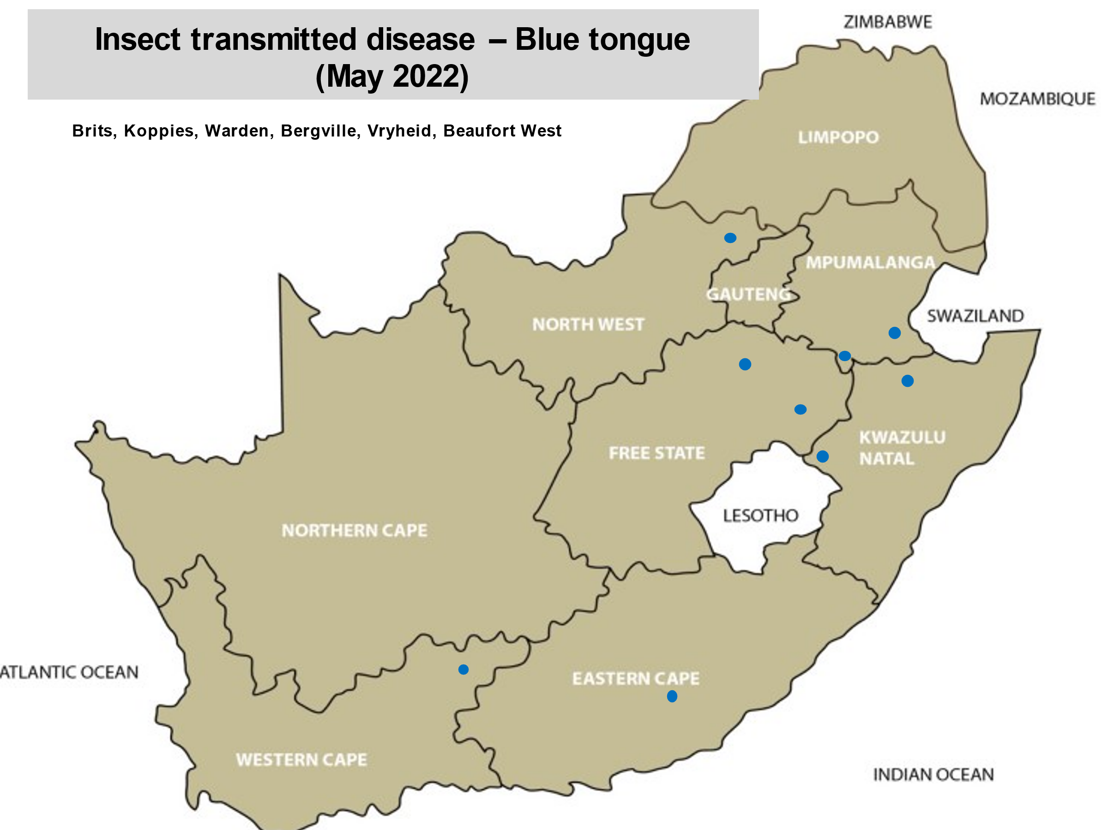
Wireworm outbreaks have been reported from all provinces. Make sure to discuss your management program with your veterinarian as resistance of this deadly internal parasite to drug groups may cause huge losses.
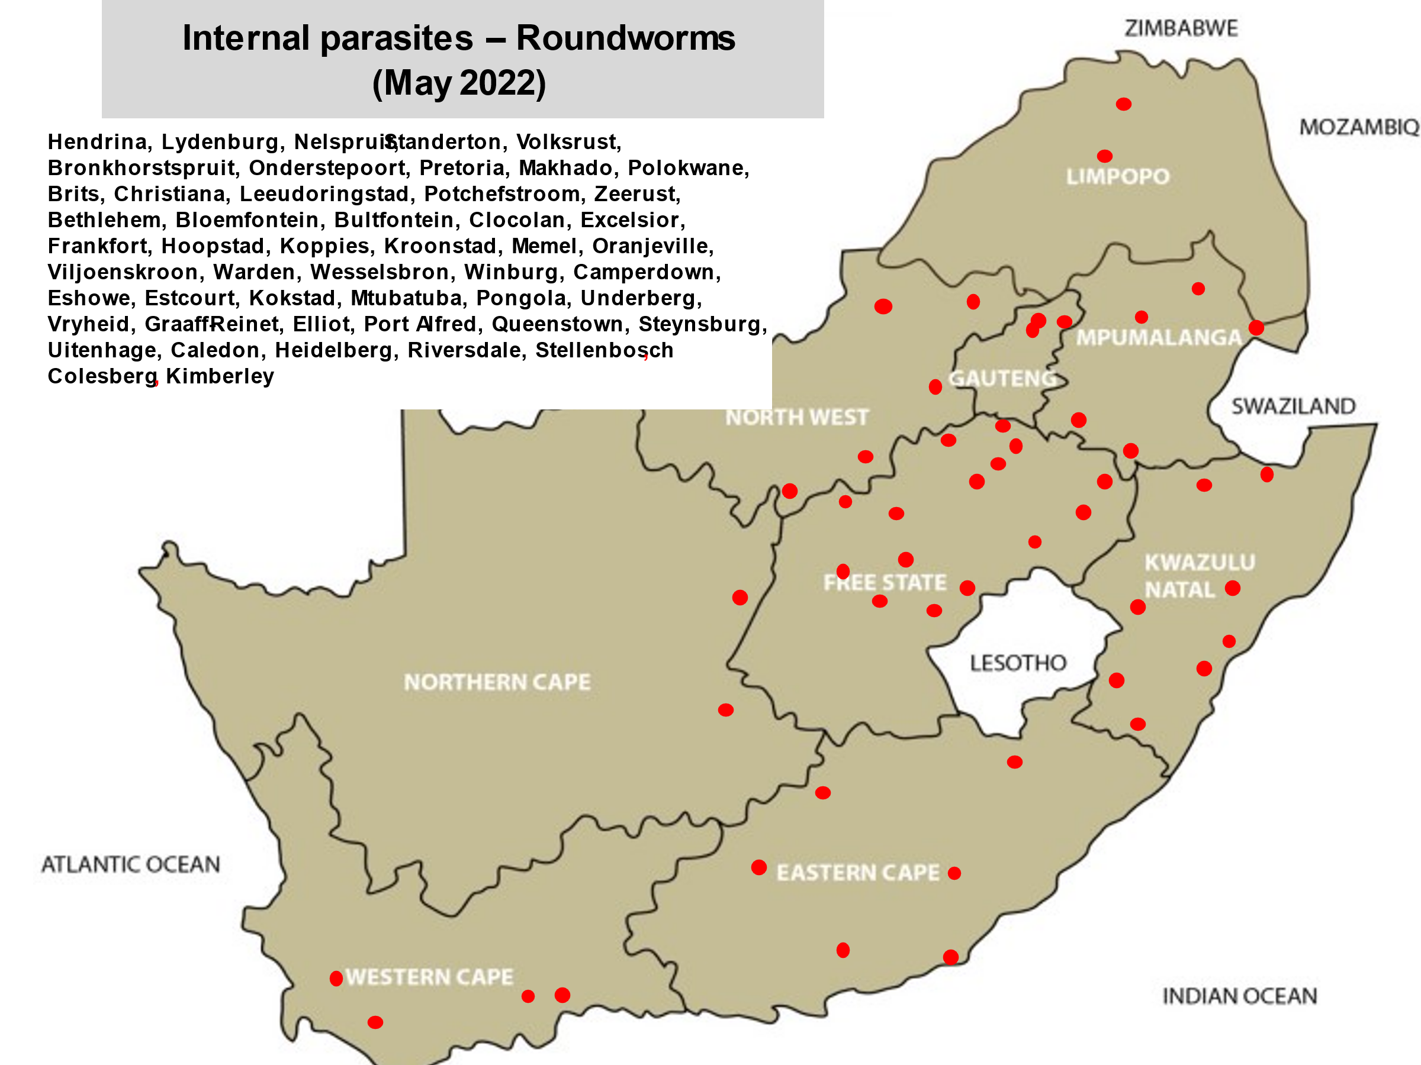

Diseases that are reported every month are Brucellosis, Trichomonosis, Vibriosis, Coccidiosis, Cryptosporidiosis, Orf, Pasteurellosis, E. coli and Pulpy kidney. Visit the link for all the disease maps and detailed reports
https://ruvasa.co.za/disease-report-2022/
To assess your risk, talk to your local veterinarian and update your vaccination and holistic parasite management program. It is important to study what diseases are prevalent in your area and to determine your risk. Take the necessary steps in time, as from experience it is seen that vaccine availability during an outbreak could be a huge problem. If vaccines are not available, insect and tick control are even more of importance.
Shows have been opened again after the COVID epidemic and due to the presence of diseases in South Africa strict biosecurity protocols should be practiced at all times! If animals are taken back to the farm from shows, quarantine these animals for 28 days and observe them twice daily before allowing them into the herd again
Visit the National Animal Health Forum’s website regularly where updates on animal health are posted (www.nahf.co.za).

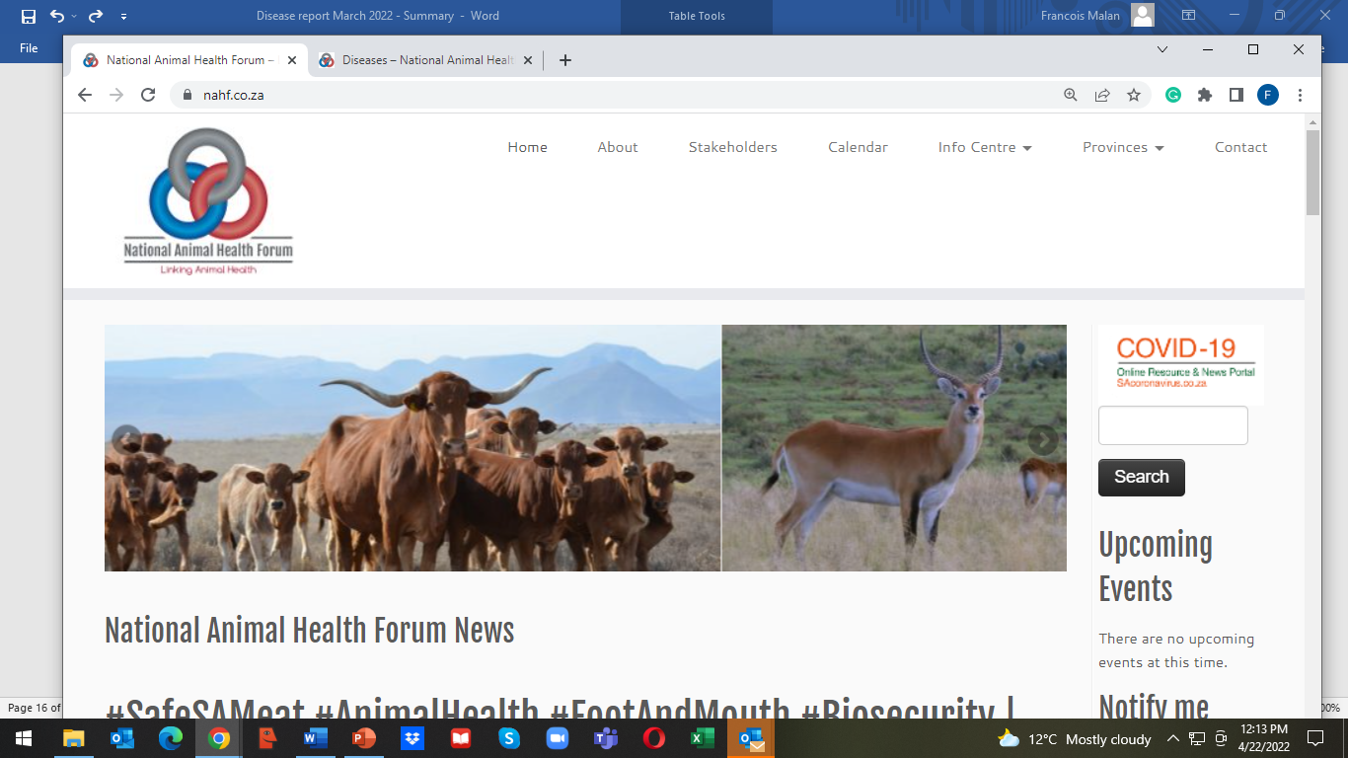
www.nahf.co.za
Click on Info centre
Click on Diseases

When last did you study the Veterinary Strategy??
https://nahf.co.za/wp-content/uploads/Vet-strategy-final-signed.pdf
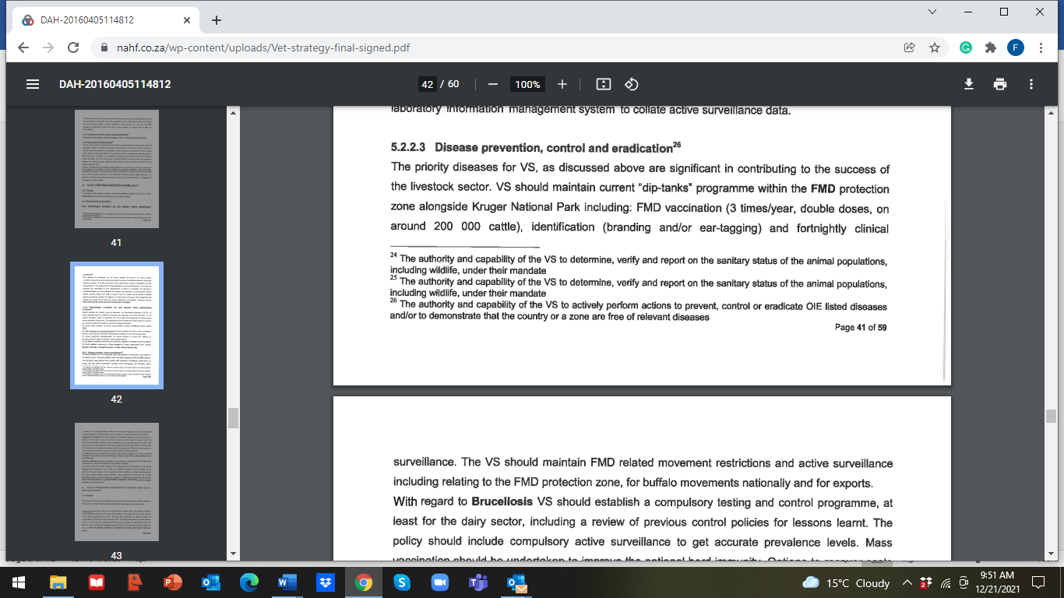
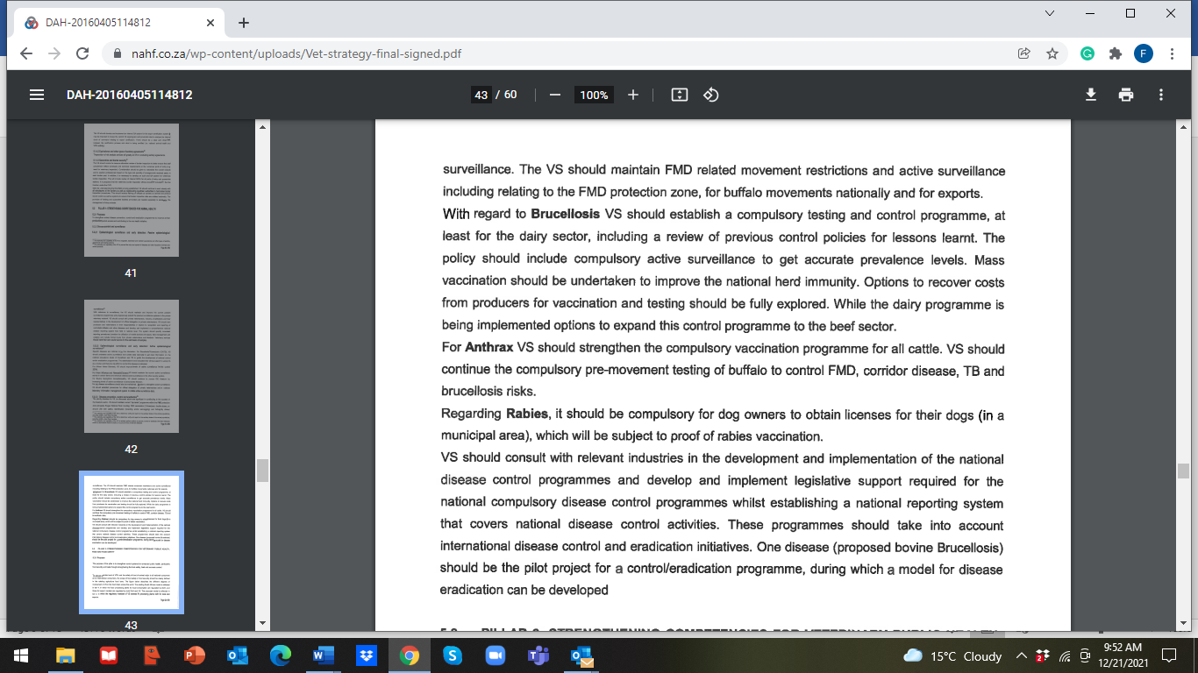
“Bovine Brucellosis – Outbreaks are mostly due to our own fault”
Again, new outbreaks of brucellosis are reported! When will we be able to say that we are winning the battle?
Brucellosis destroyed my life and this could happen to you too!

Dr. Frans Banting, a veterinarian who was infected with brucellosis nearly 40 years ago, tells his story and hopefully this will help all of us realize how devastating this disease is; and that we all have to stand together to eradicate brucellosis. It is each farmers responsibility to stop the spread of this disease.

Dr. Banting’s story:

Disease in cattle

The disease Bovine Brucellosis is also known as Contagious Abortion (CA) and in Afrikaans as “Besmetlike Misgeboorte (BM)”. Brucellosis is a herd disease, if an animal is tested positive in a herd, the whole herd is considered to be infected.

The disease is caused by a bacterium (pathogen) Brucella abortus bovis. Infected cows and pregnant heifers usually remain life-long carriers of the bacteria; spreading (excreting) the bacteria over many years. The udder and uterus are the most important organs that are infected. Blood and muscle tissue can also be infectious for a short period. Transmission by this means is very rare in humans.

Production losses occur as animals that test positive for brucellosis are slaughtered. Additional financial losses are due to:
Cost of an abortion
Cost of perinatal mortality
Cost of temporary infertility
Increased calving intervals
Cost of replacement of dairy cows
Cost of replacement of bulls
Cost due to mortality of sero-positive cows
Milk and meat production loss
Veterinary costs

(Information provided by Dr.Chris van Dijk, dairyvetza@outlook.com)

Clinical signs of infected cattle

Pregnant cows and heifers which are infected for the first time, having no resistance (immunity) to the disease, usually abort at 4 to 7 months of pregnancy. Such a fetus is usually hairless and about 30 to 40 cm in length. Calves that are stillborn may also be found in a herd. Weak calves can be born. Infected cows may abort for a second time. Retained afterbirths usually occur.

Temporary infertility after an abortion as well as mastitis may occur. Chronic cases may develop a swelling of the knee (hygroma). Cows that are carriers of the Brucella bacteria may show no clinical signs of the disease and could still calf annually and spread the disease to the rest of the herd. Bulls may also become infected.

Brucellosis in humans

In humans, brucellosis, is a zoonotic disease i.e., a disease spread from animals to humans. The disease is known as Undulant fever or Malta fever. Undulant fever is caused by Brucella abortus bovis and Malta fever by Brucella melitensis which occurs in goats.

Transmission

Humans are infected through one of the following ways:
Intake of infected raw milk, ice cream, butter or cheese
Ingestion or handling of infected raw or underdone meat, biltong or meat products. The risk is very small as the Brucella bacteria dislike dry, warm conditions. If an animal is slaughtered at an abattoir and hung (pH drop), then the risk is negligible.
Through contact or handling of an infected still born or infected calf, uterine fluid, afterbirth or bull string. The chance of infection when helping a cow during a difficult calving or removing a dead calf, is a reality!
Through pricking yourself with a syringe needle when vaccinating animals with Strain 19 or RB 51. Accidental contact of mucous membranes (eyes and mouth and open wounds) with the vaccine through aerosol transmission or breakages, could be disastrous to the farmer and personnel.

To summarize, if infected material is consumed (unpasteurised milk, meat, meat products, biltong) or if the bacteria/live vaccine comes into contact with mucous membranes (uterine fluid or fluid from infected calf) a person may become infected with brucellosis. Such an infection may enter the body through the eye, mouth, nasal cavity or skin.

Symptoms
The writer of this article was infected with brucellosis about 40 years ago. About two weeks after the infection took place, the first acute attack started.

Fever
A very high fever with profuse sweating occurred especially during the night. It felt as though his whole body was glowing. The worst attacks occurred from 22h00 to 01h00 the next morning. During the period from 07h00 to 14h00, the fever usually subsided.

Muscular pain
The pain was due to infection and was prominent in calf and thigh muscles

Arthritis and painful, swollen joints especially of the knees and hands.

Headaches
This is not a normal headache, but a sudden and serious stabbing headache within a localized area. It does not remain for a long period, but feels as if a long nail is driven into your skull. It disappears usually within a minute or might only last a few seconds.

Fatigue
An indescribable fatigue is often present. It often lasts for long periods -anything from one week to 6 months.

Weakness and muscular weakness. This weakness may be so bad that a person may not be able to work.

Weight loss and chronic diarrhoea
An affected person could lose 3 to 10 kg body weight within weeks.

Depression
Loss of interest in life. Such an attack can last for a few days or up to months.

Insomnia:
Waking during the night (especially between 22h00 and 24h00), one cannot sleep or one has a poor sleeping pattern.

Appetite
Strangely, appetite is not affected

The above listed symptoms are often confused with flu and therefore a correct diagnosis, in many cases, is not made in time. Most acute cases disappear within a month or two, A large percentage of cases develop a chronic (long lasting) infection with roughly the following symptoms:

Muscle and joint pain
Severe fatigue develops with a typical pattern. During the morning and early afternoon, the person feels normal. From about 15h00 to late at night fatigue sets in. This pattern repeats itself and may last for months or years.
Muscular weakness. A normal life is often not possible.

Treatment
If the disease is diagnosed and treated at an early stage, the patient could recover from the disease. Diagnosis is confirmed by means of a positive blood test. Unfortunately, many physicians do not recognize this disease or have insufficient knowledge of the disease and a correct diagnosis is not made.
Brucellosis is treated by giving numerous antibiotics as well as anti-inflammatory drugs, pain killers and multi-vitamins to patients. Antibiotics are given per mouth for 3 to 4 months while intra-venous drugs are given for five successive days with a drip containing nutrients.
In chronic cases the treatment is repeated if typical symptoms of the disease are seen. If infection is due to contact with the RB 51 vaccine, the infection cannot be discovered with the ordinary blood-test and the infection does not react to the ordinary treatment. Contact your medical doctor if you suspect you got infected through contact with the RB 51 vaccine.

Consequences
In serious cases it might be necessary to give the patient sick leave for an extended period. It may even be the best for the patient to retire or change his/her occupation. Brucellosis has its consequence and could change a person’s entire life!

Prevention
Brucellosis is a State Controlled Disease. Cattle are tested by taking a blood sample from an animal and sending the samples to an accredited laboratory. If it is suspected that brucellosis is present in a herd, the following procedure is followed:
Test all animals on the farm over 18 months of age. All positive animals have to be branded with a C on the neck, isolated and sent for slaughter as soon as possible (under cover of a Red Cross Permit) to an accredited abattoir. The farm will be quarantined. The herd is tested every two months until two negative tests are obtained. The test is repeated after six months and then annually thereafter.
If adult cows are bought, they should be tested before they are introduced into the herd.
Use the available registered brucellosis vaccines, Strain 19 or RB 51, according to prescribed instructions on the packet insert.
When buying animals, get a vendor’s declaration that these animals are from a brucellosis negative accredited herd. Quarantine them and test them again. Heifers should be kept separate until they have calved. Heifers should be tested from 4-5 months pregnancy and then again after calving.

Humans
Never handle suspected infectious material such as fetuses, dead calves, live weak calves or afterbirths without gloves or eye protection.
Do not drink raw milk from an unknown, untested source.

Remember: A brucellosis infected heifer, cow, dead calf or raw milk from a positive herd is a TIME BOMB which can alter your life dramatically or destroy it totally!

Written by: Dr. Frans Banting, Veterinarian and translated by Drs. Faffa Malan, Veterinarian (dokfaffa@nashuaisp.co.za) and Sewellyn Davey (sewellynd@gmail.com)

Summary of disease report for May 2022
141 Reports from veterinary practices and laboratories were received from Mpumalanga (MP) 12; Gauteng (G) 12; Limpopo (L) 7; Northwest (NW) 12; Free State (FS) 27; KwaZulu-Natal (KZN) 13; Eastern Cape (EC) 15; Western Cape (WC) 24: Northern Cape (NC) 8; Feedlots (FL) 2; Bovine consultant (BC) 1 and Laboratories (Lab) 8
Study this list – these are the most widely spread diseases as well as other conditions as reported by veterinarians, and determine your risk in collaboration with your veterinarian.
A list of diseases and conditions reported by veterinarians in 5 or more provinces
 | Number of provinces reporting
Wireworm | 9
Coccidiosis | 9
Anaplasmosis | 9
Lumpy skin disease | 9
Eye infections | 9
Lameness | 9
Pneumonia | 9
Dystocia | 9
Roundworms | 8
African red water | 8
E. coli | 8
Ringworm | 8
Abortions | 8
Abscesses | 8
Diarrhoea | 8
Poor conception | 8
Tapeworms | 7
Blue ticks | 7
Asiatic red water | 7
Pulpy kidney | 7
Orf | 7
Warts | 7
Blue udder | 7
Resistant roundworms | 6
Cryptosporidiosis | 6
Bont-legged ticks | 6
Heartwater | 6
Ephemeral fever (three-day-stiff sickness) | 6
Vibriosis | 6
Bovine malignant cattahr – BMC (snotsiekte) | 6
Calcium deficiency | 6
Mastitis | 6
Retained afterbirth | 6
Sheath prolaps | 6
Uterine prolapse | 6
Liver fluke worms | 5
Conical fluke worms | 5
Bont (heartwater) ticks | 5
Red-legged ticks | 5
Biting lice | 5
Nasal bot | 5
Trichomonosis | 5
Blackquarter | 5
Bovine brucellosis | 5
Protein deficiency | 5
Joint ill | 5
Vaginal prolapse | 5

Bovine Brucellosis

Although we have made positive steps in controlling Bovine brucellosis, the model disease stated in the Veterinary Strategy, we as a country is far from achieving our goal!

If farmers will just comply by vaccinating their animals against brucellosis, according to law, the incidence of brucellosis will drop dramatically as shedding of bacteria will drop!

Many farmers are still shrugging their shoulders and saying: “Why should I test my animals as it will only cost me money and what if there are positive animals? My farm will be placed under quarantine, so I am not going to test my animals!”

Dr Trudie Prinsloo a veterinarian and legal advisor has compiled legal aspects regarding brucellosis control and it is VERY IMPORTANT that you should avail yourself with the content of this document.

It is available in English and Afrikaans.

http://nahf.co.za/brucellosis-legal-aspects-2018-12-11/

When buying cattle, this Vendor declaration can assist you to minimize your risk!

VENDOR DECLARATION BOVINE BRUCELLOSIS
I hereby declare that I am the legal owner or authorised representative of the cattle on sale and am competent to make this declaration

1 | The cattle for sale are clearly and permanently identified |  | Yes | No
2 | The cattle for sale/slaughter were born on my farm |  | Yes | No
3 | The farm has a closed herd policy i.e. I do not buy in cattle, rent out grazing or speculate with cattle |  | Yes | No
4 | I practice bio-security on my farm to a level that is ** | Poor | Moderate | Good
5 | I vaccinate my heifer calves against Bovine Brucellosis once between the ages of 4 – 8 months |  | Yes | No
6 | In addition, I vaccinate my cattle older than 8 months with RB51 |  | Yes | No
7 | I have all the cattle on my farm tested for Bovine Brucellosis |  | Yes (date) | No
8 | My herd has been tested negative within the past year |  | Yes | No
9 | I did not buy in cattle since my last negative brucellosis test |  | Yes | No
10 | I/my vet investigates any abortions on my farm |  | Yes | No
11 | To the best of my knowledge, my immediate neighbours and farms in my area are free of Bovine Brucellosis |  | Yes | No
12 | I use a veterinarian to advise me on my cattle’s herd health |  | Yes | No
13 | The cattle handling facilities on my farm are | Poor | Average | Good

Note: Vaccination does not mean freedom from Bovine Brucellosis as cattle can still be carriers
Please attach the most recent Brucella blood test certificate

Owner or authorised representative: ………………………………………………

Signature: ………………………………………………

Date: ……………………………………….

** * Biosecurity
Poor – speculates with cattle, does not vaccinate, poor fences, cattle come into contact with other cattle
Medium – Vaccinates heifers, does not buy in cattle of unknown health status

Good – closed herd/never buys in cattle, vaccinates heifers and no contact with other cattle, follows a herd health plan as advised by his veterinarian, does not allow transport trucks onto property, washes and disinfects truck after returning from the abattoir or auction grounds.

Compiled by: Dr. Sewellyn Davey, Past Chairman of the Brucellosis Steering committee of the National Animal Health Forum
BOVINE BRUCELLOSIS IS A HERD DISEASE
If one animal is found to be positive for bovine brucellosis, the entire herd is regarded as been positive. The State Veterinarian should take responsibility for controlling and eradicating the disease from the farm.

SOP for the control of Bovine Brucellosis
Audit date:____________________________
Authorised person:__________________________

 |  | Y/N | Comment
1 | Fences and gates in good condition
2 | Gate control - log in
3 | Disinfection of vehicles coming onto the farm
4 | Protective clothing and boots given to people visiting the farm (cattle area) coming from high- risk areas eg. veterinarians, nutritionists, representatives, truck drivers, workers, etc.
5 | Sterilizing equipment coming in contact with cattle
6 | Run off water/ streams from neighboring farms
7 | All animals identified with a brand mark and ear tag
8 | Data base of all animals
9 | Closed herd
10 | When last were animals bought in or moved from another farm?
11 | Only buy in animals from a farm which has a recent negative tested brucellosis herd certificate
12 | Origin(s) of acquired cattle? Bought at an auction?
13 | Keep heifers separate from herd until they have calved and tested negative for brucellosis
14 | Quarantine camp available
15 | Separate calving camps
16 | Were all heifers vaccinated between 4 and 8 months vaccinated with Strain 19 or RB51?
17 | Any cattle vaccinated with Strain 19 over 8 months of age? History over last few years.
18 | Were there any abortions on the farm – samples taken, diagnosis?
19 | All sexually mature cattle in herd tested for bovine brucellosis (provide proof)
20 | Bovine brucellosis is a State controlled disease. Positive cattle are branded with a C on the right side of the neck.
21 | Isolation of infected animals & separate handling facilities
22 | Prohibition of movement of animals off quarantined property except under cover of a Red cross permit for slaughter at an abattoir
23 | Prohibition of use and on-farm disposal of un-boiled, un-pasteurised or un-sterilised milk on quarantined property
24 | Disinfection of places where infection is a possibility.
25 | Neighbors/ recent buyers informed of infected herd status
26 | Fly, crow and predator control
27 | Destruction of afterbirths/abortions in a responsible manner
28 | Beware of livestock, game interface

Websites that are there to assist you with information regarding animal health:

National Animal Health Forum

www.nahf.co.za

Read what the Forum is all about:
http://nahf.co.za/about/

This website will become the information centre of animal health in Southern Africa.
On the toolbar click on Stakeholders and you will find links to producer organizations and other organizations who are participating in the NAHF
http://nahf.co.za/stakeholders/

Provincial Animal Health Forums have their own site – click on Provinces http://nahf.co.za/provinces/

Important is to study the Veterinary Strategy (2016 -2026) as it gives direction to where we are going with Animal Health in South Africa.
http://nahf.co.za/wp-content/uploads/Vet-strategy-final-signed.pdf

Click on Info centre for more information on the “war” we have against Bovine Brucellosis. Please be up to date on the role all have to play to control this zoonotic disease.
http://nahf.co.za/category/diseases/brucellosis/

Information on other controlled diseases (Foot and Mouth Disease, Ovine Johne’s Disease, Pest of small stock – PPR, and African Horse Sickness) is available.

This link will continuously be updated.

Information on antibiotic resistance is also available at this address: http://nahf.co.za/category/antibiotic-resistance/

Rural Veterinary Association of South Africa
www.ruvasa.co.za
Click on Disease reporting where maps and information can be sourced on the prevalence of diseases in all provinces. Abattoir reports are available. Use the information available to update management programmes

Internal parasite control
www.wormx.info

Farm gates, Fences and Foresight, the 3 F’s!
Bear this in mind as this is where most disease-causing organisms enter or exit farms!
Major examples are: Foot and mouth disease, brucellosis, Johne’s disease, TB, cryptosporidiosis, trichomonosis, vibriosis, sheep scab, resistant parasites such as red lice, blue ticks and internal parasites (Buyer beware programmes).
Insist on VENDOR’S DECLARATIONS when buying animals.
Quarantine
Immunization programmes
Speak to your veterinarian
Abide the law- vaccinate cattle against anthrax and heifers against brucellosis!
For the detailed report and previous reports go to www.ruvasa.co.za and click on Disease reporting
Internal parasites
The following reports were received from practices regarding internal parasite infestations:
Internal parasites | MP | G | L | NW | FS | KZN | EC | WC | NC
Roundworms | x | x |  | x | x | x | x | x | x
Resistant roundworms |  | x |  | x | x | x | x | x
Wireworm | x | x | x | x | x | x | x | x | x
Brown stomach-worm |  |  |  |  | x |  | x | x
Long-necked bankruptworm
White bankruptworm |  |  |  |  | x
Large-mouthed bowelworm
Nodularworm
Lungworm
Eyeworm |  |  |  |  | x
Parafilaria | x |  | x |  |  |  |  | x
Stephanofilaria |  |  |  |  |  |  |  | x
Tapeworms | x | x |  | x | x | x | x |  | x
Liver fluke | x |  |  | x | x | x |  | x
Conical fluke | x | x |  |  | x | x | x
Cysticercosis (measles) |  |  |  |  |  |  |  | x
Schistosomiasis (bilharzia) | x
Coccidiosis | x | x | x | x | x | x | x | x | x
Cryptosporidiosis | x | x |  |  | x | x | x | x
Sarcosporidium
Giardia

Wireworm outbreaks have been reported from all 9 provinces. On some farms the mortality rate was excessive!
BEWARE
A farm has been found where the wireworm strain on the farm is resistant to ALL active de-wormer groups
Check the eye mucous membrane colour of a group of sheep in all flocks weekly! Bottle jaws and pale eye mucous membranes are indications that deaths are just around the corner!
Get advice from your veterinarian to ascertain which de-wormer group(s) are still effective on your farm by doing a faecal egg count resistance test (FECRT). Visit www.wormx.info for training material.
Group code | Generic class of actives | Example of actives
1* | Macrocyclic lactones (ML’s) | Abamectin  Doramectin  Eprinomectin  Ivermectin  Moxidectin
2* | Benzimidazoles (white drugs) | Albendazole  Fenbendazole  Febental  Ricobendazole  Triclabendazole
3* | Imidathiazoles (clear drugs) | Levamisole  Morantel
4* | Salicylanilides | Closantel  Niclosamide  Oxiclozanide  Rafoxanide  Resorantel
5* | Phenols | Nitroxinyl
6* | Sulphonamides | Clorsulon
7* | Organophosphates | Trichlorfon
8* | Isoquinolones | Praziquantel
9* | Others  Amino-acetonitryl-derivatives (AAD’s) | Piperazine  Monepantel
10* | Spiroindoles | Derquantel

Visit www.wormx.info for valuable information on parasite control!
Beware of liver fluke and conical fluke outbreaks when animals are grazing in wet areas where the intermediate hosts, water snails, are abundant.
Coccidiosis outbreaks were reported from all nine provinces. Young animals are most susceptible.
Cryptosporidiosis outbreaks, causing huge losses were reported from 6 provinces. This deadly condition has now spread to the Western Cape. Good colostrum protects new born animals. Biosecurity should be practised at all levels on the farm.
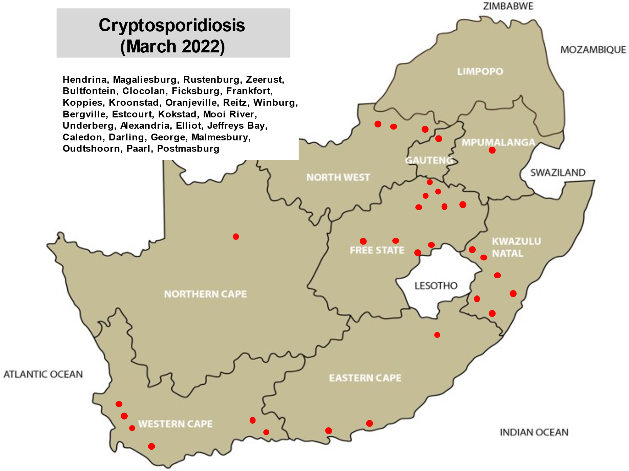
https://www.google.co.za/search?hl=en&tbm=isch&source=hp&biw=1344&bih=608&ei=PyxyXOO7OcutkwXinK3oCA&q=cryptosporidium+parvum&oq=Cryptosporidium&gs_l=img.1.1.0l10.2885.9850..16402...0.0..0.708.5719.2-4j4j3j2j1......0....1..gws-wiz-img.....0.o66yefU7Ric

Prevention of Cryptosporidiosis
Prevention is the best control method.
Animals with a well-developed immune system will generally overcome Cryptosporidium thus this should be the main aim in controlling Cryptosporidium.
A consistent, vet approved and farm appropriate vaccination program for other diseases.
Ensure no nutritional deficiencies especially vitamin A and Selenium
Excellent bio-security management
Ensure clean pathogen free water sources
Hygiene training of personnel
Consult your veterinarian

SOLUTION
HOLISTIC INTERNAL PARASITE MANAGEMENT FOR SHEEP AND GOATS

Gareth Bath, Jan van Wyk and Faffa Malan

INTRODUCTION
Over the past ten to fifteen years there has been a radical rethink on our previous worm control strategies and assumptions due to the ever-accelerating failure of anthelmintics globally. This has caused a quiet but drastic revolution in many of the “received wisdoms” which governed advice to farmers for close to a century.

For a start, we have to abandon the underlying philosophy that internal parasites are an evil plague which should be maximally suppressed, or preferably eradicated. We have to learn to live with parasites, and prevent only the unacceptable production losses, while simultaneously breeding animals fit for the environment, rather than making the environment fit for existing animals. By regarding parasites as part of the natural order of things, we will be able to see them simply as potential problems to be managed in order to achieve optimum productivity and profitability.

Only well integrated, holistic planning has a long-term chance of success, and unless all elements of our potential armamentarium are harnessed, the results will not match the expectations.

While this paper applies to helminths, and mainly nematodes, the parallels and inferences which can be made for ectoparasites, and indeed other organisms, should be obvious.

WORM MANAGEMENT PRINCIPLES

A FLOCK MANAGEMENT REQUIREMENTS

Separation of Groups
Since different classes of animals vary in their susceptibility to worm infection and its effects, they should be separated into groups, which are grazed, treated and managed as distinct entities. If these distinctions are not made one may be forced to treat the flock according to the most susceptible group. The most susceptible groups can still be managed and treated more intensively in a mixed flock, but this becomes more difficult.

Identify the groups most at risk
Research has shown that the more susceptible animals are lambs/weanlings; and pregnant/lactating ewes. The former is susceptible because they cannot yet mount an effective immune response to infection, the latter are prone to infection because of a temporary suppression of immunity. (PPRR). These groups must get special attention.
Separation of pastures
Unless pastures can be divided by fencing or herding, all sheep will be exposed to a similar challenge, regardless of whether they are susceptible or resistant to infection and its effects. This will prevent any differentiation in management and treatment. Diversion of pastures is not only good for internal parasite control; it also aids pasture management. Electric fences can be used as temporary pasturage dividers. In communally farmed areas, herding or tethering can achieve the same result without fencing.

Resting of pastures
If pastures can be separated, it is then possible to rest them effectively, which has decided advantages to pasture management and improvement. If such pastures can be rested long enough, this will also have a significant effect on the survival of worm larvae and therefore the infection rate of the flock. Although the time needed for effective resting of pastures will vary with the climate, weather and worm species, a useful rule of thumb for effective resting is at least 3 months in subtropical for temperate climates, but as little as 1 month in the tropics. The longer the rest, the better it is for worm management.

Alternation of host species
Sheep and goats share the same worm species and alternation with one another is ineffective for worm management. However, other species like cattle, horses and ostriches are generally not susceptible to the worms of sheep and goats. If they are used to graze pastures before or after sheep or goats, they act as "vacuum cleaners" on the pasture, as they ingest many larvae which cannot develop further into egg-laying adults. The other advantage is that the pasture can still be utilised in its growing season, which prevents the grass from becoming senescent, and optimises its usefulness. This aids in maintaining the profitability of the farm.

Mend water leaks
Water points (troughs, windmills) should not be allowed to leak, as this encourages the growth of grass. Since this is where sheep concentrate, the area can become lethally contaminated by larvae.

Avoid grass in pens
Where sheep or goats have to be penned for lengthy periods (usually at night, to combat theft or predation) there can be a fatal buildup of larvae on the grass growing there. Sheep become hungry overnight and will eat these morsels of food. In consequence they will ingest massive numbers of larvae. It is therefore necessary to remove all grass from such pens.

Fence off moist areas
Areas particularly prone to high moisture and therefore the survival of worm larvae, like streams and marshes, should be separated to reduce the challenge of the flock.

Strategic movement of flocks
The aim should be to create "safe" (not necessarily "worm free") pastures. By planning changes in camps or paddocks, stock will be subject to lower challenges and need less chemical treatment. Any grazing system where a significant proportion of the pasture is rested for a full growing season will be particularly effective.

Quarantine and treatment
Do not simply introduce purchased animals into the flock or herd. They must be quarantined in a worm-unfriendly pen (bare earth or concrete) and treated intensively using the best drugs and schedule. If financially feasible, do an FECRT to ensure minimum carry-over of drug-resistant parasites. Then place them on infected pasture if there is no multiple resistance.

B GENETIC SELECTION

Selection for resistance
Resistance (the acquired or innate ability to prevent or minimise infection by parasites) is heritable and can be selected for, by measuring the faecal egg counts and using only those sheep with the lowest FEC's for breeding. For practical and economic reasons, this is usually only done for rams. Some successful breeding programs have been undertaken but they require good organisation and meticulous record keeping. Culling of bad ewes and their offspring is also practical and recommended.

Selection for resilience
Resilience (the ability to withstand the effects of infection and produce satisfactorily in spite of it) is also heritable. At present, only two proven methods, FAMACHA© and Haematocrit determination exist, although preliminary results suggest that Body Condition Scoring may also be useful. The FAMACHA© System can be used only where wireworm is the major parasite. By treating according to clinical anaemia (an indicator of poor resilience), only those sheep unable to cope with wireworm are treated. This reduces selection pressure for anthelmintic resistance and at the same time allows the farmer to cull the non-copers, in the long term thus being able to breed an animal better adapted to the environment.

It is also possible to select rams by a system of allocation of selection indexes. This is currently under investigation and will require measuring individual ram FECs and FAMACHA© scores (or haematocrits) to make the measurement more accurate.

C MONITORING SYSTEMS

FEC
Regular (monthly or 2 - monthly) monitoring of faecal egg counts on a group or flock basis will help to indicate when dosing is really needed, and equally important, when it can be delayed or even omitted. A bulk (composite) FEC comprising a single count of faeces pooled from equal samples from 10 to 20 sheep is certainly cheaper than dosing the whole flock unnecessarily. Keep graphs or tables of changes to indicate when parasite buildup is likely.

FECRT
Every farmer should have the flock tested for drug resistance in the worm population on his farm, at regular intervals of not less than two years. Only by knowing exactly what the state of anthelmintic resistance on a farm is, can appropriate action be taken. Generalisations like "benzimidazole resistance is found on most farms" are not much use since they cannot tell us what the situation is on a particular farm. Just as important, we must know not only that resistance is present, but also how bad it is. Can we still use the drug group at all? Separate bulk faecal samples from each drug group will reduce the cost to acceptable levels.

FAMACHA© evaluation
Apart from selection and culling, this system also allows frequent, cheap and easy monitoring of the current situation as regards worm infection, but applies only to haemonchosis.

D OPTIMISE ANTHELMINTIC USE

Establish the important parasites species present
Unless the prevalence and importance of worm species is known, worm management becomes dangerous and unpredictable guesswork. It can also be ineffective and very costly.

Use the most suitable drug
If the parasites are ranked in order of economic importance and their susceptibility to groups of anthelmintics is known and combined with knowledge on the anthelmintic resistance situation on the farm, it is then possible to decide which drug(s) and formulations will be the most suitable in each situation. This includes their cost and a cost/benefit analysis. Neither the cheapest nor the most expensive drug is necessarily the best one to use. Beware of generic drugs sold by an unknown company.

Avoid too frequent treatment
The old approach of "dosing clean" must be completely abandoned, although not by reducing the dosage rate per animal. The aim has to be to treat only sufficient times and enough individual animals to maintain the equilibrium between parasite, host and environment (that is, worm management). Overtreatment ensures that only resistant parasites can survive. Minimal treatment programs must be the new watchword, but is must be ensured that every treatment is effective.

Treat all and stay
This is a major departure from the recommendations made for close to a century. If all sheep are to be treated, they should remain in the camp (paddock) where they were grazing before treatment. This will prevent sheep from contaminating a new pasture with only those resistant parasites which survived treatment, thus in the process unwittingly causing the selection for resistance parasites. In most cases they should remain in the paddock for at least 2-3 weeks after treatment to pick up unselected larvae for propagation of the susceptible worms in the new camp/paddock. However, should a long-acting anthelmintic be used, this period will have to be longer (2 to 3 weeks after the effective residual action ends). Particularly bolus (slow release) formulations should be used with great caution.

Treat selectively
It is preferable to treat only those sheep or goats unable to cope with the current infection challenge, provided the percentage of non-copers remains below 20%. This can be done with the FAMACHA© system for haemonchosis, or possibly with Body Condition Scoring for other parasites. If clinically unaffected animals are left untreated, an immediate move to new pasture will not be detrimental. In the absence of such selective treatment, just leaving a small percentage (10-25%) of the flock intentionally untreated can be beneficial to slow AR development.

Move then treat

Another way of achieving the same result as “treat all and stay” is to move the flock to a new “safe” pasture and delay treatment for 2-3 weeks, to allow the seeding of the new pasture with unselected worms, before treating the flock.

Herbal Remedies
These are often touted as the answer to worm control. However, unless they have been properly tested and proven by an independent body, they may be useless or even harmful.

E IMPROVED ANTHELMINTIC EFFICACY

Dose over the tongue
By placing the tip of the gun towards the back of the mouth, over the tongue, closure of the oesophageal groove does not occur and thus the full dose lands in the rumen where it is absorbed more slowly - this is particularly important for anthelmintic groups which rely on prolonged blood levels for their effect, like the benzimidazoles and macrocyclic lactones.
This prolonged level of activity (a long so-called "killing zone") means that the drug against which worms have developed a moderate degree of resistance can be made more effective, although of course the resistance of the worms is not reduced, but rather partially overcome. However, dosing (drenching) over the tongue, if done carelessly, can result in two very severe consequences:
the dose can land up the lungs, and cause pneumonia
the nozzle of the dosing gun can penetrate he pharynx and cause severe, fatal infection.
If the sheep jumps forward, the operator must let the gun ‘ride’ with the sheep, and not oppose it, and the dose must be delivered by a measured, steady pressure rather than a single squeeze.

Reduce feed intake
It has been shown in the case of benzimidazoles and closantel that reducing feed intake (i.e. starvation) for 24 hours prior to treatment will improve the absorption of the remedy because of the lower rate of flow of ingesta. As in the previous case, this results in a more effective exposure of the parasite to the drug.
In turn, this means that the drug is clinically more effective and can partially overcome drug resistance.

Repeat the dose
This only applies to benzimidazoles and macrocyclic lactones. Two doses given 12 hours apart will again increase the “killing zone” of these drugs, allowing more time for a cumulative killing effect. Thus, resistant worms can still be killed, although this is achieved at a cost since two normal doses rather than one are needed. A double dose, given at one time, will have no beneficial effect with these two groups of anthelmintics.

Increase the dose
This only applies to drugs which rely mainly on peak concentrations for their effect. In this case, a double amount of drug given at one time can overcome drug resistance in worms. This is useful for the imidasothiazoles (levamisole). There is however a relatively low safety margin, only 2x – 3x the therapeutic dose may sometimes cause problems of toxicity.

Correct dosage
It may seem too obvious, but a lot of problems are caused by not weighing sheep, not calibrating and checking the dosing gun for accuracy and repeatability, and not reconciling the amount of drug used with the number of sheep treated. Underdosing may be a factor leading to anthelmintic resistance, but it is more likely to be the cause of ineffective treatment.

Drug combinations
Combining drugs from different activity groups in one dose may temporarily improve the effective clinical action of these drugs, but only if each drug concerned is unaffected by resistance. However, many authorities believe that this will not slow the development of resistance and could even enhance it. If drugs are mixed, this can only be done if the formulation has been fully tested and carried by experts, in registered products. Home-made combinations are dangerous and illegal. Such combinations often just give temporary relief and disguise the emergence of AR until it is severe and multiple.

Sustained delivery
Medicated blocks or controlled release capsules will increase the clinical efficacy of those drugs which rely on prolonged action for their effectiveness. However, we have to bear in mind that prolonged exposure to a drug at low levels will increase selection for resistance. This approach will therefore not be permanent, and should only be used for very specific, limited purposes (e.g., weaners on green pasture) and not the entire flock in all circumstances.

Goats are different
Because of differences in the rate of metabolising drugs, goats must be treated as different to sheep. This means that goats must often be given a higher dosage rate than sheep except where there is a possibility of toxicity. Note that many anthelmintics may not be registered for use in goats, or that the recommended dose given is the same as for sheep. Unfortunately, therefore if the product is not registered for use in goats, or the dosage rate is increases, the user has no legal redress if the product is used and fails, or causes losses.

F EFFECTIVE PLANNING

Use the expert
Knowledgeable veterinarians, who know the area, farming systems and risks can construct a simple, practical, economic and effective holistic worm management strategy. They can consult helminthologists where necessary.

Use a program
Unless a basic planned system is in place and is used, actions will inevitably be largely reactive and based on ad hoc or panic decisions. But this does not imply a rigid adherence to the basic plan.

Flexibility
The program must be flexible to allow for changes in weather, management and farming systems, drug costs or other factors.

Treatment strategy
It is probably true that on most farms animals are either dosed too often, or with inappropriate drugs, or at the wrong times, or with no coherent plan. By setting up a well thought out dosing plan, we can cut out ineffective doses which only add to the selection pressure for parasite resistance. This is one of the areas in which the knowledge and skills of the local vet are vital for success.

II OTHER MEASURES AND FACTORS

Protein supplementation
Since resistance and resilience are dependent on adequate nutrition, and the most important factor identified is protein, it is possible to ameliorate the effects of parasites by feeding animals better. We need to know when and how much of what supplement must be supplied to which class of animal, and what the cost / benefit ratio would be before this aspect can be fully integrated into our overall approach.

Condition scoring
The early indications are that this may be useful for identifying individual animals for treatment against some non-haematophagous worm species. The principle is that animals with a condition score which is more than half a score below the flock or herd average are treated. If the animals have a condition score below 2 and the risk of worm infestation is high, then treatment should be given.

Weather monitoring
Factors which affect the survival, development and infectivity of larvae on pastures must be considered. Temperature, rainfall, rainfall pattern, humidity and could cover will all have an effect and must be considered when making worm management decisions.

Flock/Herd history
Without knowing details of numbers, types, ages, reproductive stages, treatment, stocking rates, grazing pressures and livestock movements, decision making is at best arbitrary and at worst potentially disastrous.

Veld/pasture assessment and history
Coupled with livestock data, the advisor has to consider details of the veld or pasture type, its condition, growth stage, the soil cover, soil moisture, slope land the grazing history.

Assessment and decision support computer programmes
A few of these are available internationally, others are under development. Using computer power, they evaluate all the known risk factors and advocate alternative actions based on the given situation and data provided. The evaluation is of course only as good as the inputs given and these programmes cannot substitute entirely for the skills, knowledge and assessment of the advisor or the farmer.

III CONTROL MEASURES UNDER DEVELOPMENT

Predacious fungi
Nematophagous fungi in the soil can severely constrain larval survival by immobilizing and killing them. Practical implementation is, however, still a long way off.

Dilution of resistance
By the re-introduction of susceptible strains to a farm where a parasite strain has become resistant to anthelmintics, it is possible to significantly reduce the degree of resistance by a dilution effect. There is some indication that this can be effective on severely affected farms, by the process is slow, labour-intensive and costly.

Vaccination
A vaccine against wireworm is now available, discuss its use with your veterinarian
Condensed Tannins

Plants containing higher levels of tannins suppress worm egg counts, but also have problems with palatability and digestibility.

Cupric oxide
Needles of oxidised copper wire dosed into the rumen will reduce worm egg counts, but the long-term toxic effects (especially with sheep) have to be considered, especially if the diet is high in copper.

Change in body weight
Lack of satisfactory weights gain, or even weight loss, can be considered as indicators for the treatment of individual animals in a flock. However, weighing is time consuming and may not be applicable in a given situation.

IV INTEGRATED PARASITE MANAGEMENT

If any of the foregoing principles are used exclusively, failure will be certain. It is only by using a prudent mix of strategies that sustainable, cost-effective measures can be established. The decision on which measures are to be used in a given situation can only be made by an expert who is conversant with local conditions. This programme will of course have to be drawn up in close consultation with the livestock owner(s).

Whether the farming system is based on communal ownership, subsistence farming, small-scale farming, commercial farming or stud farming, the principles remain the same. Only the mixture and weighting of measures used to manage parasites will vary according to circumstances.

V ACTION CHECKLIST

To implement the holistic use of all the available worm control strategies and principles, the veterinary advisor needs to go about setting up a sustainable programme methodically. The starting point is always the basic management programme, although even this may need to be modified to accommodate sustainable parasite control. Once the key activities like lambing, mating and shearing have been established, and the basic grazing programme has been decided, the requirements of effective parasite management may be superimposed. Planning is a dynamic and never-ending activity, and plans need to be revised each year as necessary.

By following the checklist, advisors can ensure that all appropriate measures have been considered and used.

Make sure that the farmer understands and supports the need for change
Ensure that all measures are practical, integrated and financially defensible
Use an incremented approach, do not try to do everything at once
Evaluate and use knowledge in stock flow, reproductive programme, grazing systems, pasture or veld conditions and weather to decide on appropriate and integrated worm management actions.
Are the groups/classes of animals properly separated? If not, implement this if possible.
Give weanlings and late pregnant/lactating ewes most attention and the best circumstances
Are the pastures properly fenced, and are there enough camps for effective management?
Implement a satisfactory pasture resting program. Keep well rested pastures for susceptible groups
Graze camps sequentially by cattle, small stock and other host species if available
Make sure that animals are getting the right nutrition, especially protein, and avoid putting animals in poor condition onto high- risk pastures
Mend water leaks and fence off moist areas
Remove all grass from pens where animals are routinely held for long periods
Buy rams selected for resistance (FEC) and/or resilience (FAMACHA©/haematocrit)
Cull the minority of ewes which are unable to cope with prevailing parasite burdens
Institute a planned program for FECs to monitor the parasite situation
Ensure that the FECRT is done every second year
Introduce TST and Institute the FAMACHA© system for haemonchosis or BCS for other worm species
Ensure that the types and relative importance of parasites have been established on each farm as well as when they are likely to occur
Select and use the best drug for each situation
If all animals are treated, do not move to new pastures for 2-3 weeks or longer depending on the drug and formulation used
Ensure that the drug used is given in the most effective way
Quarantine and treat all introductions and put them onto infected pasture
Stick to what is possible in a given situation

FAMACHA cards can be obtained through your veterinarian (famachasystem@gmail.com)
Serious problems due to diarrhoea in lambs and calves were received from many areas. In many instances Cryptosporidium and pathogenic strains of E. coli were involved. Consult your veterinarian for help!
https://www.google.co.za/search?hl=en&tbm=isch&source=hp&biw=1344&bih=608&ei=PyxyXOO7OcutkwXinK3oCA&q=cryptosporidium+parvum&oq=Cryptosporidium&gs_l=img.1.1.0l10.2885.9850..16402...0.0..0.708.5719.2-4j4j3j2j1......0....1..gws-wiz-img.....0.o66yefU7Ric

External parasites
The following reports were received from practices regarding external parasite infestations:
External parasites | MP | G | L | NW | FS | KZN | EC | WC | NC
Blue ticks | x | x | x | x | x | x |  | x
Resistant blue ticks | x |  |  |  | x | x
Heartwater ticks | x | x | x | x |  | x
Brown ear-ticks | x |  |  |  |  | x
Bont-legged ticks | x |  |  | x | x | x | x |  | x
Red-legged ticks | x |  |  | x | x | x |  | x
Paralysis ticks |  |  |  |  | x |  | x | x
Tampans |  |  |  | x
Biting lice | x | x |  |  | x | x |  | x
Sucking lice |  |  |  |  | x
Fleas
Itch mites
Sheep scab |  |  |  | x | x |  |  | x | x
Mange mites |  |  |  | x | x
Nuisance flies | x |  |  |  | x | x |  | x
Midges |  |  |  |  | x |  |  | x
Mosquitoes |  |  |  |  | x
Blowflies |  |  |  | x |  |  | x | x
Tsetse flies
Screw-worm |  |  | x |  | x
Gedoelstia (uitpeuloogsiekte)
Nasal bot |  | x |  | x | x | x |  | x

After the good rains in many parts of the country an explosion of tick numbers has occurred!
Blue ticks (African and Asiatic blue ticks) are able to transmit African and Asiatic red water anaplasmosis and lumpy skin disease.
Make sure to assess the blue tick resistance status on your farm before buying tickicides. Your veterinarian will be able to collect engorged blue ticks to be tested for resistance.
Heartwater, transmitted by bont-ticks.
Ticks also cause anaemia, udder, ear and hide damage.
Most important is to prevent udder damage. Ticks with long mouth parts such as bont and bont-legged ticks, can cause irreparable damage to teats and the udder.
Screw-worm infestation is rife after tick damage.
Actives to be tested for resistance are: organophosphates, pyrethroids, amidines and fipronil. Actives, only registered for controlling blue ticks are: macrocyclic lactones, fluazuron (acaracide growth regulator).
Discuss your tick control programme with your veterinarian.
Tick borne diseases
The following tick-borne diseases were reported by practices in the provinces:
Tick borne diseases | MP | G | L | NW | FS | KZN | EC | WC | NC
African red water | x | x | x | x | x | x | x | x
Asiatic red water | x | x |  | x | x | x | x | x
Anaplasmosis | x | x | x | x | x | x | x | x | x
Heartwater | x | x | x | x |  | x | x
Lumpy skin disease | x | x | x | x | x | x | x | x | x
Corridor disease |  |  |  |  |  | x
Theileriosis

Asiatic red water is spreading and is one of the deadliest diseases in cattle.
Deaths occur when introducing susceptible animals into areas where tick borne diseases are present!
Numerous mortalities were reported.
Anaplasmosis outbreaks were reported from 9 provinces! Biting flies are the main transmitters of this disease.
Using the same needle when vaccinating cattle may also be the reason for an anaplasmosis outbreak!
Red water and anaplasmosis can be confirmed by examining blood smears under a microscope.
The keyword is: vaccinate your animals! Contact your veterinarian.
Beware of moving susceptible animals into areas where infected ticks are present or moving animals with infected ticks to disease free areas! Before deciding to buy animals speak to both veterinarians – from the area moving the animals and the area where they are going to.
Tick toxicosis
Tick toxicosis | MP | G | L | NW | FS | KZN | EC | WC | NC
Sweating sickness | x | x |  | x | x

Sweating sickness is caused by a toxin injected into calves by females of the bont-legged tick specie.
Insect transmittable diseases
The following insect transmittable diseases were reported by practices in the provinces:
Insect transmittable diseases | MP | G | L | NW | FS | KZN | EC | WC | NC
Lumpy skin disease | x | x | x | x | x | x | x | x | x
Pseudo Lumpy skin disease (Allerton virus)
Ephemeral fever (Three-day-stiff sickness) |  | x |  | x | x | x |  | x | x
Blue tongue |  |  |  | x | x | x |  | x
Rift Valley Fever
Wesselsbron disease
Nagana |  |  |  |  |  | x

A dramatic increase of insect transmitted diseases occurred after good rains. Fell in many parts of the country.
Venerial diseases
The following venereal diseases were reported by practices in the provinces:
Venereal diseases | MP | G | L | NW | FS | KZN | EC | WC | NC
Trichomonosis | x |  |  | x | x | x | x
Vibriosis | x |  | x |  | x | x |  | x | x
Pizzle disease |  |  |  |  | x
Actinobacillus seminis plus HPA

BEWARE
New cases of trichomonosis are reported every month and this disease is out of control.
Make sure to buy bulls from farmers where biosecurity measures are in place and bulls are tested for these diseases at regular intervals. Trichomonosis were reported from 4 provinces.
Venerial diseases are HERD diseases! Calculate your losses if these diseases are not eradicated on your farm!
Make sure that fences are in good order and gates closed so that bulls cannot escape to neighbouring cows that may be infected with Tritrichomonas and become infected or infected neighbouring bulls are jumping fences to your farm.
Cattle study groups should discuss preventative and control measures with their veterinarians. Be sure to test bulls regularly for these diseases.
Beware when buying in or sharing bulls! Remember female animals may also be infected.
Study the Good management SOP’s for cattle farmers on the RPO website
http://www.rpo.co.za/wp-content/uploads/2016/04/nuutRPO-NERPO-Code-Addendum.pdf
http://www.rpo.co.za/wp-content/uploads/2016/04/nuutRPO-NERPO-Code-Addendum-4-Good-management-practices-and-SOPs-for-cattle-farmers-1.pdf
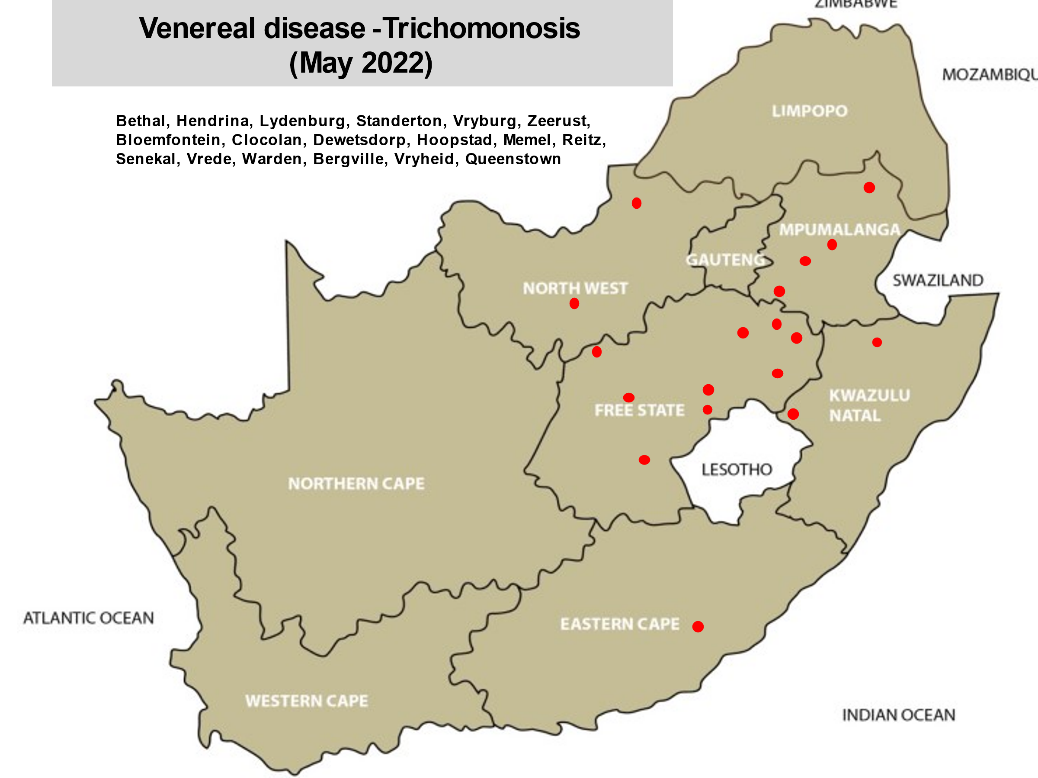Consider Trichomonosis as an area disease, farmers should work together to keep areas free from diseases such as trichomonosis, brucellosis, tuberculosis, Johne’s disease and sheep scab.
Bacterial diseases
The following bacterial diseases were reported by practices in the provinces:
Bacterial diseases | MP | G | L | NW | FS | KZN | EC | WC | NC
Anthrax
Blackquarter | x |  |  | x | x | x | x
Clostridial disease |  |  |  |  |  |  | x
Botulism |  |  |  |  | x |  |  |  | x
Pulpy kidney | x |  |  | x | x | x | x | x | x
Lamb dysentery |  |  |  | x | x
Swelled head |  | x | x |  |  | x
Red gut (cattle) | x |  |  |  |  | x |  | x
Blood gut (sheep) |  |  |  | x |  |  | x | x
Tetanus |  | x |  |  | x
Salmonellosis |  |  |  |  | x | x | x
Klebsiella
Bovine brucellosis | x |  | x | x | x | x
Brucella melitensis (goats)
Ovine brucellosis (Ram’s disease) |  |  |  |  |  |  | x
Bovine tuberculosis |  |  |  |  | x
Johne’s |  |  |  |  |  |  |  | x
Leptospirosis
Listeriosis |  |  |  |  |  |  |  | x
Pseudomonas |  |  |  |  |  |  |  | x
Pasteurella multocida
Pasteurellosis (see pneumonia -lungs) | x | x | x | x | x | x | x | x | x
Fusibacterium necrophorum | x | x |  |  | x |  |  | x
Septicaemia |  |  |  | x | x |  |  | x
E. coli | x | x | x | x | x | x |  | x | x
Klebsiella
Coxiella (Q-fever) |  |  |  |  |  | x
Mycoplasma
Histophilus somni
Enzootic abortion |  |  |  |  | x |  |  | x | x
Lumpy wool (Dermatophilus) |  |  |  |  | x | x | x
Bovine dermatophilosis (Senkobo disease)
Uterine gangrene
Wooden tongue
Lumpy jaw
Interdigital dermatitis
Most of the bacterial diseases can be prevented by vaccination! Discuss and update your programme regularly in consultation with your local veterinarian!
Multi-clostridial vaccines should be used if blackquarter outbreaks still occur when only using a vaccine containing Clostridium chauvoei. Remember to give a booster vaccine when using an inactivated vaccine for the first time. Read the packet insert!! Study the table above and determine the risk for animals on your farm.
Get advice from your veterinarian on Cryptosporidium/E. coli outbreaks in your area and what to do to prevent losses in lambs and calves. Biosecurity!!!!!!!!
Enzootic abortion contributes to the disappearance of foetuses in sheep and goats scanned pregnant. Vaccinate replacement ewes with the live vaccine before putting them to the ram!
Pulpy kidney (Clostridium perfringens type D – epsilon toxin) is still the biggest killer of sheep. There are various factors that could lead to pulpy kidney such as: the intestinal tract stops functioning (stasis), sudden change from poor veld to lush artificial pastures; sudden change in diet; grazing of fodder crops such as lucerne, green wheat and green oats, diet high in protein, overeating of concentrates or fertile pastures, deworming and coccidiosis infection. Sudden changes in the weather and grazing in wilted pastures, may also play a predisposing role.
Be sure to vaccinate animals against botulism especially if chicken litter is going to be fed to animals.
Q-fever, a zoonosis, seems to be more prevalent, beware! An abortion storm in sheep should make farmers aware of Q-fever!
Challenging farmer’s unions and study groups to eradicate brucellosis in their area!! Many success stories are received! Brucellosis is a herd disease!!!
Ask for vendor’s declarations before buying in animals and quarantine them before releasing them onto the farm!!!!
Calves may become infected when drinking infected colostrum!
A positive heifer is a TROJAN HORSE!!! This latent carrier of brucellosis may only test positive after calving!!!!!
PREVENTION IS BETTER AND CHEAPER THAN TREATMENT!
Do not save yourself bankrupt!
Q-fever, enzootic abortion, brucellosis, are all zoonotic diseases and should be handled with utmost care!
Viral diseases
The following viral diseases were reported by practices in the provinces:
Viral diseases | MP | G | L | NW | FS | KZN | EC | WC | NC
BMC (snotsiekte) |  | x | x | x | x |  | x | x
Rabies (cattle) |  |  |  |  |  |  |  |  | x
BVD |  | x
IBR |  |  |  |  | x | x | x
BRSV
PI3
Maedi visna virus
Rotavirus |  |  |  |  |  |  |  | x
Coronavirus
Enzootic bovine leucosis (EBL) |  |  |  |  | x | x | x | x
Foot and Mouth Disease |  |  |  |  |  | x
Sheep leucosis |  |  |  |  |  |  |  | x
Jaagsiekte |  |  |  |  |  |  | x
Orf | x | x |  | x | x | x |  | x | x
Warts | x | x |  | x | x | x |  | x | x
Herpes mammillitis - goats

There is no treatment for viral diseases with the result that animals have to be protected by vaccinations if they are available.
Preventative vaccinations are the best way to protect animals against viruses and bacteria causing pneumonia.
Keep cattle and wildebeest well separated especially when wildebeest are under stress to prevent snotsiekte outbreaks! There is also a sheep associated form of the disease.
Have a dialogue with your neighbour if wildebeest are in the area.
BMC is a notifiable disease and have to be reported to the State Veterinarian.
http://nahf.co.za/controlled-and-notifiable-diseases/
Discuss vaccination programmes and biosecurity measures with your veterinarian.
Orf (vuilbek) is a zoonosis.
Enzootic bovine leucosis virus is transmitted by blood (vaccinations, rectal examinations, certain procedures, etc.) This disease, EBL, can be latent in your herd. As there is no vaccine available, be extra careful not to introduce the disease into your herd. More information is received warning us that this disease is also a zoonosis. Talk to your veterinarian as to take necessary precautionary measures.
Fungal diseases
The following fungal disease was reported by practices in the provinces:
Fungal diseases | MP | G | L | NW | FS | KZN | EC | WC | NC
Ringworm | x | x | x | x | x | x |  | x | x

Protozoal diseases
Protozoal diseases | MP | G | L | NW | FS | KZN | EC | WC | NC
Besnoitiosis (olifantsvelsiekte) |  |  | x

Toxicities
The following toxicities were reported by practices in the provinces:
Toxicities | MP | G | L | NW | FS | KZN | EC | WC | NC
Cardiac glycoside
Slangkop
Gifblaar
Gousiekte
Wilde dadel
Cestrum (ink berry) |  |  |  | x | x |  | x
Tulip | x |  |  |  | x | x
Cynanchum (bobbejaantou) |  |  |  |  |  |  |  | x
Facial eczema |  |  |  |  |  |  |  | x
Lantana | x |  | x | x |  | x
Prussic acid | x
Damkweek (cyanide)
Acacia nilotica
Senecio | x
Cotula nigellifolia (stagger wood)
Geeldikkop (duwweltjies) and dikoor |  |  |  |  | x
Vermeersiekte
Misbek (plant poisoning)
Hertia pallens (Nenta, krimpsiekte) |  |  |  |  |  |  |  | x
Chrysocoma ciliata (bitterbos)
Crotalaria (stywesiekte bossie)
Solanum incanum (maldronksiekte)
Gnidia burchelli (Januariebos, besembossie, harpuisbos))
Gomphocarpus (Asclepias) fruticosus (milkweed)
Heliotropium (potato weed)
Bracken fern
January bush (Gnidia polycephalatus)
Chinkerinchee
Ceylons rose
Datura
Sarcostemme viminale (melktou, caustic bush)
Malva parviflora (kiesieblaar)
Bitou
Cotula nigellifolia (Stagger weed, stootsiektebossie)
Eucalyptus (bloekom) bark/leaves
Kikuyu
Ryegrass
Grass staggers
Lush pastures (Dikkop)
Lasiospermum (Ganskweek)
Solanum incanum
Paspalum staggers
Phalaris aquaticum (Phalaris staggers)
Photosensitivity (Turksnaald, Erodium moschatum)
Photosensitivity (Stellenbosch)
Photosensitivity
Swelled head (Dikkop) toxicity)
Sporodesmin toxicity
Lusern
Mycotoxicosis | x |  |  |  |  |  | x | x
Apergillus
Aflatoxin
Diplodiosis |  |  |  |  | x
Lupins |  |  |  |  |  |  |  | x
Soya
Syringa berries
Acorn
Cycad
Alium cepa
Kraalbos, Geelbos (Galenia africana)
Radish
Carrot poisoning
Onion poisoning
Bracken fern
Pollen beetle (Astylus atromaculatus)
Senna toxicity
Water contamination |  |  |  |  |  | x
Oxalates
Nitrate |  |  |  |  | x
Amaranthus
Tannins
Urea |  |  |  |  | x | x | x
Excessive protein
Salt
Snake bite |  |  |  |  | x
Bee stings
Moth cocoons (impaction)
Blue green algae
Copper
Selenium
Zinc
Zinc sulphite
Fluoride
Lead
Alcohol poisoning
Paraquat
Phosamine
Aldicarb
Organophosphate
Zinc phosphide
Xanthium
Pyrethroid
Amitraz |  | x
Levamisole
Macrocyclic Lactone/Ivermectin
Moxidectin
Oxytetracycline
Tilmicosin
Bromoxynil nitrate
Ionophor
Monensin
Hypo
Diazinon
Carbofuran (carbamate)
Glutaraldehyde
Glyphosate
Chemical products
Chicken litter
Medicated maize seed

Beware when buying in animals or moving them into rested grazing camps as they are the animals which usually eat toxic plants such as gifblaar, tulip and ink berries (Cestrum).
Do have activated charcoal on the farm as charcoal is the antidote for tulip poisoning! Dosage: 2 gram per Kg body weight, 1 Kg charcoal for 500kg animal. Toxic plants are sometimes eaten by young animals that do not know these plants. Be aware of this situation and know where these plants are growing on the farm.
Urea poisoning occurs every now and then on farms. Make sure that licks containing urea are mixed and formulated properly. Many mortalities were reported where mixing instructions and calculations were not followed correctly! Make sure that licks containing urea do not get wet during the rainy season.
Every now and then goats die when they are injected in the neck area, rather inject them in the tail fold.
Nutritional deficiencies
The following nutritional deficiencies were reported by practices in the provinces:
Deficiencies | MP | G | L | NW | FS | KZN | EC | WC | NC
Energy |  | x |  | x | x | x
Protein | x | x |  | x | x | x
Phosphate | x |  |  | x |  |  | x
Calcium |  | x |  | x | x | x | x | x

It is important that ewes and cows receive sufficient supplementation so as to have optimal colostrum quality for their offspring!
We are thankfull for rains that fell in most areas of the country, but there are still some areas where drought conditions are still present! We pray with you for rain!

Micro-nutritional and vitamin deficiencies
The following micro-nutritional deficiencies and vitamins were reported by practices in the provinces:
Deficiencies | MP | G | L | NW | FS | KZN | EC | WC | NC
Iodine
Copper |  |  |  |  |  | x
Zinc |  |  |  |  |  | x
Selenium |  |  |  | x | x | x
Magnesium |  |  |  | x | x |  | x
Manganese
Vitamin A |  |  |  | x | x
Vitamin B 1 |  |  |  | x |  | x |  | x

There are antagonists such as calcium, iron and sulphur which hamper the uptake of micro-minerals. Have water and soil samples analysed to see what the levels of these antagonists are. Arrange with your veterinarian to have liver samples analysed to determine the status of these micro-minerals in your herd or flock.
Selenium is a powerful anti-oxidant and necessary for immunity. Check the status of the herd.
Beware of fluoride poisoning as borehole water levels drop.
Supplement animals with vitamin A and Zinc during winter and drought conditions.
Multifactorial diseases and other conditions
The following conditions were reported by practices in the provinces
Multifactorial diseases and other conditions | MP | G | L | NW | FS | KZN | EC | WC | NC
Abortions | x | x | x | x | x | x |  | x | x
Stillbirths | x |  |  |  | x | x |  | x
Abscesses | x | x |  | x | x | x | x | x | x
Intestinal ulcers
Bladder stones –urolithiasis |  |  |  |  | x
Blindness | x |  |  |  | x | x |  | x
Bloat | x |  |  |  | x |  |  | x | x
Blue udder | x | x |  | x | x | x | x | x
Diarrhoea | x | x | x | x | x | x | x | x
Epididymitis |  |  |  |  |  |  |  | x
Eye cancer | x |  |  |  | x | x |  | x
Eye infections | x | x | x | x | x | x | x | x | x
Skin lymphoma
Allergic insect bites |  |  |  |  |  |  | x
Joint ill | x |  |  | x | x | x | x
Cystitis
Icterus
Lameness/foot problems | x | x | x | x | x | x | x | x | x
Lung infection | x | x | x | x | x | x | x | x | x
Mastitis |  | x |  | x | x | x |  | x | x
Navel ill |  |  |  |  | x | x
Umbilical hernia
Red gut (sheep, torsion of gut) | x
Rectal prolapse
Rumen stasis |  |  |  |  |  | x
Abdominal impaction
Abdominal hernia
Floppy kid syndrome
Swelsiekte
Traumatic reticulo-peritonitis | x | x |  |  | x | x |  | x
Trauma | x |  |  |  |  |  |  | x
Teeth wear
Plastic bags (ingestion)
Downer | x |  |  |  | x | x |  | x
Obturator nerve paralysis
Anorexia
Poor condition
Anaphylactic shock
Immune incompetence
Vestibular syndrome (middle ear infection)
Hernia
Deformaties |  |  |  |  | x
Wet carcases at abattoir |  |  |  |  |  |  |  | x
Yellow carcases at abattoir |  |  |  |  |  |  |  | x
Pseudomonolysis
Mismothering |  |  |  |  | x
Neonatal deaths

Discuss the origin, treatment and prevention of these diseases with your veterinarian.
The cause of abortions should be established: brucellosis, enzootic abortion, Q-fever, leptospirosis, Rift valley fever, infectious disease causing a fever, etc. The necessary preventative measures can then be taken.
Metabolic diseases
The following diseases were reported by practices in the provinces:
Metabolic diseases | MP | G | L | NW | FS | KZN | EC | WC | NC
Acidosis | x |  |  |  | x |  |  | x
Displaced abomasum |  |  |  |  |  | x |  | x
Ketosis (domsiekte) |  |  |  |  | x
Milk fever |  |  |  |  | x |  |  | x

Make sure that you adapt animals to feed containing concentrates as more and more cases of acidosis are reported when grazing animals on harvested maize fields. Overeating of soya leads to an alkalosis.
Discuss the etiology, treatment and prevention of these diseases with your veterinarian.
Reproductive diseases
Reproductive diseases | MP | G | L | NW | FS | KZN | EC | WC | NC
Dystocia (difficult births) | x | x | x | x | x | x | X | x | x
Endometritis | x |  |  |  | x | x |  | x
Metritis | x |  |  | x | x | x |  | x
Hydrops
Poor conception | x | x | x | x | x | x | x | x
Retained afterbirth | x | x |  | x | x | x |  | x
Sheath prolapse |  |  | x | x | x | x |  | x | x
Uterine prolapse | x |  |  | x | x | x |  | x | x
Vaginal prolapse | x |  |  | x | x | x |  | x
Penis injury
Orchitis
Sub-fertile rams |  |  |  |  |  |  | x
Hypogonadism

Secret of making money is to have an offspring of EACH heifer, cow, ewe or doe on the farm and wean that calf, lamb or kid EVERY YEAR!!

A poor conception rate on many farms is a huge issue. Consult your veterinarian to rectify this problem.
Environmental conditions
 | MP | G | L | NW | FS | KZN | EC | WC | NC
Exposure to cold | x |  |  |  | x
Frozen to death |  |  |  |  | x
Heat stress
Lightning |  |  |  | x |  | x
Electrocution
Drought |  |  |  |  |  |  |  | x

Other conditions
 | MP | G | L | NW | FS | KZN | EC | WC | NC
Dermatosparaxis
Genetic disorders |  | x |  | x
Drug residues (milk, meat, liver, kidney etc)
Preditors |  |  |  |  | x |  | x |  | x
Theft/Sabotage | x |  |  |  | x | x | x
Trauma (fractures etc) |  | x | x
Trauma (veldfires)

In the CODE OF CONDUCT of the RPO the following standard operating procedures are documented. The local veterinarian should be your partner to help you achieve the necessary standards. http://www.rpo.co.za/BestPractices/English.aspx
PRECAUTIONARY MEASURES TO SUPPORT BIO-SECURITY.

Precautionary measures are required to protect the herd against diseases acquired because of external contact. The following categories are of concern:

1. DIRECT LIVESTOCK PURCHASES (and own animals returning):
The following should be verified before importing new animals into the herd:
How long animals have resided at the purchase or previous location?
Have there been any recent disease outbreaks in the location?
Do brand marks clearly confirm ownership?
Was a vaccination program followed (need paper or veterinarian proof). What are the local prevalent external parasites and the routinely implemented control program?
Is a veterinarian supported control program against transmittable diseases followed?
Dates and sufficient number of tests for reproductive diseases of both male and female
Dates and tests for zoonotic diseases
The above should also be verified with the purchaser’s own veterinarian.

2. PURCHASES FROM SALES OR SPECULATORS
Purchase only in areas which are not in close proximity to scheduled areas
Visually inspect the animals before purchasing for:
* brand marks
* parasite infestation

3. TRANSPORT TO THE FARM
Use only reputable transporters
Has the truck been cleaned and disinfected?
Truck to follow the shortest uninterrupted route
Truck to take the shortest route to the handling facilities
Do not allow the truck personnel to get in contact with the farm herd

4. ARRIVAL ON THE FARM
Off-load the livestock to limit stress and to be visually evaluated for any unnatural
conditions.
Isolate them from the farm herd and shared facilities for at least 21 days (quarantine)
Retest for diseases of concern if needed, before mixing with the rest of the herd
Process new arrivals within 24 hrs after arrival (unique ID tag brand, dip, dose, vaccinate)
Inspect regularly

5. FEED PURCHASES
Ensure bales of hay are sourced from areas that are not bordering scheduled areas
Purchase feed from reputable dealers only
Avoid buying feed in second hand bags
Ensure feed trucks are also disinfected and cleaned, especially if also used to transport animals to abattoirs

6. VISITORS
Do not allow strangers or their vehicles amongst the livestock
Ensure fences are well maintained and preferably jackal and warthog proof

7. EMPLOYEES
Do not allow the employees to eat in feed stores
Supply employees with sufficient ablution facilities
Regularly arrange to let employees be medicated for tape worm and have health check-ups
Keep record of all employee livestock on the property
Treat employee livestock with separate but dedicated health programs
Ensure employees understand the reason behind the implemented bio-security measures to help ensure compliance.

GENERAL AND REPRODUCTION MANAGEMENT

Record keeping: All animals are individually identified and recorded.
To prove ownership: All animals are marked with the registered brand mark according to the Animal Identification Act, No 6 of 2002.
A defined breeding season is the basis of effective management: The breeding season coincides with the rainy season, i.e. the period when nutritive value of the pasture is at its best.
Sufficient energy reserves in the herd as measured by condition scoring are vital, especially for effective breeding, and when inadequate the herd is supplemented in consultation with a nutritionist: Condition scoring of bulls and cows are regularly done, particularly at the onset of the breeding season and supplemented if necessary.
Bull - cow ratios are maintained: A ratio of 1 to 25 is maintained in every separate herd.
Fertility of breeding bulls: All breeding bulls are tested for mating ability and semen quality before the breeding season.
Sexually transferable diseases: Sheath washes or scrapes on bulls are performed annually.
Diseases that can cause poor conception, abortion or weak calves: Cows are vaccinated against such diseases in consultation with the veterinarian.
Breeding success monitored by a veterinarian: Rectal pregnancy or scan diagnosis is done by the veterinarian 8 weeks after the breeding season.
Twenty percent of cows or more not pregnant: Further tests are done to determine cause of low pregnancy rate.
Culling of non-pregnant cows: Non-pregnant cows are removed from the herd and considered a necessary bonus to supporting herd income.

HERD HEALTH AND BIO-SECURITY
Maintenance of herd health is key to a successful enterprise: A veterinarian should visit the farm bi-annually at least.
Calf mortality before 3 months of age is an important reason for poor weaning percentage: Good management practices are applied to limit early calf deaths.
Some diseases and parasites (internal and external) are more often encountered in specific areas: Annual vaccinations and a parasite control program should be applied according to regional requirements and in liaison with the veterinarian.
Farmers selling weaned calves to feedlots may want to have a market advantage compared to others: A specific vaccination program is applied before weaning for that purpose.
Herds may be at risk of being exposed to CA and TB: The herd is tested annually for CA and all heifers are vaccinated against CA between 4 and 8 months of age with an efficient, approved remedy. The herd is tested at least every 5 years for TB
Precautionary measures are required to prevent diseases being imported into the herd: A quarantine program to keep incoming animals separate is followed. All incoming animals have a suitable certificate of negative test results or are of a certified clean, closed herd.
Stock remedies and medicines should be registered, correctly stored and used before the transpire date: All medicines and stock remedies are registered, stored and applied according to prescription.
Prescribed medicines with a specific application are under the control of the veterinary profession: All prescription medicines are obtained and applied under prescription from a veterinarian.

Practices that had nothing to report
Bathurst – Jane Pistorius
Beestekraal – Dr. Alwyn Venter
Calvinia – Dr. Bertus Nel
Cape Town - Dr. Sophette Gers
Harrismith – Dr. Wim Slabber
Magaliesburg – Dr. Ryan Jeffrey
Malalane – Drs. Van Sittert and Van Sittert
Muldersdrift – Dr. Clare Speedy
Nigel – Dr.Cindy vd Westhuizen
Vaalwater – Dr. Hampie van Staden
Vanderbylpark - Dr. Kobus Kok
Vetdiagnostix - Dr. Rick Last

Equines

Mpumalanga
Lydenburg
Midges – 2
African Horse Sickness - 1

Limpopo
Makhado
African Horse Sickness - 2

KwaZulu-Natal
Eshowe
Midges – 2
African Horse Sickness – 2
Draschia – 2
Opthalmia - 2
Newcastle
African Horse Sickness – 4 deaths

Eastern Cape
Bathurst
Piroplasmosis – 1
Port Alfred
Tick related pastern dermatitis - 2

Northern Cape
Colesberg
Neurological form of Middelburg virus

Game

Mpumalanga
Lydenburg
Wireworm – 1

North West
Schweizer-Reneke
Dystocia – Giraffe
Dystocia – Sable

KwaZulu-Natal
Pongola
Brown ear-tick - 1

Eastern Cape
Port Alfred
Interdigital abscess – 1 Tick related in a bonte-bok

Swine
Eastern Cape
Port Alfred
Coccidiosis – 2 Four cases in piglets

Western Cape
Ceres
African swine fever – numerous farms

Monthly report on Livestock and Wildlife isolations for May 2022 from Vetdiagnostix – Microbiology Laboratory, supplied by dr. Marijke Henton (henton@vetdx.co.za)
Bovine Respiratory Disease was caused by Mycoplasma [5], Mannheimia haemolytica [4], Pasteurella multocida [2], Histophilus somni [2] and Trueperella pyogenes [2]. Trueperella pyogenes also caused bovine conjunctivitis and an abscess.
Gangrenous myositis was caused by Clostridium novyi [2] and C. chauvoei.
Two cases of bovine abortion were due to Salmonella Dublin, and S. Dublin also caused septicaemia in a calf.
Haemorrhagic Septicaemia due to P. multocida type B caused acute death in 8-month-old bovine weaners.
Enteritis in calves was due to an E. coli which had 3 different virulence factors, which indicated that it was an Enteropathogenic E. coli, responsible for dysentery in older calves.
A similar Enteropathogenic E. coli caused enteritis in lambs, and Cryptosporidium together with E. coli caused enteritis in others.
Pneumonia in sheep was due to Mannheimia haemolytica, and pneumonia in sheep and goats was caused by Histophilus somni.
Abscesses in sheep were due to T. pyogenes, a spinal abscess was due to the anaerobe, Prevotella, and intestinal abscesses were associated with Rhodococcus equi and Pseudomonas aeruginosa.
Klebsiella pneumoniae caused an umbilical infection in a lamb.
Trueperella pyogenes also caused abscesses in pigs, and E. coli caused enteritis in piglets.

The only interesting case in wildlife was one in a captive leopard cub, which died of Salmonella Enteritidis enteritis.

Monthly report on livestock and wildlife isolations for May 2022 by Department Veterinary Tropical Diseases Bacteriology Laboratory, University of Pretoria, supplied by Dr Annelize Jonker
Domestic ruminants
Streptococcus suis was isolated from a placenta sample from an aborted lamb.
Escherichia coli was isolated from a placenta sample from an aborted lamb.
Escherichia coli was isolated from stomach content, lung, liver, spleen and kidney samples from an aborted calf.
Escherichia coli was isolated from stomach content sample from another aborted calf.
Streptococcus dysgalactiae was isolated from a placenta sample from an aborted calf.
Clostridium perfringens and a haemolytic Escherichia coli was isolated from a sample of small intestine from a juvenile rhino.

Monthly May 2022: Dr Theo Kotzé – Diagnostic monthly report – Biosecurity – Diagnostic tracing and detection
U77365845@vodamail.co.za
0827849706
Diagnostic monthly report
No new zoonotic or antimicrobial resistant pathogens or controlled diseases found.
Feedlot report received from Dr. Eben du Preez for May 2022 (edupreez1@telkomsa.net)
Condition | Comments and Specie
Liver fluke | B 2
Blue ticks | B 3
African red water | B 1
Asiatic red water | B 1
Anaplasmosis | B 3
Theileriosis | B 1
Lumpy skin disease | B 1
Red gut | B 3
Ringworm | B 3
Histophilus somni | B 3
BVD | B 1
IBR | B 3
EBL | B 1
Warts | B 3
Energy excess | B 3
Phosphate deficiency | B 3
Vitamin B 1 deficiency | B 3, O 2
Zinc deficiency | B 3
Vitamin A deficiency | B 3, O 3
Poor conception | B 1
Retained afterbirth | B 1
Joint ill | B 2
Lameness | B 3
Lung infection | B 3, O 1
Diarrhoea | B 3
Eye infection | B 2
Abscesses | B 3
Trauma | B 3, O 3
Pericarditis | B 3

Feedlot report received from Drs. Morris, Morris and Le Riche May 2022 (shaun@octavoscene.co.za)

Condition | Comments and Specie
Pneumonia | B 3
Chronic lungs | B 3
Red water | B 3
Lumpy skin disease | B 2

Monthly report on Livestock and Wildlife isolations for May 2022 from IDEXX Laboratories supplied by dr. Liza du Plessis (Liza-DuPlessis@idexx.com)
Condition | Comments and Specie
Tick paralysis | G 1
Heartwater | B 2, O 1
Bacterial myocarditis | B 1
Septicaemia | G 1
Bacterial enteritis | O 1
Hepatotoxicity | O 1
Lungs | B 1, G1
Diarrhoea (E.coli) | B 2
Abortions | B, O, C  Various, non-infectious, brucellosis (B), chlamydiosis (O)

