Monthly report on livestock disease trends as informally reported by veterinarians belonging to
October 2021
the Ruminant Veterinary Association of South Africa (RuVASA), a group of the South African Veterinary Association

Previous disease reports can be seen on the RuVASA website www.ruvasa.co.za
These reports include data from individual practices
Click on Disease Reports
Click on the required dates of Disease Reports
The following practices and laboratories (150) submitted reports during October 2021:

Mpumalanga (11)
Bethal – Dr. Hardus Pieters
Ermelo - Dr. Ben Potgieter
Grootvlei – Dr. Neels van Wyk
Hendrina – Dr. Anja Steinberg
Lydenburg – Dr. Marietjie Malan
Lydenburg – Drs. Trümpelmann and Steyn
Malalane – Drs. Van Sittert and Van Sittert
Middelburg – Dr. Neil Fourie
Nelspruit – Dr. André Beytel
Standerton – Dr. Kobie Kroon
Volksrust – Dr. Johan Blaauw

Gauteng (12)
Bapsfontein – Drs. Engelbrecht and Olivier
Bronkhorstspruit – Dr. De Bruin, De Bruin and Labuschagne
Hammanskraal – Dr. Hentie Engelbrecht
Irene (ARC) – Dr. Maggie Wepener
Krugersdorp (Veeartsnetwerk) – Dr. Danie Odendaal
Magaliesburg – Dr. Ryan Jeffery
Nigel – Dr. Cindy van der Westhuizen
Nigel – Dr. Henry Labuschagne
Onderstepoort Veterinary Academic Hospital – Proff. Holm and Leask and Drs. Fitte, Grobler, Hentzen, Koeppel, Magadu, Magagula, Marufu, Mokoele, O’Dell, Tagwirreyi, Tshuma, Van den Hurk and Van der Leek
Pretoria – Dr. Hanneke Pienaar
Rayton – Dr. Frans Malan
Vanderbijlpark – Dr. Kobus Kok

Limpopo (8)
Bela-Bela (Warmbaths) – Dr. Nele Sabbe
Hoedspruit – Dr. Llana van Wyk
Makhado (Louis Trichardt) – Drs. Harris, Klopper and Jacobs
Modimolle (Nylstroom) – Drs. Huber, Bredell and Barnard
Mokopane (Potgietersburg) – Dr. Henk Visser
Polokwane (Pietersburg) – Drs. Watson, Viljoen, Jansen van Vuuren, Van Rooyen, Snyman and Cremona
Thabazimbi – Dr. Minette Nel
Vaalwater – Dr. Hampie van Staden

North West (15)
Beestekraal -Dr. Alwyn Venter
Bloemhof – Dr. Cizelle Naude
Brits – Dr. Boshoff and Coertze
Brits – Dr. Gerhardus Scheepers
Christiana – Dr. Pieter Nel
Klerksdorp – Drs. Van den Berg, Van den Berg, Van der Walt and Greyling
Leeudoringstad – Dr. Ian Jonker
Lichtenburg – Dr. Nelmarie-Krüger-Rall
Ottosdal – Dr. Sharnelle Pretorius
Potchefstroom – Dr. Martin Jordaan
Rustenburg – Drs. Grobler, Sparks, Stoffberg and Otterman
Schweizer-Reneke – Dr. Pieter Venter
Stella - Dr. Magdaleen Vosser
Vryburg – Dr. Jurie Kritzinger
Zeerust – Dr. Lizahn Venter

Free State (31)
Bethlehem - Drs. Strydom and Strydom
Bethlehem - Dr. J.C. du Plessis
Bloemfontein – Dr. Stephan Wessels
Bothaville – Dr. Gerrie Kemp
Botshabelo – Dr. Savannah Stutchbury
Bultfontein – Dr. Santjie Pieterse
Clocolan – Drs. Wasserman and Kleynhans
Dewetsdorp – Dr. Marike Badenhorst
Excelsior – Dr. Dedré Nel
Ficksburg – Dr. Woody Kotzé
Frankfort – Drs. Lesssing, Cilliers and Janse van Rensburg
Harrismith – Dr. Wim Slabber
Hoopstad – Dr. Kobus Pretorius
Hoopstad – Dr. Cassie van der Walt
Koppies – Dr. Kobus Bester
Kroonstad – Drs. Daffue, Eksteen, Van Zyl and Van der Walt
Kroonstad – Dr. Marten Wessels
Memel – Drs. Nixon and Nixon
Oranjeville - Dr. D’Wall Hauptfleish
Parys – Drs. Wessels and Wessels
Reitz – Dr. Murray Smith
Senekal – Dr. Jan Blignaut
Smithfield – Dr. Nienke van Hasselt
Viljoenskroon – Dr. Johan Kahts
Vrede – Drs. Bester-Cloete en Myburgh
Vrede – Dr. Rudolph Fourie
Vrede – Dr. Daleen Roos
Warden – Dr. Paul Reynolds
Wesselsbron – Dr. Johan Jacobs
Winburg – Drs. Albertyn and Albertyn
Zastron – Drs. Troskie and Strauss

KwaZulu-Natal (14)
Bergville – Dr. Ariena Shepherd
Bergville -Dr. Jubie Müller
Camperdown – Dr. Anthony van Tonder
Dundee – Drs. Marais and Fynn
Estcourt – Drs. Turner, Tedder, Taylor, Tratschler, Van Rooyen and Alwar
Kokstad – Drs. Clowes, Lees, Malan, Koekemoer, Cronje and Kilian
Mooi River – Drs. Edmunds, Fowler and Taylor
Mtubatuba – Dr. Trevor Viljoen
Newcastle – Dr. Barry Rafferty
Pietermaritzburg – Drs. Kretzmann, Watkins, De Freitas and Barnard
Pongola – Dr. Heinz Kohrs
Underberg – Drs. King, Delaney and Huysamer
Underberg – Dr. Tod Collins
Vryheid – Drs. Theron and Theron

Eastern Cape (16)
Adelaide – Dr. Steve Cockroft
Alexandria – Dr. Charlene Boy
Alexandria – Dr. Johan Olivier
Aliwal North – Drs. Troskie and Strauss
Bathurst – Dr. Jane Pistorius
Elliot - Drs. Clowes, Lees, Malan, Koekemoer, Cronje and Kilian
Graaff- Reinet - Dr. Roland Larson
Graaff-Reinet – Hobson, Strydom and Hennesy
Humansdorp – Drs. Van Niekerk, Jansen van Vuuren and Davis
Jeffreys Bay – Drs. Lategan and Hoek
Kareedouw – Dr. Marten Bootsma
Port Alfred – Dr. Leon de Bruyn
Queenstown – Dr. Clara Blaeser
Steynsburg – Dr. Johan van Rooyen
Stutterheim – Dr. Dave Waterman
Uitenhage – Drs. Mulder and Krüger

Western Cape (22)
Beaufort West - Dr. Jaco Pienaar
Beaufort West – Dr. Bennie Grobler
Caledon – Drs. Louw and Viljoen
Caledon – Drs. Small, Greyling and Viljoen
Darling – Drs. Van der Merwe, Adam, Jenkins and Lord
George – Drs. Strydom, Truter and Pettifer
Heidelberg – Dr. Albert van Zyl
Malmesbury – Dr. Otto Kriek
Malmesbury – Dr. Heyns and Zolner
Malmesbury – Drs. Bosman and Groenewald
Moorreesburg – Dr. Suenette Kotzé
Oudtshoorn – Dr. Glen Carlisle
Oudtshoorn -Dr. Adriaan Olivier
Paarl – Dr. Carla van der Merwe
Piketberg – Dr. André van der Merwe
Plettenberg Bay – Dr. André Reitz
Riversdale – Drs. Du Plessis, Taylor and De Bruyn
Stellenbosch – Dr. Alfred Kidd
Swellendam – Drs. Malan and Fourie
Vredenburg – Dr. Izak Rust
Wellington – Drs. Van Zyl and Louw
Worcester – Drs. De Wet and Rabe

Northern Cape (9)
Calvinia – Dr. Bertus Nel
Colesberg – Drs. Rous and Rous
De Aar – Dr. Donald Anderson
Kathu – Dr. Jan Vorster
Kimberley – Drs. Smith and Van der Merwe
Kimberley – State Vet Group
Kuruman – Dr. Gerhard van der Westhuizen
Postmasburg – Dr. Boeta van der Merwe
Upington – Drs. Vorster, Visser and Oosthuizen

Feedlots (2)
Dr. Eben Du Preez
Drs. Morris, Morris and Le Riche

Biosecurity consultant (1)
Bloemfontein - Dr. Theo Kotzé

Laboratory reports (9)
Dr. Marijke Henton - Vetdiagnostix, Johannesburg
Dr. Liza du Plessis – Idexx SA - Pretoria
Dr. Rick Last - Vetdiagnostix
Provincial Veterinary laboratory (Dr. Annelie Cloete) - Stellenbosch
Dr. Mark Chimes – Dairy Standard, George
Dr. Sophette Gers – Pathcare, Cape Town
Prof. Emily Mitchell – Wildlife, University of Pretoria
Ms. Amanda McKenzie – Vryburg Veterinary Laboratory
Dr. Annelize Jonker, Veterinary Tropical Disease Bacterial Lab. University of Pretoria

Key message:
Rain has fallen in many parts of the country and this means ticks, insects and worms. Reports of diseases transmitted by ticks (African and Asiatic red water; Anaplasmosis; Heartwater, Lumpy skin disease and Sweating sickness) and biting insects (Anaplasmosis; Blue tongue; Ephemeral fever; Lumpy skin disease; Rift Valley fever and African Horse Sickness) have been received. Tick damage especially to the udders of cows could cause great economic loss to farmers.
Wireworm outbreaks have been reported from all nine provinces. Make sure to discuss your management program with your veterinarian as resistance of this deadly internal parasite to drug groups may cause huge losses.
Diseases that are reported every month are Brucellosis, Trichomonosis, Vibriosis, Cryptosporidiosis, Orf, Pasteurellosis, E. coli, Pulpy kidney.
To assess your risk, talk to your local veterinarian and update your vaccination and holistic parasite management program. Visit the Ruminant Veterinary Association of South Africa’s website (www.ruvasa.co.za) and click on Disease reporting to see what diseases are prevalent in your area. Take the necessary steps in time, as from experience it is seen that vaccine availability during an outbreak could be a huge problem. If vaccines are not available insect and tick control are of utmost importance.
Visit the National Animal Health Forum’s website regularly where updates on animal health are psted (www.nahf.co.za).
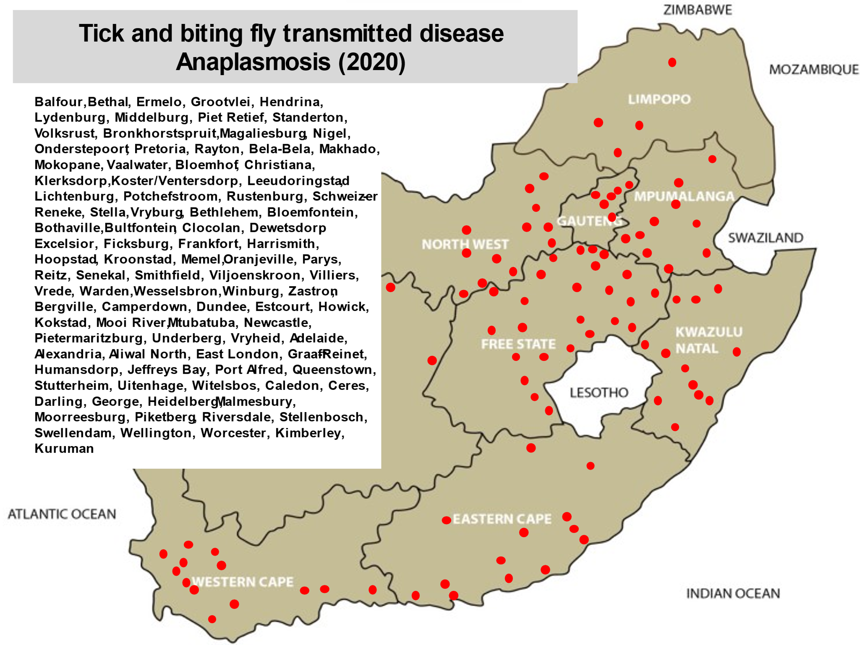
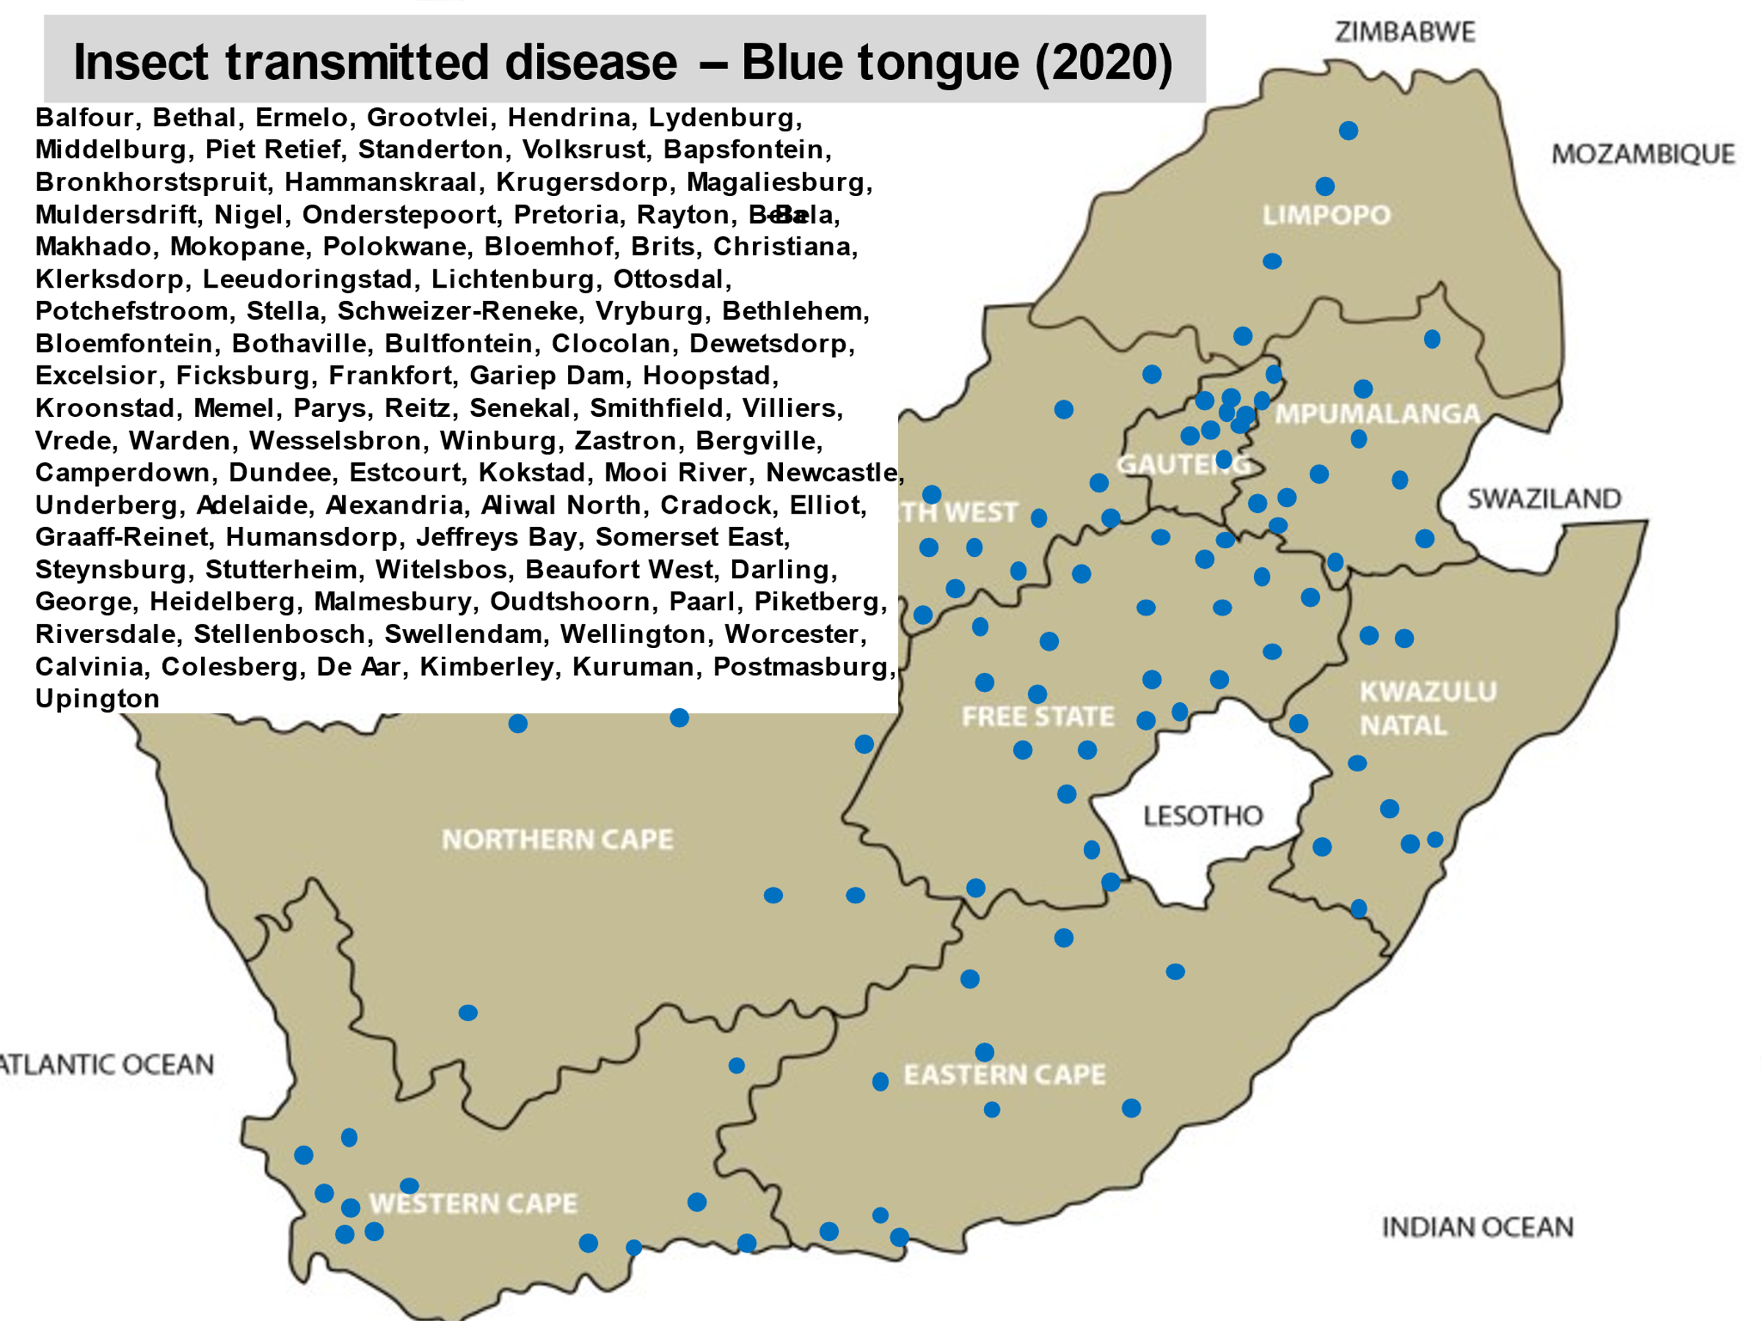

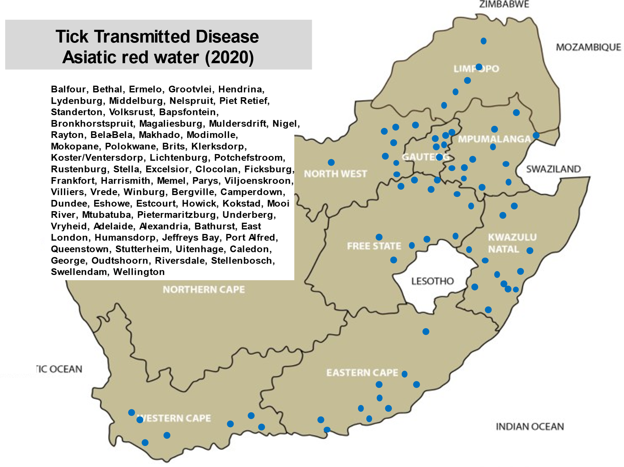
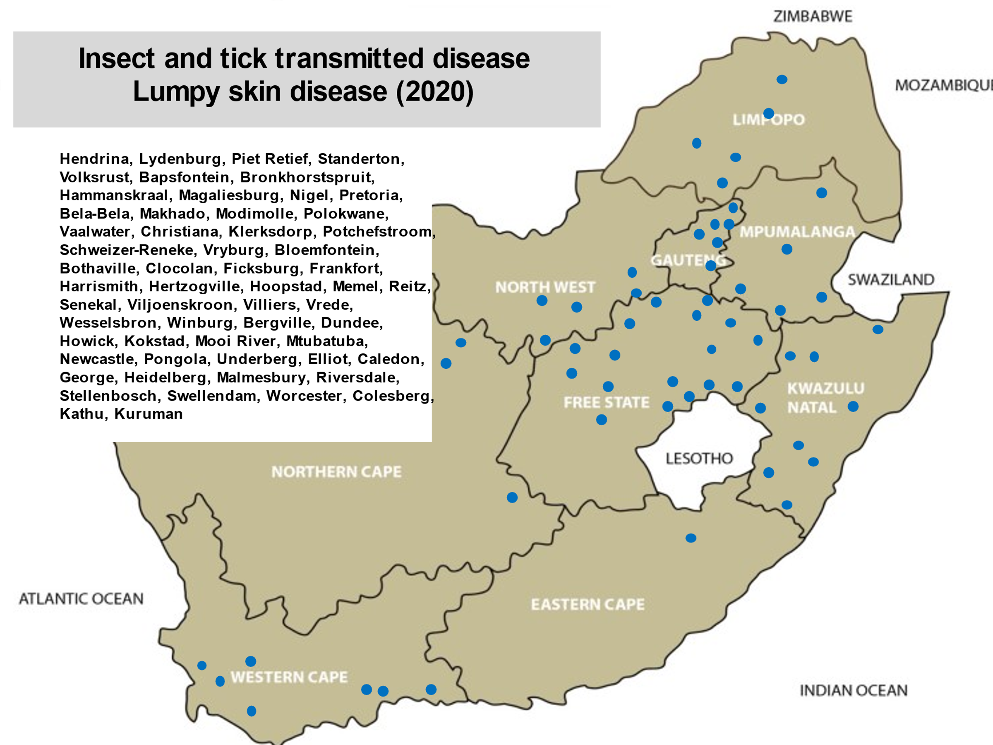

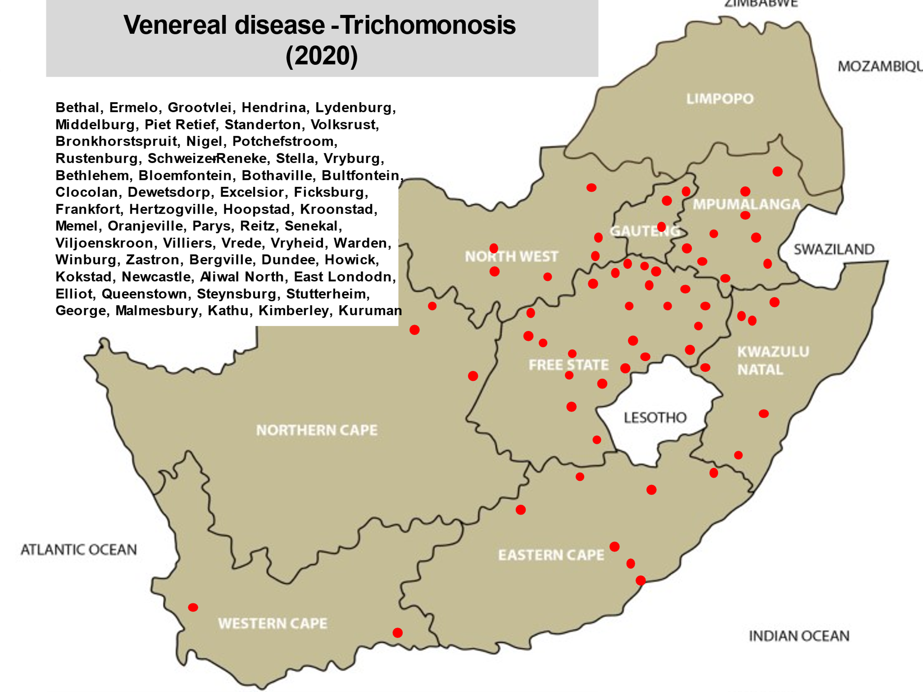

“Bovine Brucellosis and Asiatic red water– Outbreaks are mostly due to our own fault”
Again, new outbreaks of brucellosis are reported! When will we be able to say that we are winning the battle?
Reasons mentioned why this disease of cattle and humans are not controlled:
Farmers buy cattle at auctions with unknown disease status
Lack of a vendor declaration
Animals are not vaccinated against brucellosis and Asiatic red water
Bought in animals are not quarantined and tested for brucellosis
Cattle on adjacent farms not tested for brucellosis.
Brucellosis is an area disease
Positive stray cattle could cause outbreaks
Insufficient knowledge of the diseases by farmers
Positive animals not branded with a C on the neck
Insufficient funding to control the disease (vehicles, petrol, manpower)
Role flies play in the transmission of disease
Take responsibility for animal health or face the consequences.
Below are links that are available for your perusal:
#BrakesonBrucellosis
http://nahf.co.za/category/diseases/brucellosis/
Brucellosis Campaign: What is Brucellosis?
http://nahf.co.za/brucellosis-campaign-what-is-brucellosis-brakesonbrucellosis/
Brucellosis awareness – do you know?
http://nahf.co.za/brucellosis-awareness-do-you-know/
Brucellosis - Have you tested?
http://nahf.co.za/brakesonbrucellosis-have-you-tested/
Brucellosis - Dangers of consuming raw dairy products
http://nahf.co.za/brucellosis-campaign-week-2-brakesonbrucellosis-collaboratetestvaccinate-dangers-of-consuming-raw-dairy-products/
Brucellosis – The silent enemy in humans
http://nahf.co.za/brakesonbrucellosis-brucellosis-the-silent-enemy-in-humans/
Brucellosis - The Trojan Horse for your herd
http://nahf.co.za/brakesonbrucellosis-brucellosis-the-trojan-horse-for-your-herd/
Brucellosis: Is a herd disease
http://nahf.co.za/brakesonbrucellosis-brucellosis-is-a-herd-disease/
Brucellosis: Cattle branding – C=Brucellosis positive
http://nahf.co.za/brakesonbrucellosis-brucellosis-cattle-branding-cbrucellosis-positive/
Brucellosis – Farmer Responsibility
http://nahf.co.za/brakesonbrucellosis-farmer-responsibility/
Brucellosis – Abattoirs
http://nahf.co.za/brakesonbrucellosis-abattoirs/
Brucellosis – Is the consumer at risk for contracting Brucellosis?
http://nahf.co.za/brakesonbrucellosis-is-the-consumer-at-risk-for-contracting-brucellosis/
Brucellosis – Prevention for the Veterinarian and Para-Veterinarian
http://nahf.co.za/brakesonbrucellosis-prevention-for-the-veterinarian-and-para-veterinarian/
Foot and Mouth Disease
https://nahf.co.za/update-report-foot-and-mouth-disease-outbreak-kzn-mtubatuba-10-september-2021/
Biosecurity guidelines
http://nahf.co.za/wp-content/uploads/FMD-Basic-Biosecurity-Guidelines-2019-11-19-Ver-3-1.pdf
1. During a FMD outbreak it is the producer’s responsibility to keep their animals from getting infected.
2. Although FMD does not pose a food safety or public health concern it has a major impact on animal health and international trade.
3. Each commercial farm should appoint a biosecurity manager.
4. A written biosecurity plan is a basic requirement.
5. Development of a plan must be done by the biosecurity manager with assistance from a veterinarian.
6. The biosecurity plan must include a line of separation/demarcation of the biosecurity area.
7. Training:
a. Train all personnel in biosecurity principles at least annually.
8. Access: a. Access points to the area must be identified and demarcated clearly.
b. Loading site must be identified away from animals.
c. A cleaning and disinfection station needs to be made available and should be away from any animals and an SOP for cleaning of all vehicles entering the biosecurity area must be adhered to.
d. Parking areas away from animal areas must be provided.
e. Vehicle movement pathways must be mapped.
f. Draw up a map demarcating all these areas.
g. The control boundary should always be respected and identified to all personnel.
h. No access of vehicles or personnel to the biosecure area unless via proper decontamination protocols. People with any suspected contact with infected animals (or having been in an affected area) should stay away from “clean animals for at least a week.
i. Access points should be respected, well demarcated and procedures of access described. Biosecurity Guidelines-FMD 2019-11-19 2
j. Animals arriving on the farm should only be directly from a guaranteed healthy herd accompanied by signed and dated veterinary health certificates.
k. Personnel entering the biosecure area should shower and change clothing before entering the area.
l. Logbooks of all persons, vehicles, equipment etc entering or leaving the biosecure area, should be kept.
m. No entry of persons, vehicles or products should be allowed if not expressly permitted by the biosecurity officer.
n. Feed brought into the biosecure area should only be from sources determined by the biosecurity manager.
o. For further information go to www.securebeef.org
9. Quarantine:
a. For extra security cattle should be quarantined at least 100 meters for 21 days away from the herd.
b. There will be absolutely no contact with the herd either directly or indirectly.
c. They should only be introduced after clinical (and preferably serological) evaluation.

It is now the time that we take ownership of our own industry!!!!!!!!

Visit the website of the Organisation for Animal Health
https://www.oie.int/en/home/

We should be able to export our products derived from animal origin!!!!!!!!!!
Paris, 18 March 2021 – Since its creation in 1924, the OIE is the mandated international organisation collecting data on, observing and analysing animal diseases throughout the world. Through its current World Animal Health Information System (WAHIS), the Organisation ensures the prompt dissemination of information on potentially devastating outbreaks and facilitates decision making in terms of international trade of animals and animal products by collecting, verifying and publishing official animal health information, following a standardised process, thus providing high quality, reliable data.

Safeguarding animal and public health, global security and international trade

The basis of Disease Control is Animal Identification and Tracebility
Visit: https://www.icar.org/index.php/certifications/animal-identification-certifications/

Very important legislation regarding the biosecurity rules for livestock agents

http://nahf.co.za/biosecurity-rules-for-livestock-agents-gazetted-13-november-2020-no-43900-board-notice-135-of-200/
http://nahf.co.za/wp-content/uploads/Biosecurity-Rules-for-Livestock-Agents-Gazetted-13-November-2020-No-43900-Board-Notice-135-of-200.pdf
BACKGROUND and DEFINITIONS:
These rules will regulate the livestock agent’s industry with specific reference to required precautions to take during the gathering of live animals at auctions to reduce the risk of the spreading controlled, notifiable and other animal diseases.
In summary, each livestock agent/auctioneer will comply with the following:
a) The rules for auctions in this document.
b) Registration with the Agricultural Produce Agents Council (APAC) is compulsory and only registered agents will be allowed to conduct business.
c) Acceptance of responsibilities in terms of Sections 11 and 26 of the Animal Diseases Act, Act 35 of 1984. This gazette is also available free online at www.gpwonline.co.za 206 No. 43900 GOVERNMENT GAZETTE, 13 NOVEMBER 2020
d) An external audit of the auction facilities and all procedures, including these rules for auctions, will be undertaken by an independent auditor, these audits will need to be submitted to APAC bi-annually.
e) Every livestock agent must appoint a Biosecurity practitioner (a person registered with the South African Veterinary Council).
“Biosecure area” is the area where only animals whose documentation has been verified, identification and health status has been confirmed by a SAVC qualified person, i.e. animals unlikely to pose a significant risk of carrying any contagious disease-causing agents, as well as persons who have been decontaminated to the satisfaction of a biosecurity practitioner are allowed to enter;
“Biosecurity practitioner” a person registered with the South African Veterinary Council, who oversees compliance with minimum biosecurity requirements for animals from different origins congregating for auctioning, in line with the requirements of Sections 11 and 26 of the Animal Diseases Act, Act 35 of 1984 and the rules in this document;
“Animal Owner Health Attestation” is a signed declaration from the owner of the animals that attests: This gazette is also available free online at www.gpwonline.co.za STAATSKOERANT, 13 NOVEMBER 2020 No. 43900 207 3
• The name and location of the farm/area of origin.
• The absence of overt signs of disease and parasites.
• The absence of unexplained mortalities on the property of origin in the preceding 28 days.
• No new animal introductions to the property of origin in the preceding 14 days.
• Where possible, and especially during periods of disease control restrictions in specific localities, confirmation of this health status by the farm’s attending veterinarian is ideal, see Addendum A of this document.
Identification of animals
a) All animals accepted at an auction must be properly and permanently marked with the owner’s registered mark in accordance with the Animal Identification Act, Act 6 of 2002, and regulations published in Government Gazette no 25732 of 21 November 2003.
b) Animals without registered marks shall not be off-loaded at the biosecure area.
c) No freshly branded animals may be accepted.
d) No animals with wet paint marks of previous auctions may be accepted within 28 days after the previous sale.
e) No branding or marking of animals is allowed on the auction premises.
f) The auctioneer must ensure the registered brand belongs to the owner, check the brand marking certificate and ID of the owner and driver/transporter where applicable and to follow up any suspicious brands with the local Stock Theft Unit. The livestock agent must insist on a confirmation of their reporting of the noncompliance with the Stock Theft Act and keep these on record
g) The ear tag / identity tag for each animal’s individual identification – as per the Livestock Identification and Traceability System, shall correspond with the list of animals in the Original Animal Owner Health Attestation.
Checking animals arriving at auctions
All animals must, upon arrival, be checked for lesions or clinical signs of disease or external parasites. In addition, animals shall be checked for official marks/brands indicating any of the controlled animal diseases such as Brucellosis, Tuberculosis and Foot and mouth disease. If there is any suspicion of any infectious disease, please refer to section 10 below.
Summary of disease report for October 2021
150 Reports from veterinary practices and laboratories were received (Mpumalanga (MP) 11; Gauteng (G) 12; Limpopo (L) 8; Northwest (NW) 15; Free State (FS) 31; KwaZulu-Natal (KZN) 14; Eastern Cape (EC) 16; Western Cape (WC) 22: Northern Cape (NC) 9; Feedlots (FL) 2; Bovine consultant (BC) 1 and Laboratories (Lab) 9
Study this list – these are the most widely spread diseases and conditions, reported by veterinarians, and determine your risk in collaboration with your veterinarian.
A list of diseases and conditions reported by veterinarians in 5 or more provinces
 | Number of provinces reporting
Wireworm | 9
Pulpy kidney | 9
Orf | 9
Ringworm | 9
Abscesses | 9
Eye infections | 9
Dystocia | 9
Roundworms | 8
Coccidiosis | 8
Blue ticks | 8
Bont-legged ticks | 8
Anaplasmosis | 8
Asiatic red water | 8
Pasteurellosis (lungs) | 8
E. coli | 8
Energy deficiency | 8
Protein deficiency | 8
Abortions | 8
Diarrhoea | 8
Retained afterbirth | 8
Uterine prolapse | 8
Vaginal prolapse | 8
Liver fluke | 7
Conical fluke | 7
Cryptosporidiosis | 7
African red water | 7
Lumpy skin disease | 7
Bovine brucellosis | 7
Warts | 7
Tulip toxicity | 7
Urea poisoning | 7
Lameness/foot problems | 7
Lungs (pneumonia) | 7
Mastitis | 7
Downer | 7
Heartwater ticks | 6
Blackquarter | 6
Stillbirths | 6
Acidosis | 6
Metritis | 6
Sheath prolapse | 6
Tapeworms | 5
Paralysis ticks | 5
Nuisance flies | 5
Midges | 5
Trichomonosis | 5
Vibriosis | 5
Swelled head | 5
Blood gut (sheep) | 5
Salmonellosis | 5
Phosphate deficiency | 5
Bloat | 5
Joint ill | 5
Milk fever | 5
Theft | 5

Bovine Brucellosis

Although we have made positive steps in controlling Bovine brucellosis, the model disease stated in the Veterinary Strategy, we as a country is far from achieving our goal!

If farmers will just comply by vaccinating their animals against brucellosis, according to law, the incidence of brucellosis will drop dramatically as shedding of bacteria will drop!

Many farmers are still shrugging their shoulders and saying: “Why should I test my animals as it will only cost me money and what if there are positive animals? My farm will be placed under quarantine, so I am not going to test my animals!”

Dr. Trudie Prinsloo a veterinarian and legal advisor has compiled legal aspects regarding brucellosis control and it is VERY IMPORTANT that you should avail yourself with the content of this document.

It is available in English and Afrikaans.

http://nahf.co.za/brucellosis-legal-aspects-2018-12-11/

When buying cattle, this Vendor declaration can help you to minimize your risk!

VENDOR DECLARATION BOVINE BRUCELLOSIS
I hereby declare that I am the legal owner or authorised representative of the cattle on sale and am competent to make this declaration

1 | The cattle for sale are clearly and permanently identified |  | Yes | No
2 | The cattle for sale/slaughter were born on my farm |  | Yes | No
3 | The farm has a closed herd policy i.e. I do not buy in cattle, rent out grazing or speculate with cattle |  | Yes | No
4 | I practice bio-security on my farm to a level that is ** | Poor | Moderate | Good
5 | I vaccinate my heifer calves against Bovine Brucellosis once between the ages of 4 – 8 months |  | Yes | No
6 | In addition, I vaccinate my cattle older than 8 months with RB51 |  | Yes | No
7 | I have all the cattle on my farm tested for Bovine Brucellosis |  | Yes (date) | No
8 | My herd has been tested negative within the past year |  | Yes | No
9 | I did not buy in cattle since my last negative brucellosis test |  | Yes | No
10 | I/my vet investigates any abortions on my farm |  | Yes | No
11 | To the best of my knowledge, my immediate neighbours and farms in my area are free of Bovine Brucellosis |  | Yes | No
12 | I use a veterinarian to advise me on my cattle’s herd health |  | Yes | No
13 | The cattle handling facilities on my farm are | Poor | Average | Good

Note: Vaccination does not mean freedom from Bovine Brucellosis as cattle can still be carriers
Please attach the most recent Brucella blood test certificate

Owner or authorised representative: ………………………………………………

Signature: ………………………………………………

Date: ……………………………………….

** * Biosecurity
Poor – speculates with cattle, does not vaccinate, poor fences, cattle come into contact with other cattle
Medium – Vaccinates heifers, does not buy in cattle of unknown health status

Good – closed herd/never buys in cattle, vaccinates heifers and no contact with other cattle, follows a herd health plan as advised by his veterinarian, does not allow transport trucks onto property, washes and disinfects truck after returning from the abattoir or auction grounds.

Compiled by: Dr. Sewellyn Davey, Past Chairman of the Brucellosis Steering committee of the National Animal Health Forum

SOP for the control of Bovine Brucellosis
Audit date:____________________________
Authorised person:__________________________

 |  | Y/N | Comment
1 | Fences and gates in good condition
2 | Gate control - log in
3 | Disinfection of vehicles coming onto the farm
4 | Protective clothing and boots given to people visiting the farm (cattle area) coming from high- risk areas eg. veterinarians, nutritionists, representatives, truck drivers, workers, etc.
5 | Sterilizing equipment coming in contact with cattle
6 | Run off water/ streams from neighbouring farms
7 | All animals identified with a brand mark and ear tag
8 | Data base of all animals
9 | Closed herd
10 | When last were animals bought in or moved from another farm?
11 | Only buy in animals from a farm which has a recent negative tested brucellosis herd certificate
12 | Origin(s) of acquired cattle? Bought at an auction?
13 | Keep heifers separate from herd until they have calved and tested negative for brucellosis
14 | Quarantine camp available
15 | Separate calving camps
16 | Were all heifers vaccinated between 4 and 8 months vaccinated with Strain 19 or RB51?
17 | Any cattle vaccinated with Strain 19 over 8 months of age? History over last few years.
18 | Were there any abortions on the farm – samples taken, diagnosis?
19 | All sexually mature cattle in herd tested for bovine brucellosis (provide proof)
20 | Bovine brucellosis is a State controlled disease. Positive cattle are branded with a C on the right side of the neck.
21 | Isolation of infected animals & separate handling facilities
22 | Prohibition of movement of animals off quarantined property except under cover of a Red cross permit for slaughter at an abattoir
23 | Prohibition of use and on-farm disposal of un-boiled, un-pasteurised or un-sterilised milk on quarantined property
24 | Disinfection of places where infection is a possibility.
25 | Neighbors/ recent buyers informed of infected herd status
26 | Fly, crow and predator control
27 | Destruction of afterbirths/abortions in a responsible manner
28 | Beware of livestock, game interface

Websites that are there to help you with information regarding animal health:

National Animal Health Forum

www.nahf.co.za

Read what the Forum is all about:
http://nahf.co.za/about/

This website will become the information centre of animal health in Southern Africa.
On the toolbar click on Stakeholders and you will find links to producer organizations and other organizations who are participating in the NAHF
http://nahf.co.za/stakeholders/

Provincial Animal Health Forums have their own site – click on Provinces http://nahf.co.za/provinces/

Important is to study the Veterinary Strategy (2016 -2026) as it gives direction to where we are going with Animal Health in South Africa.
http://nahf.co.za/wp-content/uploads/Vet-strategy-final-signed.pdf

Click on Info centre for more information on the “war” we have against Bovine Brucellosis. Please be up to date on the role all have to play to control this zoonotic disease.
http://nahf.co.za/category/diseases/brucellosis/

Information on other controlled diseases (Foot and Mouth Disease, Ovine Johne’s Disease, Pest of small stock – PPR, and African Horse Sickness) is available.

This link will continuously be updated.

Information on antibiotic resistance is also available at this address: http://nahf.co.za/category/antibiotic-resistance/

Rural Veterinary Association of South Africa
www.ruvasa.co.za
Click on Disease reporting where maps and information can be sourced on the prevelance of diseases in all provinces. Abattoir reports are available. Use the information available to update management programmes

Internal parasite control
www.wormx.info

Farm gates, Fences and Foresight, the 3 F’s!
Bear this in mind as this is where most disease-causing organisms enter or exit farms!
Major examples are: Foot and mouth disease, brucellosis, Johne’s disease, TB, cryptosporidiosis, trichomonosis, vibriosis, sheep scab, resistant parasites such as red lice, blue ticks and internal parasites (Buyer beware programmes).
Insist on VENDOR’S DECLARATIONS when buying animals.
Quarantine
Immunization programmes
Speak to your veterinarian
Abide the law- vaccinate cattle against anthrax and heifers against brucellosis!
For the detailed report and previous reports go to www.ruvasa.co.za and click on Disease reporting
Internal parasites
The following reports were received from practices regarding internal parasite infestations:
Internal parasites | MP | G | L | NW | FS | KZN | EC | WC | NC
Roundworms |  | x | x | x | x | x | x | x | x
Resistant roundworms |  | x |  |  | x |  |  | x
Wireworm | x | x | x | x | x | x | x | x | x
Brown stomach-worm |  |  |  |  |  |  | x | x
Long-necked bankruptworm
White bankruptworm
Large-mouthed bowelworm
Nodularworm
Lungworm
Eyeworm
Parafilaria |  |  | x |  | x | x
Tapeworms | x |  |  | x | x |  |  | x | x
Liver fluke | x | x | x |  | x | x | x | x
Conical fluke | x | x |  | x | x | x | x | x
Cysticercosis (measles) |  |  |  |  | x |  |  | x
Schistosomiasis (bilharzia)
Coccidiosis | x | x | x | x | x | x | x | x
Cryptosporidiosis | x | x |  | x | x | x | x | x
Sarcosporidium |  |  |  |  |  |  |  | x
Giardia

Intestinal-worm outbreaks have been reported from all 9 provinces. On some farms mortality the rate was excessive!
BEWARE
A farm has been found where the wireworm strain on the farm is resistant to ALL active dewormer groups
Check the eye mucous membrane colour of a group of sheep in all flocks weekly! Bottle jaws and pale eye mucous membranes are indications that deaths are just around the corner!
Get advice from your veterinarian to ascertain which dewormer group(s) are still effective on your farm by doing a faecal egg count resistance test (FECRT). Visit www.wormx.info for training material.
Group code | Generic class of actives | Example of actives
1* | Macrocyclic lactones (ML’s) | Abamectin  Doramectin  Eprinomectin  Ivermectin  Moxidectin
2* | Benzimidazoles (white drugs) | Albendazole  Fenbendazole  Febental  Ricobendazole  Triclabendazole
3* | Imidathiazoles (clear drugs) | Levamisole  Morantel
4* | Salicylanilides | Closantel  Niclosamide  Oxiclozanide  Rafoxanide  Resorantel
5* | Phenols | Nitroxinyl
6* | Sulphonamides | Clorsulon
7* | Organophosphates | Trichlorfon
8* | Isoquinolones | Praziquantel
9* | Others  Amino-acetonitryl-derivatives (AAD’s) | Piperazine  Monepantel
10* | Spiroindoles | Derquantel

Visit www.wormx.info for valuable information on parasite control!
Beware of liver fluke and conical fluke outbreaks when animals are grazing in vleis and other wet areas where the intermediate hosts, water snails, are abundant.
Coccidiosis outbreaks were reported from all 9 provinces. Young animals are most susceptible.
Cryptosporidiosis outbreaks, causing huge losses were reported from 6 provinces. This deadly condition has now spread to the Western Cape. A product has been registered to treat animals against this deadly parasite. Good colostrum protects new born animals. Biosecurity should be practised at all levels on the farm.
https://www.google.co.za/search?hl=en&tbm=isch&source=hp&biw=1344&bih=608&ei=PyxyXOO7OcutkwXinK3oCA&q=cryptosporidium+parvum&oq=Cryptosporidium&gs_l=img.1.1.0l10.2885.9850..16402...0.0..0.708.5719.2-4j4j3j2j1......0....1..gws-wiz-img.....0.o66yefU7Ric

Prevention of Cryptosporidiosis
Prevention is the best control method.
Animals with a well-developed immune system will generally overcome Cryptosporidium thus this should be the main aim in controlling Cryptosporidium.
A consistent, vet approved and farm appropriate vaccination program for other diseases.
Ensure no nutritional deficiencies especially vitamin A and Selenium
Excellent bio-security management
Ensure clean pathogen free water sources
Hygiene training of personnel
Consult your veterinarian

SOLUTION
HOLISTIC INTERNAL PARASITE MANAGEMENT FOR SHEEP AND GOATS

Gareth Bath, Jan van Wyk and Faffa Malan

INTRODUCTION
Over the past ten to fifteen years there has been a radical rethink on our previous worm control strategies and assumptions due to the ever-accelerating failure of anthelmintics globally. This has caused a quiet but drastic revolution in many of the “received wisdoms” which governed advice to farmers for close to a century.

For a start, we have to abandon the underlying philosophy that internal parasites are an evil plague which should be maximally suppressed, or preferably eradicated. We have to learn to live with parasites, and prevent only the unacceptable production losses, while simultaneously breeding animals fit for the environment, rather than making the environment fit for existing animals. By regarding parasites as part of the natural order of things, we will be able to see them simply as potential problems to be managed in order to achieve optimum productivity and profitability.

Only well integrated, holistic planning has a long-term chance of success, and unless all elements of our potential armamentarium are harnessed, the results will not match the expectations.

While this paper applies to helminths, and mainly nematodes, the parallels and inferences which can be made for ectoparasites, and indeed other organisms, should be obvious.

WORM MANAGEMENT PRINCIPLES

A FLOCK MANAGEMENT REQUIREMENTS

Separation of Groups
Since different classes of animals vary in their susceptibility to worm infection and its effects, they should be separated into groups, which are grazed, treated and managed as distinct entities. If these distinctions are not made one may be forced to treat the flock according to the most susceptible group. The most susceptible groups can still be managed and treated more intensively in a mixed flock, but this becomes more difficult.

Identify the groups most at risk
Research has shown that the more susceptible animals are lambs/weanlings; and pregnant/lactating ewes. The former is susceptible because they cannot yet mount an effective immune response to infection, the latter are prone to infection because of a temporary suppression of immunity. (PPRR). These groups must get special attention.
Separation of pastures
Unless pastures can be divided by fencing or herding, all sheep will be exposed to a similar challenge, regardless of whether they are susceptible or resistant to infection and its effects. This will prevent any differentiation in management and treatment. Diversion of pastures is not only good for internal parasite controll, it also aids pasture management. Electric fences can be used as temporary pasturage dividers. In communally farmed areas, herding or tethering can achieve the same result without fencing.

Resting of pastures
If pastures can be separated, it is then possible to rest them effectively, which has decided advantages to pasture management and improvement. If such pastures can be rested long enough, this will also have a significant effect on the survival of worm larvae and therefore the infection rate of the flock. Although the time needed for effective resting of pastures will vary with the climate, weather and worm species, a useful rule of thumb for effective resting is at least 3 months in subtropical for temperate climates, but as little as 1 month in the tropics. The longer the rest, the better it is for worm management.

Alternation of host species
Sheep and goats share the same worm species and alternation with one another is ineffective for worm management. However, other species like cattle, horses and ostriches are generally not susceptible to the worms of sheep and goats. If they are used to graze pastures before or after sheep or goats, they act as "vacuum cleaners" on the pasture, as they ingest many larvae which cannot develop further into egg-laying adults. The other advantage is that the pasture can still be utilised in its growing season, which prevents the grass from becoming senescent, and optimises its usefulness. This aids in maintaining the profitability of the farm.

Mend water leaks
Water points (troughs, windmills) should not be allowed to leak, as this encourages the growth of grass. Since this is where sheep concentrate, the area can become lethally contaminated by larvae.

Avoid grass in pens
Where sheep or goats have to be penned for lengthy periods (usually at night, to combat theft or predation) there can be a fatal buildup of larvae on the grass growing there. Sheep become hungry overnight and will eat these morsels of food. In consequence they will ingest massive numbers of larvae. It is therefore necessary to remove all grass from such pens.

Fence off moist areas
Areas particularly prone to high moisture and therefore the survival of worm larvae, like streams and marshes, should be separated to reduce the challenge of the flock.

Strategic movement of flocks
The aim should be to create "safe" (not necessarily "worm free") pastures. By planning changes in camps or paddocks, stock will be subject to lower challenges and need less chemical treatment. Any grazing system where a significant proportion of the pasture is rested for a full growing season will be particularly effective.

Quarantine and treatment
Do not simply introduce purchased animals into the flock or herd. They must be quarantined in a worm-unfriendly pen (bare earth or concrete) and treated intensively using the best drugs and schedule. If financially feasible, do an FECRT to ensure minimum carry-over of drug-resistant parasites. Then place them on infected pasture if there is no multiple resistance.

B GENETIC SELECTION

Selection for resistance
Resistance (the acquired or innate ability to prevent or minimise infection by parasites) is heritable and can be selected for, by measuring the faecal egg counts and using only those sheep with the lowest FEC's for breeding. For practical and economical reasons, this is usually only done for rams. Some successful breeding programs have been undertaken but they require good organisation and meticulous record keeping. Culling of bad ewes and their offspring is also practical and recommended.

Selection for resilience
Resilience (the ability to withstand the effects of infection and produce satisfactorily in spite of it) is also heritable. At present, only two proven methods, FAMACHA© and Haematocrit determination exist, although preliminary results suggest that Body Condition Scoring may also be useful. The FAMACHA© System can be used only where wireworm is the major parasite. By treating according to clinical anaemia (an indicator of poor resilience), only those sheep unable to cope with wireworm are treated. This reduces selection pressure for anthelmintic resistance and at the same time allows the farmer to cull the non-copers, in the long term thus being able to breed an animal better adapted to the environment.

It is also possible to select rams by a system of allocation of selection indeces. This is currently under investigation and will require measuring individual ram FECs and FAMACHA© scores (or haematocrits) to make the measurement more accurate.

C MONITORING SYSTEMS

FEC
Regular (monthly or 2 - monthly) monitoring of faecal egg counts on a group or flock basis will help to indicate when dosing is really needed, and equally important, when it can be delayed or even omitted. A bulk (composite) FEC comprising a single count of faeces pooled from equal samples from 10 to 20 sheep is certainly cheaper than dosing the whole flock unnecessarily. Keep graphs or tables of changes to indicate when parasite buildup is likely.

FECRT
Every farmer should have the flock tested for drug resistance in the worm population on his farm, at regular intervals of not less than two years. Only by knowing exactly what the state of anthelmintic resistance on a farm is, can appropriate action be taken. Generalisations like "benzimidazole resistance is found on most farms" are not much use since they cannot tell us what the situation is on a particular farm. Just as important, we must know not only that resistance is present, but also how bad it is. Can we still use the drug group at all? Separate bulk faecal samples from each drug group will reduce the cost to acceptable levels.

FAMACHA© evaluation
Apart from selection and culling, this system also allows frequent, cheap and easy monitoring of the current situation as regards worm infection, but applies only to haemonchosis.

D OPTIMISE ANTHELMINTIC USE

Establish the important parasites species present
Unless the prevalence and importance of worm species is known, worm management becomes dangerous and unpredictable guesswork. It can also be ineffective and very costly.

Use the most suitable drug
If the parasites are ranked in order of economic importance and their susceptibility to groups of anthelmintics is known and combined with knowledge on the anthelmintic resistance situation on the farm, it is then possible to decide which drug(s) and formulations will be the most suitable in each situation. This includes their cost and a cost/benefit analysis. Neither the cheapest nor the most expensive drug is necessarily the best one to use. Beware of generic drugs sold by an unknown company.

Avoid too frequent treatment
The old approach of "dosing clean" must be completely abandoned, although not by reducing the dosage rate per animal. The aim has to be to treat only sufficient times and enough individual animals to maintain the equilibrium between parasite, host and environment (that is, worm management). Overtreatment ensures that only resistant parasites can survive. Minimal treatment programs must be the new watchword, but is must be ensured that every treatment is effective.

Treat all and stay
This is a major departure from the recommendations made for close to a century. If all sheep are to be treated, they should remain in the camp (paddock) where they were grazing before treatment. This will prevent sheep from contaminating a new pasture with only those resistant parasites which survived treatment, thus in the process unwittingly causing the selection for resistance parasites. In most cases they should remain in the paddock for at least 2-3 weeks after treatment to pick up unselected larvae for propagation of the susceptible worms in the new camp/paddock. However, should a long-acting anthelmintic be used, this period will have to be longer (2 to 3 weeks after the effective residual action ends). Particularly bolus (slow release) formulations should be used with great caution.

Treat selectively
It is preferable to treat only those sheep or goats unable to cope with the current infection challenge, provided the percentage of non-copers remains below 20%. This can be done with the FAMACHA© system for haemonchosis, or possibly with Body Condition Scoring for other parasites. If clinically unaffected animals are left untreated, an immediate move to new pasture will not be detrimental. In the absence of such selective treatment, just leaving a small percentage (10-25%) of the flock intentionally untreated can be beneficial to slow AR development.

Move then treat

Another way of achieving the same result as “treat all and stay” is to move the flock to a new “safe” pasture and delay treatment for 2-3 weeks, to allow the seeding of the new pasture with unselected worms, before treating the flock.

Herbal Remedies
These are often touted as the answer to worm control. However, unless they have been properly tested and proven by an independent body, they may be useless or even harmful.

E IMPROVED ANTHELMINTIC EFFICACY

Dose over the tongue
By placing the tip of the gun towards the back of the mouth, over the tongue, closure of the oesophageal groove does not occur and thus the full dose lands in the rumen where it is absorbed more slowly - this is particularly important for anthelmintic groups which rely on prolonged blood levels for their effect, like the benzimidazoles and macrocyclic lactones.
This prolonged level of activity (a long so-called "killing zone") means that the drug against which worms have developed a moderate degree of resistance can be made more effective, although of course the resistance of the worms is not reduced, but rather partially overcome. However, dosing (drenching) over the tongue, if done carelessly, can result in two very severe consequences:
the dose can land up the lungs, and cause pneumonia
the nozzle of the dosing gun can penetrate he pharynx and cause severe, fatal infection.
If the sheep jumps forward, the operator must let the gun ‘ride’ with the sheep, and not oppose it, and the dose must be delivered by a measured, steady pressure rather than a single squeeze.

Reduce feed intake
It has been shown in the case of benzimidazoles and closantel that reducing feed intake (i.e. starvation) for 24 hours prior to treatment will improve the absorption of the remedy because of the lower rate of flow of ingesta. As in the previous case, this results in a more effective exposure of the parasite to the drug.
In turn, this means that the drug is clinically more effective and can partially overcome drug resistance.

Repeat the dose
This only applies to benzimidazoles and macrocyclic lactones. Two doses given 12 hours apart will again increase the “killing zone” of these drugs, allowing more time for a cumulative killing effect. Thus, resistant worms can still be killed, although this is achieved at a cost since two normal doses rather than one are needed. A double dose, given at one time, will have no beneficial effect with these two groups of anthelmintics.

Increase the dose
This only applies to drugs which rely mainly on peak concentrations for their effect. In this case, a double amount of drug given at one time can overcome drug resistance in worms. This is useful for the imidasothiazoles (levamisole). There is however a relatively low safety margin, only 2x – 3x the therapeutic dose may sometimes cause problems of toxicity.

Correct dosage
It may seem too obvious, but a lot of problems are caused by not weighing sheep, not calibrating and checking the dosing gun for accuracy and repeatability, and not reconciling the amount of drug used with the number of sheep treated. Underdosing may be a factor leading to anthelmintic resistance, but it is more likely to be the cause of ineffective treatment.

Drug combinations
Combining drugs from different activity groups in one dose may temporarily improve the effective clinical action of these drugs, but only if each drug concerned is unaffected by resistance. However, many authorities believe that this will not slow the development of resistance and could even enhance it. If drugs are mixed, this can only be done if the formulation has been fully tested and carried by experts, in registered products. Home made combinations are dangerous and illegal. Such combinations often just give temporary relief and disguise the emergence of AR until it is severe and multiple.

Sustained delivery
Medicated blocks or controlled release capsules will increase the clinical efficacy of those drugs which rely on prolonged action for their effectiveness. However, we have to bear in mind that prolonged exposure to a drug at low levels will increase selection for resistance. This approach will therefore not be permanent, and should only be used for very specific, limited purposes (e.g. weaners on green pasture) and not the entire flock in all circumstances.

Goats are different
Because of differences in the rate of metabolising drugs, goats must be treated as different to sheep. This means that goats must often be given a higher dosage rate than sheep except where there is a possibility of toxicity. Note that many anthelmintics may not be registered for use in goats, or that the recommended dose given is the same as for sheep. Unfortunately, therefore if the product is not registered for use in goats, or the dosage rate is increases, the user has no legal redress if the product is used and fails, or causes losses.

F EFFECTIVE PLANNING

Use the expert
Knowledgeable veterinarians, who know the area, farming systems and risks can construct a simple, practical, economic and effective holistic worm management strategy. They can consult helminthologists where necessary.

Use a programme
Unless a basic planned system is in place and is used, actions will inevitably be largely reactive and based on ad hoc or panic decisions. But this does not imply a rigid adherence to the basic plan.

Flexibility
The program must be flexible to allow for changes in weather, management and farming systems, drug costs or other factors.

Treatment strategy
It is probably true that on most farms animals are either dosed too often, or with inappropriate drugs, or at the wrong times, or with no coherent plan. By setting up a well thought out dosing plan, we can cut out ineffective doses which only add to the selection pressure for parasite resistance. This is one of the areas in which the knowledge and skills of the local vet are vital for success.

II OTHER MEASURES AND FACTORS

Protein supplementation
Since resistance and resilience are dependent on adequate nutrition, and the most important factor identified is protein, it is possible to ameliorate the effects of parasites by feeding animals better. We need to know when and how much of what supplement must be supplied to which class of animal, and what the cost / benefit ratio would be before this aspect can be fully integrated into our overall approach.

Condition scoring
The early indications are that this may be useful for identifying individual animals for treatment against some non-haematophagous worm species. The principle is that animals with a condition score which is more than half a score below the flock or herd average are treated. If the animals have a condition score below 2 and the risk of worm infestation is high, then treatment should be given.

Weather monitoring
Factors which affect the survival, development and infectivity of larvae on pastures must be considered. Temperature, rainfall, rainfall pattern, humidity and could cover will all have an effect and must be considered when making worm management decisions.

Flock/Herd history
Without knowing details of numbers, types, ages, reproductive stages, treatment, stocking rates, grazing pressures and livestock movements, decision making is at best arbitrary and at worst potentially disastrous.

Veld/pasture assessment and history
Coupled with livestock data, the advisor has to consider details of the veld or pasture type, its condition, growth stage, the soil cover, soil moisture, slope land the grazing history.

Assessment and decision support computer programmes
A few of these are available internationally, others are under development. Using computer power, they evaluate all the known risk factors and advocate alternative actions based on the given situation and data provided. The evaluation is of course only as good as the inputs given and these programmes cannot substitute entirely for the skills, knowledge and assessment of the advisor or the farmer.

III CONTROL MEASURES UNDER DEVELOPMENT

Predacious fungi
Nematophagous fungi in the soil can severely constrain larval survival by immobilizing and killing them. Practical implementation is, however, still a long way off.

Dilution of resistance
By the re-introduction of susceptible strains to a farm where a parasite strain has become resistant to anthelmintics, it is possible to significantly reduce the degree of resistance by a dilution effect. There is some indication that this can be effective on severely affected farms, by the process is slow, labour-intensive and costly.

Vaccination
A vaccine against wireworm is now available, discuss its use with your veterinarian
Condensed Tannins

Plants containing higher levels of tannins suppress worm egg counts, but also have problems with palatability and digestibility.

Cupric oxide
Needles of oxidised copper wire dosed into the rumen will reduce worm egg counts, but the long-term toxic effects (especially with sheep) have to be considered, especially if the diet is high in copper.

Change in body weight
Lack of satisfactory weights gain, or even weight loss, can be considered as indicators for the treatment of individual animals in a flock. However, weighing is time consuming and may not be applicable in a given situation.

IV INTEGRATED PARASITE MANAGEMENT

If any of the foregoing principles are used exclusively, failure will be certain. It is only by using a prudent mix of strategies that sustainable, cost-effective measures can be established. The decision on which measures are to be used in a given situation can only be made by an expert who is conversant with local conditions. This programme will of course have to be drawn up in close consultation with the livestock owner(s).

Whether the farming system is based on communal ownership, subsistence farming, small-scale farming, commercial farming or stud farming, the principles remain the same. Only the mixture and weighting of measures used to manage parasites will vary according to circumstances.

V ACTION CHECKLIST

To implement the holistic use of all the available worm control strategies and principles, the veterinary advisor needs to go about setting up a sustainable programme methodically. The starting point is always the basic management programme, although even this may need to be modified to accommodate sustainable parasite control. Once the key activities like lambing, mating and shearing have been established, and the basic grazing programme has been decided, the requirements of effective parasite management may be superimposed. Planning is a dynamic and never-ending activity, and plans need to be revised each year as necessary.

By following the checklist, advisors can ensure that all appropriate measures have been considered and used.

Make sure that the farmer understands and supports the need for change
Ensure that all measures are practical, integrated and financially defensible
Use an incremented approach, do not try to do everything at once
Evaluate and use knowledge in stock flow, reproductive programme, grazing systems, pasture or veld conditions and weather to decide on appropriate and integrated worm management actions.
Are the groups/classes of animals properly separated? If not, implement this if possible.
Give weanlings and late pregnant/lactating ewes most attention and the best circumstances
Are the pastures properly fenced, and are there enough camps for effective management?
Implement a satisfactory pasture resting program. Keep well rested pastures for susceptible groups
Graze camps sequentially by cattle, small stock and other host species if available
Make sure that animals are getting the right nutrition, especially protein, and avoid putting animals in poor condition onto high- risk pastures
Mend water leaks and fence off moist areas
Remove all grass from pens where animals are routinely held for long periods
Buy rams selected for resistance (FEC) and/or resilience (FAMACHA©/haematocrit)
Cull the minority of ewes which are unable to cope with prevailing parasite burdens
Institute a planned program for FECs to monitor the parasite situation
Ensure that the FECRT is done every second year
Introduce TST and Institute the FAMACHA© system for haemonchosis or BCS for other worm species
Ensure that the types and relative importance of parasites have been established on each farm as well as when they are likely to occur
Select and use the best drug for each situation
If all animals are treated, do not move to new pastures for 2-3 weeks or longer depending on the drug and formulation used
Ensure that the drug used is given in the most effective way
Quarantine and treat all introductions and put them onto infected pasture
Stick to what is possible in a given situation

FAMACHA cards can be obtained through your veterinarian (famachasystem@gmail.com)
Serious problems due to diarrhoea in lambs and calves were received from many areas. In many instances Cryptosporidium and pathogenic strains of E. coli were involved. Consult your veterinarian for help!
https://www.google.co.za/search?hl=en&tbm=isch&source=hp&biw=1344&bih=608&ei=PyxyXOO7OcutkwXinK3oCA&q=cryptosporidium+parvum&oq=Cryptosporidium&gs_l=img.1.1.0l10.2885.9850..16402...0.0..0.708.5719.2-4j4j3j2j1......0....1..gws-wiz-img.....0.o66yefU7Ric

External parasites
The following reports were received from practices regarding external parasite infestations:
External parasites | MP | G | L | NW | FS | KZN | EC | WC | NC
Blue ticks | x | x | x | x | x | x | x | x
Resistant blue ticks |  |  |  |  | x | x
Heartwater ticks | x | x | x | x |  | x | x
Brown ear-ticks |  |  |  | x |  | x |  | x
Bont-legged ticks | x |  |  | x | x | x | x | x | x
Red-legged ticks |  |  |  | x | x | x |  | x
Paralysis ticks |  | x |  |  | x | x | x |  | x
Tampans
Biting lice |  |  |  |  | x |  |  | x
Sucking lice |  |  |  |  | x |  |  | x | x
Fleas
Itch mites |  |  |  |  | x
Sheep scab |  |  |  |  | x | x
Mange mites |  | x |  | x | x
Nuisance flies | x |  |  |  | x | x | x | x
Midges | x |  |  | x | x |  |  | x | x
Mosquitoes |  |  |  |  |  |  |  |  | x
Blowflies |  |  |  |  | x | x |  | x
Tsetse flies
Screw-worm |  |  | x
Gedoelstia (uitpeuloogsiekte)
Nasal bot | x |  |  |  | x | x

Blue ticks (African and Asiatic blue ticks) are able to transmit African and Asiatic red water anaplasmosis and lumpy skin disease.
Make sure to assess the blue tick resistance status on your farm before buying tickicides. Your veterinarian will be able to collect engorged blue ticks to be tested for resistance.
Heartwater, transmitted by bont ticks.
Ticks also cause anaemia, udder, ear and hide damage.
Most important is to prevent udder damage. Ticks with long mouth parts such as bont and bont-legged ticks, can cause irreparable damage to teats and the udder.
Screw-worm infestation is rife after tick damage.
Actives to be tested for resistance are: organophosphates, pyrethroids, amidines and fipronil. Actives, only registered for controlling blue ticks are: macrocyclic lactones, fluazuron (acaracide growth regulator).
Discuss your tick control programme with your veterinarian.
Now is the time to update your management programme with the help of your veterinarian!
Farmers that are serious about blue tick management should study this article!!
Tick borne diseases
The following tick-borne diseases were reported by practices in the provinces:
Tick borne diseases | MP | G | L | NW | FS | KZN | EC | WC | NC
African red water | x |  | x | x | x | x | x | x
Asiatic red water | x | x | x | x | x | x | x | x
Anaplasmosis | x | x |  | x | x | x | x | x | x
Heartwater | x | x | x | x |  | x | x
Lumpy skin disease | x | x |  | x | x | x |  | x | x
Corridor disease
Theileriosis

Asiatic red water is spreading and is one of the deadliest diseases in cattle (8 provinces).
Numerous mortalities were reported.
Anaplasmosis outbreaks were reported from 8 provinces! Biting flies are the main transmitters of this disease.
Using the same needle when vaccinating cattle may also be the reason for an anaplasmosis outbreak!
Red water and anaplasmosis can be confirmed by examining blood smears under a microscope.
The keyword is: vaccinate your animals! Contact your veterinarian.
Beware of moving susceptible animals into areas where infected ticks are present or moving animals with infected ticks to disease free areas! Before deciding to buy animals speak to both veterinarians – from the area moving the animals and the area where they are going to.
Tick toxicosis
Tick toxicosis | MP | G | L | NW | FS | KZN | EC | WC | NC
Sweating sickness |  |  |  | x | x |  |  | x

Sweating sickness is caused by a toxin injected into calves by females of the bont-legged tick specie.
Insect transmittable diseases
The following insect transmittable diseases were reported by practices in the provinces:
Insect transmittable diseases | MP | G | L | NW | FS | KZN | EC | WC | NC
Lumpy skin disease | x | x |  | x | x | x |  | x | x
Pseudo Lumpy skin disease (Allerton virus)
Ephemeral fever (Three-day-stiff sickness) |  |  |  |  |  |  |  | x
Blue tongue | x |  |  |  | x |  | x | x
Rift Valley Fever
Wesselsbron
Nagana |  |  |  |  |  | x

Now is the time to ensure that your animals are protected against insect-transmitted diseases, in time, for the rainy season! The last RVF outbreak was in May 2018 in Jacobsdal.
http://www.scielo.org.za/scielo.php?script=sci_arttext&pid=S0030-24652013000100002
RIFT VALLEY FEVER
Below a link to the 2021 RVF Partners' and Stakeholders' Meeting. Very important information!
https://www.dropbox.com/sh/2bqcqfg8ss928e9/AADvo9p_IkNv-zz6S-RIfLLfa?dl=0
If an abortion storm occurs, inform your veterinarian immediately!!!
When outbreaks occur sufficient stocks of vaccines may not be available.
Pregnant animals are to be vaccinated with the inactivated vaccine!
Study the packet insert!
Infectious diseases cause a rise in temperature and pregnant animals may resorb or abort the foetuses!
Venerial diseases
The following venereal diseases were reported by practices in the provinces:
Venereal diseases | MP | G | L | NW | FS | KZN | EC | WC | NC
Trichomonosis | x |  |  | x | x | x | x
Vibriosis | x | x |  | x | x |  | x
Pizzle disease |  |  |  |  | x
Actinobacillus seminis plus HPA

BEWARE
New cases of trichomonosis are reported every month and this disease is out of control.
Make sure to buy bulls from farmers where biosecurity measures are in place and bulls are tested for these diseases at regular intervals. Trichomonosis wer reported from 5 provinces.
Venerial diseases are HERD diseases! Calculate your losses if these diseases are not eradicated on your farm!
Make sure that fences are in tact and gates closed so that bulls cannot escape to neighbouring cows that may be infected with Tritrichomonas and become infected or infected neighbouring bulls are jumping fences to your farm.
Cattle study groups should discuss preventative and control measures with their veterinarians. Be sure to test bulls regularly for these diseases.
Beware when buying in or sharing bulls! Remember female animals may also be infected.
Study the Good management SOP’s for cattle farmers on the RPO website
http://www.rpo.co.za/wp-content/uploads/2016/04/nuutRPO-NERPO-Code-Addendum.pdf
http://www.rpo.co.za/wp-content/uploads/2016/04/nuutRPO-NERPO-Code-Addendum-4-Good-management-practices-and-SOPs-for-cattle-farmers-1.pdf
Consider Trichomonosis as an area disease, farmers should work together to keep areas free from diseases such as trichomonosis, brucellosis, tuberculosis, Johne’s disease and sheep scab.
Bacterial diseases
The following bacterial diseases were reported by practices in the provinces:
Bacterial diseases | MP | G | L | NW | FS | KZN | EC | WC | NC
Anthrax
Blackquarter | x |  |  | x | x | x | x |  | x
Clostridial disease
Botulism |  | x |  | x | x |  |  | x
Pulpy kidney | x | x | x | x | x | x | x | x | x
Lamb dysentery
Swelled head | x | x |  |  | x | x |  | x
Red gut (cattle) | x |  |  | x |  | x | x
Blood gut (sheep) | x |  | x |  | x |  |  | x | x
Tetanus |  |  |  |  | x |  | x | x
Salmonellosis |  | x |  | x | x | x |  | x
Klebsiella
Bovine brucellosis | x | x | x | x | x | x |  |  | x
Brucella melitensis (goats)
Ovine brucellosis (Ram’s disease) |  |  |  | x | x |  |  | x | x
Bovine tuberculosis
Johne’s |  |  |  |  |  |  |  | x
Leptospirosis
Listeriosis |  |  |  |  |  |  |  | x
Pseudomonas
Pasteurella multocida
Pasteurellosis (see pneumonia -lungs) |  | x | x | x | x | x | x | x | x
Fusibacterium necrophorum |  |  |  | x | x |  |  | x
Septicaemia | x |  |  |  | x |  |  | x
E. coli | x | x | x |  | x | x | x | x | x
Klebsiella
Coxiella (Q-fever)
Mycoplasma
Histophilus somni
Enzootic abortion | x | x | x |  | x
Lumpy wool (Dermatophilus) |  |  |  |  |  | x |  | x | x
Bovine dermatophilosis (Senkobo disease) |  | x
Uterine gangrene |  |  |  |  | x
Wooden tongue
Lumpy jaw |  |  |  |  |  |  |  | x
Interdigital dermatitis
Most of the bacterial diseases can be prevented by vaccination! Discuss and update your programme regularly in consultation with your local veterinarian!
Multi-clostridial vaccines should be used if blackquarter outbreaks still occur when only using a vaccine containing Clostridium chauvoei. Remember to give a booster vaccine when using an inactivated vaccine for the first time. Read the packet insert!! Study the table above and determine the risk for animals on your farm.
Get advice from your veterinarian on Cryptosporidium/E. coli outbreaks in your area and what to do to prevent losses in lambs and calves. Biosecurity!!!!!!!!
Enzootic abortion contributes to the disappearance of foetuses in sheep and goats scanned pregnant. Vaccinate replacement ewes with the live vaccine before putting them to the ram!
Pulpy kidney (Clostridium perfringens type D – epsilon toxin) is still the biggest killer of sheep. There are various factors that could lead to pulpy kidney such as: the intestinal tract stops functioning (stasis), sudden change from poor veld to lush artificial pastures; sudden change in diet; grazing of fodder crops such as lucerne, green wheat and green oats, diet high in protein, overeating of concentrates or fertile pastures, deworming and coccidiosis infection. Sudden changes in the weather and grazing in wilted pastures, may also play a predisposing role.
Be sure to vaccinate animals against botulism especially if chicken litter is going to be fed to animals.
Q-fever, a zoonosis, seems to be more prevalent, beware! An abortion storm in sheep should make farmers aware of Q-fever!
Challenging farmer’s unions and study groups to eradicate brucellosis in their area!! Many success stories are received! Brucellosis is a herd disease!!!
Ask for vendor’s declarations before buying in animals and quarantine them before releasing them onto the farm!!!!
Calves may become infected when drinking infected colostrum!
A positive heifer is a TROJAN HORSE!!! This latent carrier of brucellosis may only test positive after calving!!!!!
PREVENTION IS BETTER AND CHEAPER THAN TREATMENT!
Do not save yourself bankrupt!
Q-fever, enzootic abortion, brucellosis, are all zoonotic diseases and should be handled with utmost care!
Viral diseases
The following viral diseases were reported by practices in the provinces:
Viral diseases | MP | G | L | NW | FS | KZN | EC | WC | NC
BMC (snotsiekte) |  | x | x |  |  |  |  | x
Rabies (cattle) |  |  | x | x
BVD |  | x |  |  | x
IBR |  |  |  | x | x | x |  | x
BRSV
PI3
Maedi visna virus
Rotavirus |  | x |  |  | x | x
Coronavirus |  | x
Enzootic bovine leucosis (EBL) |  |  |  |  |  | x | x | x
Sheep leucosis
Jaagsiekte |  |  |  | x
Orf | x | x | x | x | x | x | x | x | x
Warts | x | x | x | x | x | x | x
Herpes mammillitis - goats

There is no treatment for viral diseases with the result that animals have to be protected by vaccinations if they are available.
Preventative vaccinations are the best way to protect animals against viruses and bacteria causing pneumonia.
Keep cattle and wildebeest well separated especially when wildebeest are under stress to prevent snotsiekte outbreaks! There is also a sheep associated form of the disease.
Have a dialogue with your neighbour if wildebeest are in the area.
BMC is a notifiable disease and have to be reported to the State Veterinarian.
http://nahf.co.za/controlled-and-notifiable-diseases/
Discuss vaccination programmes and biosecurity measures with your veterinarian.
Orf (vuilbek) is a zoonosis.
Enzootic bovine leucosis virus is transmitted by blood (vaccinations, rectal examinations, certain procedures, etc.) This disease, EBL, can be latent in your herd. As there is no vaccine available, be extra careful not to introduce the disease into your herd. More information is received warning us that this disease is also a zoonosis. Talk to your veterinarian as to take necessary precautionary measures.
Fungal diseases
The following fungal disease was reported by practices in the provinces:
Fungal diseases | MP | G | L | NW | FS | KZN | EC | WC | NC
Ringworm | x | x | x | x | x | x | x | x | x

Protozoal diseases
Protozoal diseases | MP | G | L | NW | FS | KZN | EC | WC | NC
Besnoitiosis (olifantsvelsiekte)

Toxicities
The following toxicities were reported by practices in the provinces:
Toxicities | MP | G | L | NW | FS | KZN | EC | WC | NC
Cardiac glycoside |  |  |  | x |  |  |  | x | x
Slangkop
Crotalaria
Gifblaar |  | x |  | x
Gousiekte |  |  |  | x
Wilde dadel
Cestrum (ink berry) | x | x |  | x | x
Tulip | x |  |  | x | x | x | x | x | x
Cynanchum (bobbejaantou) |  |  |  |  |  |  | x
Facial eczema |  |  |  |  |  |  |  | x
Lantana |  |  |  |  |  | x
Prussic acid |  |  |  | x
Damkweek (cyanide)
Acacia nilotica
Senecio | x |  |  |  | x | x | x
Cotula nigellifolia (stagger wood)
Geeldikkop (duwweltjies) and dikoor |  |  |  |  | x |  |  | x
Vermeersiekte |  |  |  |  |  |  |  |  | x
Misbek (plant poisoning)
Hertia pallens (Nenta, krimpsiekte)
Chrysocoma ciliata (bitterbos)
Crotolaria (stywesiekte bossie)
Solanum incanum (maldronksiekte)
Gnidia burchelli (Januariebos, besembossie, harpuisbos))
Gomphocarpus (Asclepias) fruticosus (milkweed)
Heliotropium (potato weed)
Bracken fern
January bush (Gnidia polycephalatus)
Chinkerinchee |  |  |  |  |  |  |  | x
Ceylons rose
Datura
Sarcostemme viminale (melktou, caustic bush)
Malva parviflora (kiesieblaar)
Bitou
Cotula nigellifolia (Stagger weed, stootsiektebossie)
Eucalyptus (bloekom) bark/leaves
Kikuyu |  | x
Ryegrass |  |  |  |  |  | x |  | x
Grass staggers
Lush pastures (Dikkop)
Lasiospermum (Ganskweek)
Solanum incanum
Paspalum staggers
Phalaris aquaticum (Phalaris staggers)
Photosensitivity (Turksnaald, Erodium moschatum)
Photosensitivity (Stellenbosch)
Photosensitivity
Swelled head (Dikkop) toxicity)
Sporodesmin toxicity
Lusern
Mycotoxicosis |  |  |  |  |  |  | x | x
Apergillus
Aflatoxin
Diplodiosis
Lupins
Soya
Syringa berries
Acorn
Cycad
Alium cepa
Kraalbos, Geelbos (Galenia africana)
Radish
Carrot poisoning
Onion poisoning
Bracken fern
Pollen beetle (Astylus atromaculatus)
Senna toxicity
Water contamination
Oxalates
Nitrate
Amaranthus
Tannins
Urea | x |  | x | x | x | x | x |  | x
Salt
Snake bite |  |  |  |  | x | x
Bee stings
Moth cocoons (impaction)
Blue green algae
Copper |  |  |  |  | x |  |  | x
Selenium
Zinc
Zinc sulphite
Fluoride
Lead
Alcohol poisoning
Paraquat
Phosamine
Aldicarb
Organophosphate |  |  |  |  | x |  |  | x
Zinc phosphide
Xanthium
Pyrethroid
Amitraz
Levamisole
Marocyclic Lactone/Ivermectin | x
Moxidectin
Oxytetracycline
Tilmicosin
Bromoxynil nitrate
Ionophor
Monensin
Hypo
Diazinon
Glyphosate
Chicken litter
Medicated maize seed

Beware when buying in animals or moving them into rested grazing camps as they are the animals which usually eat toxic plants such as gifblaar, tulip and ink berries (Cestrum).
Do have activated charcoal on the farm as charcoal is the antidote for tulip poisoning! Dosage: 2 gram per Kg body weight, 1 Kg charcoal for 500kg animal. Toxic plants are sometimes eaten by young animals that do not know these plants. Be aware of this situation and know where these plants are growing on the farm.
Urea poisoning occurs every now and then on farms. Make sure that licks containing urea are mixed and formulated properly. Many mortalities were reported where mixing instructions and calculations were not followed correctly! Make sure that licks containing urea do not get wet during the rainy season.
Every now and then goats die when they are injected in the neck area, rather inject them in the tail fold.
Nutritional deficiencies
The following nutritional deficiencies were reported by practices in the provinces:
Deficiencies | MP | G | L | NW | FS | KZN | EC | WC | NC
Energy | x | x | x | x | x | x | x |  | x
Protein | x | x | x | x | x | x | x |  | x
Phosphate |  |  | x | x |  | x |  | x | x
Calcium |  | x |  | x |  | x |  | x

It is important that ewes and cows receive sufficient supplementation so as to have optimal colostrum quality for their offspring!
We are thankfull for rains that fell in most areas of the country, but there are still some areas where drought conditions are still present! We pray with you for rain!

Micro-nutritional and vitamin deficiencies
The following micro-nutritional deficiencies and vitamins were reported by practices in the provinces:
Deficiencies | MP | G | L | NW | FS | KZN | EC | WC | NC
Iodine
Copper |  |  |  |  |  |  | x
Zinc |  |  |  |  |  | x
Selenium |  | x |  | x |  |  | x
Magnesium |  |  |  | x | x | x |  | x
Manganese
Vitamin A |  |  | x | x | x |  | x
Vitamin B 1 |  | x | x |  |  |  |  | x

There are antagonists such as calcium, iron and sulphur which hamper the uptake of micro-minerals. Have water and soil samples analysed to see what the levels of these antagonists are. Arrange with your veterinarian to have liver samples analysed to determine the status of these micro-minerals in your herd or flock.
Selenium is a powerful anti-oxidant and necessary for immunity. Check the status of the herd.
Beware of fluoride poisoning as borehole water levels drop.
Supplement animals with vitamin A and Zinc during winter and drought conditions.
Multifactorial diseases and other conditions
The following conditions were reported by practices in the provinces
Multifactorial diseases and other conditions | MP | G | L | NW | FS | KZN | EC | WC | NC
Abortions | x | x |  | x | x | x | x | x | x
Stillbirths |  | x |  | x | x | x | x |  | x
Abscesses | x | x | x | x | x | x | x | x | x
Intestinal ulcers
Bladder stones –urolithiasis | x |  |  | x | x |  |  | x
Blindness |  |  |  | x | x | x |  |  | x
Bloat |  |  |  | x | x | x |  | x | x
Blue udder | x |  |  |  | x |  | x | x
Diarrhoea | x | x | x | x | x | x | x | x | x
Epididymitis | x |  |  |  | x |  |  |  | x
Eye cancer |  |  |  |  | x | x |  | x
Eye infections | x | x | x | x | x | x | x | x | x
Skin lymphoma
Joint ill | x | x |  |  | x | x |  | x
Cystitis
Icterus
Lameness/foot problems | x | x |  | x | x | x | x | x
Lung infection | x | x |  | x | x | x | x | x | x
Mastitis | x | x |  | x | x | x | x | x
Navel ill |  | x |  |  | x | x |  | x
Umbilical hernia
Red gut (sheep, torsion of gut)
Rectal prolaps
Rumen stasis
Abdominal impaction
Abdominal hernia
Floppy kid syndrome
Swelsiekte
Traumatic reticulo-peritonitis |  |  | x | x |  | x
Trauma |  | x |  |  |  |  | x | x
Teeth wear
Plastic bags (ingestion)
Downer | x | x |  | x | x | x |  | x | x
Poor condition
Anaphylactic shock |  |  | x |  |  |  |  | x
Immune incompetence
Vestibular syndrome (middle ear infection) |  |  | x |  | x
Hernia
Deformaties
Wet carcases at abattoir | x |  |  | x |  |  |  | x
Yellow carcases at abattoir | x |  |  | x |  |  |  | x
Pseudomonolysis
Mismothering |  |  |  |  |  |  | X
Neonatal deaths

Discuss the origin, treatment and prevention of these diseases with your veterinarian.
The cause of abortions should be established: brucellosis, enzootic abortion, Q-fever, leptospirosis, Rift valley fever, infectious disease causing a fever, etc. The necessary preventative measures can then be taken.
Metabolic diseases
The following diseases were reported by practices in the provinces:
Metabolic diseases | MP | G | L | NW | FS | KZN | EC | WC | NC
Acidosis | x | x |  |  | x | x | x | x | x
Displaced abomasum |  |  |  |  |  | x
Ketosis (domsiekte) |  |  |  | x | x | x |  | x
Milk fever | x |  |  | x | x | x |  | x

Make sure that you adapt animals to feed containing concentrates as more and more cases of acidosis are reported when grazing animals on harvested maize fields. Overeating of soya leads to an alkalosis.
Discuss the etiology, treatment and prevention of these diseases with your veterinarian.
Reproductive diseases
Reproductive diseases | MP | G | L | NW | FS | KZN | EC | WC | NC
Dystocia (difficult births) | x | x | x | x | x | x | X | x | x
Endometritis |  |  |  | x | x |  |  | x
Metritis |  | x |  | x | x | x | x | x
Hydrops
Poor conception |  | x |  |  | x | x
Retained afterbirth | x | x | x | x | x | x | x | x
Sheath prolaps |  | x |  | x | x | x |  | x | x
Uterine prolaps | x |  | x | x | x | x | x | x | x
Vaginal prolaps | x | x | x | x | x | x | x | x
Penis injury
Orchitis
Sub-fertile rams

Secret of making money is to have an offspring of EACH heifer, cow, ewe or doe on the farm and wean that calf, lamb or kid EVERY YEAR!!

A poor conception rate on many farms is a huge issue. Consult your veterinarian to rectify this problem.
Environmental conditions
 | MP | G | L | NW | FS | KZN | EC | WC | NC
Exposure to cold |  | x |  |  | x | x
Frozen to death
Heat stress | x |  |  | x | x | x |  |  | x
Lightning | x |  |  | x | x | x |  |  | x
Electrocution
Drought |  |  | x

Other conditions
 | MP | G | L | NW | FS | KZN | EC | WC | NC
Dermatosparaxis |  |  |  |  |  |  |  | x
Genetic disorders |  |  |  |  | x |  | x
Drug residues (milk, meat, liver, kidney etc)
Preditors |  |  |  | x | x
Theft/Sabotage |  |  |  | x | x
Trauma (fractures etc) | x | x |  |  |  | x |  |  | x
Trauma (veldfires) |  |  |  |  |  |  |  |  | x

In the CODE OF CONDUCT of the RPO the following standard operating procedures are documented. The local veterinarian should be your partner to help you achieve the necessary standards. http://www.rpo.co.za/BestPractices/English.aspx
PRECAUTIONARY MEASURES TO SUPPORT BIO-SECURITY.

Precautionary measures are required to protect the herd against diseases acquired because of external contact. The following categories are of concern:

1. DIRECT LIVESTOCK PURCHASES (and own animals returning):
The following should be verified before importing new animals into the herd:
How long animals have resided at the purchase or previous location?
Have there been any recent disease outbreaks in the location?
Do brand marks clearly confirm ownership?
Was a vaccination program followed (need paper or veterinarian proof). What are the local prevalent external parasites and the routinely implemented control program?
Is a veterinarian supported control program against transmittable diseases followed?
Dates and sufficient number of tests for reproductive diseases of both male and female
Dates and tests for zoonotic diseases
The above should also be verified with the purchaser’s own veterinarian.

2. PURCHASES FROM SALES OR SPECULATORS
Purchase only in areas which are not in close proximity to scheduled areas
Visually inspect the animals before purchasing for:
* brand marks
* parasite infestation

3. TRANSPORT TO THE FARM
Use only reputable transporters
Has the truck been cleaned and disinfected?
Truck to follow the shortest uninterrupted route
Truck to take the shortest route to the handling facilities
Do not allow the truck personnel to get in contact with the farm herd

4. ARRIVAL ON THE FARM
Off-load the livestock to limit stress and to be visually evaluated for any unnatural
conditions.
Isolate them from the farm herd and shared facilities for at least 21 days (quarantine)
Retest for diseases of concern if needed, before mixing with the rest of the herd
Process new arrivals within 24 hrs after arrival (unique ID tag brand, dip, dose, vaccinate)
Inspect regularly

5. FEED PURCHASES
Ensure bales of hay are sourced from areas that are not bordering scheduled areas
Purchase feed from reputable dealers only
Avoid buying feed in second hand bags
Ensure feed trucks are also disinfected and cleaned, especially if also used to transport animals to abattoirs

6. VISITORS
Do not allow strangers or their vehicles amongst the livestock
Ensure fences are well maintained and preferably jackal and warthog proof

7. EMPLOYEES
Do not allow the employees to eat in feed stores
Supply employees with sufficient ablution facilities
Regularly arrange to let employees be medicated for tape worm and have health check-ups
Keep record of all employee livestock on the property
Treat employee livestock with separate but dedicated health programs
Ensure employees understand the reason behind the implemented bio-security measures to help ensure compliance.

GENERAL AND REPRODUCTION MANAGEMENT

Record keeping: All animals are individually identified and recorded.
To prove ownership: All animals are marked with the registered brand mark according to the Animal Identification Act, No 6 of 2002.
A defined breeding season is the basis of effective management: The breeding season coincides with the rainy season, i.e. the period when nutritive value of the pasture is at its best.
Sufficient energy reserves in the herd as measured by condition scoring are vital, especially for effective breeding, and when inadequate the herd is supplemented in consultation with a nutritionist: Condition scoring of bulls and cows are regularly done, particularly at the onset of the breeding season and supplemented if necessary.
Bull - cow ratios are maintained: A ratio of 1 to 25 is maintained in every separate herd.
Fertility of breeding bulls: All breeding bulls are tested for mating ability and semen quality before the breeding season.
Sexually transferable diseases: Sheath washes or scrapes on bulls are performed annually.
Diseases that can cause poor conception, abortion or weak calves: Cows are vaccinated against such diseases in consultation with the veterinarian.
Breeding success monitored by a veterinarian: Rectal pregnancy or scan diagnosis is done by the veterinarian 8 weeks after the breeding season.
Twenty percent of cows or more not pregnant: Further tests are done to determine cause of low pregnancy rate.
Culling of non-pregnant cows: Non-pregnant cows are removed from the herd and considered a necessary bonus to supporting herd income.

HERD HEALTH AND BIO-SECURITY
Maintenance of herd health is key to a successful enterprise: A veterinarian should visit the farm bi-annually at least.
Calf mortality before 3 months of age is an important reason for poor weaning percentage: Good management practices are applied to limit early calf deaths.
Some diseases and parasites (internal and external) are more often encountered in specific areas: Annual vaccinations and a parasite control program should be applied according to regional requirements and in liaison with the veterinarian.
Farmers selling weaned calves to feedlots may want to have a market advantage compared to others: A specific vaccination program is applied before weaning for that purpose.
Herds may be at risk of being exposed to CA and TB: The herd is tested annually for CA and all heifers are vaccinated against CA between 4 and 8 months of age with an efficient, approved remedy. The herd is tested at least every 5 years for TB
Precautionary measures are required to prevent diseases being imported into the herd: A quarantine program to keep incoming animals separate is followed. All incoming animals have a suitable certificate of negative test results or are of a certified clean, closed herd.
Stock remedies and medicines should be registered, correctly stored and used before the transpire date: All medicines and stock remedies are registered, stored and applied according to prescription.
Prescribed medicines with a specific application are under the control of the veterinary profession: All prescription medicines are obtained and applied under prescription from a veterinarian.

Practices that had nothing to report
Adelaide – Dr. Steve Cockroft
Alexandria – Dr. Johan Olivier
Beestekraal – Dr. Alwyn Venter
Cape Town - Dr. Sophette Gers
Elsenburg (Stellenbosch)– Dr. Annelie Cloete
Harrismith – Dr. Wim Slabber
Kareedouw - Dr. Marten Bootsma
Nigel – Dr. Cindy van der Westhuizen
Ottosdal – Dr. Sharnelle Pretorius
Thabazimbi – Dr. Minette Nel
Vanderbylpark - Dr. Kobus Kok
Vredenburg – Dr. Izak Rust
Wellington – Dr. William van Zyl

Oudtshoorn – Report from Dr. Adriaan Olivier (Southafrican Ostrich Business Chamber) for October 2021

Diarrhoea (colitis) | Clostrial overgrowth – triggered heat stress (heaters or climatic)
Diarrhoea | 3 - Consistent with soil pica after short spell (mm) of rain
Red gut | 2 - Feed intake up and down/ leads to gastro-intestinal-tract disturbance and red gut – clostridial enteroxaemia
Septicaemia | Hatchery – dirty eggs at collection/ hygiene within dry-off room
Soil pica and rectal prolaps | 2 - Soil pica and heat stress = Cryptosporidium exposure increased dramaticaly with immune compromise
Water contamination | 3 - Brackish water – high sodium chloride content – reduced intake of feed and slower growth. When we moved to freshwater significant improvement.
Selenium deficiency | 1
Vitamin E | 1

Equines

Mpumalanga
Lydenburg
Nuisance flies - 2

Limpopo
Hoedspruit
African Horse Sickness - 1

Eastern Cape
Port Alfred
Piroplasmosis – 2 cases, Bathurst; 1 case Clumber
Stomatitis – Donkey, Martindale

Northern Cape
Colesberg
Fungal skin disease – 2
Eye infection - 1

Game

Limpopo
Bela Bela
Renal failure – Cheetah (old animal)
Internal parasites – Sable
Hoedspruit
Bont ticks – 3, tick bites causing wounds
Modimolle
Cold exposure – Nyala 3

Swine

Gauteng
Irene
E. coli – 7 cases
Retained foetal membranes – 1
Lameness – 2
Constipation – 1
Anorexia – 2
Splay leg – 1
Abscess – 1
Skin bruising - 1
Onderstepoort
Coccidiosis -1
Rayton
Pneumonia - Sow

Eastern Cape
Port Alfred
Sarcoptic mange – 7 cases

Alpaca

Limpopo
Bela-Bela
Heartwater - 1

Monthly report on Livestock and Wildlife isolations for October 2021 from Vetdiagnostix – Microbiology Laboratory, supplied by dr. Marijke Henton (henton@vetdx.co.za)
Vetdiagnostix microbiology
Bovine pneumonia was caused by Pasteurella multocida and Mannheimia haemolytica, abortion by Brucella abortus, septicaemia by Salmonella Dublin, enteritis by E. coli [4] and Clostridium perfringens [3], one of which was typed as A.
A single case of gangrenous myositis was due to Clostridium novyi.
Trueperella pyogenes caused abscesses in cattle and sheep, and also caused pericarditis in a buffalo. Other abscesses in sheep were associated with Corynebacterium pseudotuberculosis and E. coli.
Ovine enteritis was caused by Clostridium perfringens and E. coli [3], one of which was together with rotavirus. Pneumonia was due to Mannheimia haemolytica.
Septicaemia in pigs was due to Pasteurella multocida [2]. The isolate from one farm, situated on the Rand, was typed as type F. This is only the second case of type F in South Africa as far as is known. The first was also from pigs, in KZN, only a few months ago. Type F was originally isolated from turkeys, but it is now known that it can cause disease in pigs and ruminants as well.
Immunity to P. multocida is heavily dependent on the capsule. Available vaccines do not contain type F and would therefore not be protective.
Other infections from pigs were all due to E. coli. They were enteritis [3], septicaemia and vaginitis.

Monthly report on livestock and wildlife isolations for October 2021 by Department Veterinary Tropical Diseases Bacteriology Laboratory, University of Pretoria, supplied by Dr Annelize Jonker (Annelize.jonker@up.ac.za)
Livestock
Streptococcus suis was isolated from lung samples from two goats.
Trueperella pyogenes was isolated form a lung sample of a goat.

Wildlife
Yersinia pseudotuberculosis was isolated from an intestine sample from a buffalo that suffered from enteritis.

Monthly report for October 2021 from Dr R D Last (BVSc; M.Med.Vet(Path); MRCVS)
Specialist Veterinary Pathologist, Vetdiagnostix - Veterinary Pathology Services
LIVESTOCK DISEASE SURVEILANCE
LIVESTOCK SPECIES | DISEASE AGENT | NO. CASES | LOCATION
OVINE ADULT | OPP - JAAGSIEKTE | 1 | PRETORIA, GAUTENG
OVINE ADULT | MANNHEIMIA HAEMOLYTICA PNEUMONIA | 1 | DUNDEE, KZN
OVINE LAMB | OXALATE NEPHROSIS | 1 | NEWCASTLE, KZN
BOVINE CALF | MECONIUM ASPIRATION WITH E. COLI PNEUMONIA | 1 | NEWCASTLE, KZN
OVINE LAMB | CRYPTOSPORIDIOSIS | 1 | NEWCASTLE, KZN
BOVINE ADULT | ACUTE ANAPLASMOSIS | 1 | FICKSBURG, FREE STATE
BOVINE CALF | CRYPTOSPORIDIOSIS + SALMONELLA DUBLIN | 1 | JEFFERIES BAY, E.CAPE
BOVINE CALF | SALMONELLA TYPHIMURIUM | 1 | HOOPSTAD, FREE STATE
OVINE YEARLING | TRUEPERELLA PYOGENES PNEUMONIA | 1 | BOSBERG, N. CAPE

Monthly October 2021 report: Dr. Annelie Cloete – Elsenburg, Stellenbosch
Nothing to report
Monthly October 2021: Dr Theo Kotzé – Biosecurity consultant Bloemfontein
U77365845@vodamail.co.za
0827849706
Diagnostic monthly report
No new zoonotic or antimicrobial resistant pathogens or controlled diseases found.
Feedlot report received from Dr. Eben du Preez for October 2021 (edupreez1@telkomsa.net)
Condition | Comments and Specie
Liver fluke | B 2
Parafilaria | B 2
Red-legged ticks | B 3
Bont legged tick | B 2
Red legged tick | B 3
Biting lice | B 1
Nuisance flies | B 3
African red water | B 1
Anaplasmosis | B 3
Heartwater | B 1
Red gut | B 3
Pulpy kidney | B 1
Ringworm | B 3
Histophilus somni | B 3
BVD | B2
IBR | B 3
Warts | B 3
Foot rot | B 3
Septicaemia | B 3, O 2
Energy excess | B 3
Phosphate deficiency | B 3
Vitamin B1 deficiency | B 3
Zinc deficiency | B 2
Vitamin A deficiency | B 3
Abortions | B 2
Retained afterbirth | B 1
Lameness | B 3
Lung infection | B 3
Diarrhoea | B 3
Eye problems | B 3
Abscesses | B 3
Trauma | B, O 3
Pericarditis | B 3

Feedlot report received from Drs. Morris, Morris and Le Riche October 2021 (shaun@octavoscene.co.za)

Condition | Comments and Specie
African red water | B 3
Digestive problems | B 3
Lung problems decreased | B
Lumpy skin disease | B 2

Monthly report on Livestock and Wildlife isolations for October 2021 from IDEXX Laboratories supplied by dr. Liza du Plessis (Liza-DuPlessis@idexx.com)
Condition | Comments and Specie
Bacterial enteritis | O 3
Clostridial metritis (Clostridium septicum) | C 2
Haemorrhagic septicaemia | O 1
Abortions: Brucellosis  Chlamydiosis  Various non-infectious abortions | B  O  B, O, C
Abortion | E 1
Infectious abortion | E 1
Lung infection | B 1
Diarrhoea, E. coli | Calves

Monthly report from Dr. Emily Mitchell October 2021 - Wildlife cases: Faculty of Veterinary Science
