
September 2023

Monthly report on livestock disease trends as informally reported by veterinarians belonging to
the Ruminant Veterinary Association of South Africa (RuVASA), a group of the South African Veterinary Association

Previous disease reports can be accessed on the RuVASA website (www.ruvasa.co.za)
These reports include data from individual practices
Click on Disease Reports
Click on the required dates of Disease Reports
The following practices and laboratories (142) submitted reports during September 2023:

Mpumalanga (14)
Bethal – Dr. Hardus Pieters
Delmas – Drs. Pieter van der Merwe and Danie Nolte
Ermelo – Dr. Ben Potgieter
Grootvlei – Dr. Neels van Wyk
Hendrina – Dr. Anja Steinberg
Lydenburg – Dr. Marietjie Malan
Lydenburg – Drs. Trümpelmann and Steyn
Malalane – Drs. Van Sittert and Van Sittert
Middelburg – Dr. Neil Fourie
Nelspruit – Dr. André Beytel
Piet Retief – Drs. Niebuhr and Weber
Standerton – Dr. Kobie Kroon
Standerton – Dr. Schalk van der Merwe
Volksrust – Dr. Johan Blaauw

Gauteng (12)
Afrivet Training Services – Dr. Danie Odendaal and Matthew Carter
Bapsfontein – Drs. Engelbrecht and Olivier
Bronkhorstspruit – Drs. De Bruin, De Bruin and Labuschagne
Hammanskraal – Dr. Hentie Engelbrecht
Krugersdorp (Veeartsnetwerk) – Dr. Danie Odendaal
Magaliesburg – Dr. Ryan Jeffery
Muldersdrift – Drs. Speedy and Enslin
Nigel – Dr. Cindy van der Westhuizen
Nigel - Dr. Henry Labuschagne
Onderstepoort Veterinary Academic Hospital – Proff. Holm and Leask and Drs. Fitte, Grobler, Hentzen, Koeppel, Magadu, Magagula, Marufu, Mokoele, O’Dell, Tagwirreyi, Tshuma and Van den Hurk
Pretoria – Dr. Hanneke Pienaar
Vanderbijlpark – Dr. Kobus Kok

Limpopo (7)
Bela-Bela – Dr. Nele Sabbe
Hoedspruit – Dr. Llana van Wyk
Modimolle (Nylstroom) – Drs. Van Niekerk and Te Brugge
Mokopane (Potgietersburg) – Dr. Henk Visser
Polokwane (Pietersburg) – Drs. Watson, Viljoen, Jansen van Vuuren, Van Rooyen, Snyman and Cremona
Tzaneen – ZZ2 Farm practice – Dr. Danie Odendaal
Vaalwater – Dr. Hampie van Staden

North West (12)
Beestekraal - Dr. Alwyn Venter
Brits – Drs. Boshoff and Coertze
Brits – Dr. Gerhardus Scheepers
Christiana – Dr. Pieter Nel
Klerksdorp, Hartebeesfontein, Fochville, Ottosdal, Potchefstroom, Coligny – Drs. Van den Berg, Van den Berg, Geral, Greyling and Stander
Lichtenburg – Dr. Nelmarie-Krüger-Rall
Potchefstroom – Dr. Maartin Jordaan
Rustenburg – Drs. Grobler, Sparks, Stoffberg and Otterman
Schweizer-Reneke- Dr. Pieter Venter
Stella - Dr. Magdaleen Vosser
Vryburg – Dr. Marnus de Jager
Wolmaranstad – Dr. Cizelle Naudé

Free State (26)
Bloemfontein – Dr. Stephan Wessels
Bothaville – Dr. Gerrie Kemp
Bultfontein – Dr. Santjie Pieterse
Clocolan – Drs. Wasserman, Kleynhans and Boshoff
Dewetsdorp – Dr. Marike Badenhorst
Excelsior – Dr. Dedré Nel
Fauresmith – Staatsveearts – Dr.Nienke van Hasselt
Ficksburg – Dr. Woody Kotzé
Frankfort – Drs. Lessing, Cilliers and Janse van Rensburg
Hertzogville – Dr. Nico Hendrikz
Hoopstad – Dr. Kobus Pretorius
Hoopstad – Dr. Cassie van der Walt
Koppies – Dr. Kobus Bester
Kroonstad – Drs. Daffue, Eksteen, Van Zyl and Van der Walt
Kroonstad – Dr. Maartin Wessels
Memel – Drs. Nixon and Nixon
Oranjeville - Dr. D’Wall Hauptfleisch
Parys – Drs. Wessels and Wessels
Senekal – Dr. Jan Blignaut
Smithfield – Dr. Nienke van Hasselt
Viljoenskroon – Dr. Johan Kahts
Villiers – Drs. Hattingh, Maree and Lourens
Vrede – Dr. Daleen Roos
Warden – Dr. Paul Reynolds
Wesselsbron – Dr. Johan Jacobs
Winburg – Drs. Albertyn and Albertyn

KwaZulu-Natal (12)
Bergville - Dr. Ariena Shepherd
Bergville -Dr. Jubie Müller
Camperdown – Dr. Anthony van Tonder
Estcourt – Drs. Turner, Tedder, Taylor, Tratschler, Van Rooyen and Alwar
Howick – Drs. Hughes, Lund, Gordon, Allison and Taylor
Kokstad (East Griqualand – Kokstad, Matatiele and Elliot)– Drs. Clowes, Lees, Malan, Koekemoer, Cronje and Kilian
Mooi River – Drs. Fowler and Graver
Mtubatuba – Dr. Trevor Viljoen
Pongola – Dr. Heinz Kohrs
Underberg – Dr. Tod Collins
Underberg – Drs. King, Delaney and Huysamer
Vryheid - Drs. Theron and Theron

Eastern Cape (14)
Adelaide – Dr. Steve Cockroft
Alexandria – Dr. Charlene Boy
Alexandria – Dr. Johan Olivier
Aliwal North – Dr. Freddie Strauss
Bathurst – Dr. Jane Pistorius
Elliot - Drs. Clowes, Lees, Malan, Koekemoer, Cronje, Kilian and Holyoake
Graaff- Reinet - Dr. Roland Larson
Graaff-Reinet – Drs. Hobson, Strydom and Hennesy
Humansdorp – Drs. Van Niekerk, Jansen van Vuuren and Davis
Queenstown – Dr. Clara Blaeser
Queenstown – Drs. Du Preez, Klopper, De Klerk, Wentzel and Webster
Steynsburg – Dr. Johan van Rooyen
Stutterheim – Dr. Dave Waterman
Uitenhage – Drs. Mulder and Krüger

Western Cape (22)
Beaufort West – Dr. Andri Oosthuizen
Caledon – Drs. Louw and Viljoen
Caledon – Drs. Small, Greyling and Viljoen
Darling – Drs. Van der Merwe, Adam, Jenkins and Lord
George – Drs. Strydom, Truter and Pettifer
George – Dr. Putter and Vermeulen
Heidelberg – Dr. Albert van Zyl
Malmesbury – Dr. Otto Kriek
Malmesbury – Drs. Heyns and Zolner
Malmesbury – Dr. Ida Glover
Moorreesburg – Dr. Suenette Kotzé
Oudtshoorn – Dr. Glen Carlisle
Oudtshoorn -Dr. Adriaan Olivier
Paarl – Dr. Carla van der Merwe
Piketberg – Dr. André van der Merwe
Plettenberg Bay – Dr. André Reitz
Riversdale – Drs. Du Plessis, Taylor and De Bruyn
Stellenbosch – Dr. Alfred Kidd
Swellendam – Drs. Malan and Fourie
Swellendam – Drs. Marlia de Wet, Marnus Smit and Lize Venter
Vredenburg – Dr. Izak Rust
Worcester – Drs. De Wet and Rabe

Northern Cape (8)
Calvinia – Dr. Bertus Nel
Colesberg – Drs. Rous and Rous
De Aar – Dr. Donald Anderson
Kathu – Dr. Jan Vorster
Kimberley – State Vet Group (Calvinia, Colesberg, De Aar, Groblershoop, Kimberley, Kuruman, Loeriesfontein, Prieska, Upington)
Postmasburg – Dr. Boeta van der Merwe
Upington – Drs. Vorster, Visser and Oosthuizen

Feedlots (2)
Dr. Eben Du Preez
Drs. Morris, Morris and Barnard

Biosecurity consultant (1)
Bloemfontein - Dr. Theo Kotzé

Laboratory reports (12)
Dr. Adriaan Olivier – South African Ostrich Business Chamber
Dr. Marijke Henton - Vetdiagnostix, Johannesburg
Dr. Rick Last -Vetdiagnostix, South Africa
Dr. Annelize Jonker, Veterinary Tropical Disease Bacterial Laboratory, University of Pretoria
Dr. Liza du Plessis – Pathcare, Pretoria
Dr. Annelie Cloete – Western Cape, Provincial Veterinary Laboratory, Elsenburg, Stellenbosch
Dr. Bennie Grobler - University of Stellenbosch, Dept. of Animal Science
Dr. Mark Chimes – Dairy Standards, George
Dr. Hanri Bester-Cloete – Bloemfontein Provincial Veterinary Laboratory
Dr. Clara Blaeser, Queenstown Provincial Laboratory
Prof. Emily Mitchell – Wildlife, University of Pretoria
Me. Amanda McKenzie – Vryburg Veterinary Laboratory

Key message:
Code of best practice for Beef Farmers is available and should be studied and implemented
Red meat
RPO-Code-of-Best-Practice-complete.pdf (nahf.co.za)
RPO-Kode-van-Beste-Praktyk-volledig.pdf (nahf.co.za)

For the latest update on Foot and Mouth Disease visit:
SDAH-Epi-23083113440 (nahf.co.za)
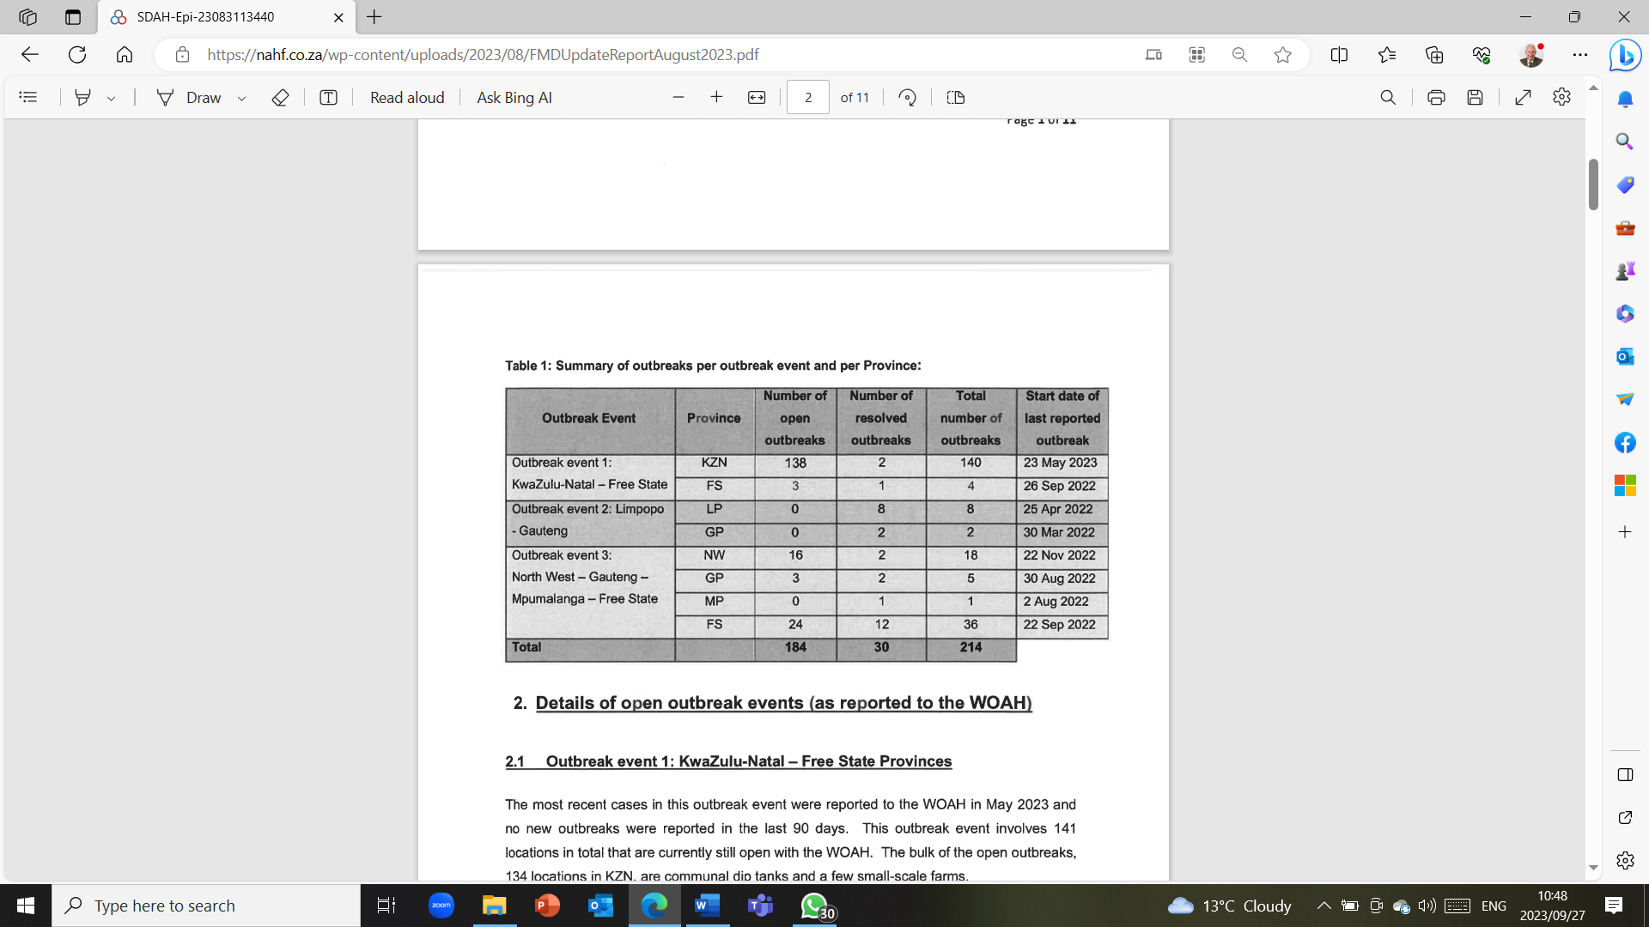

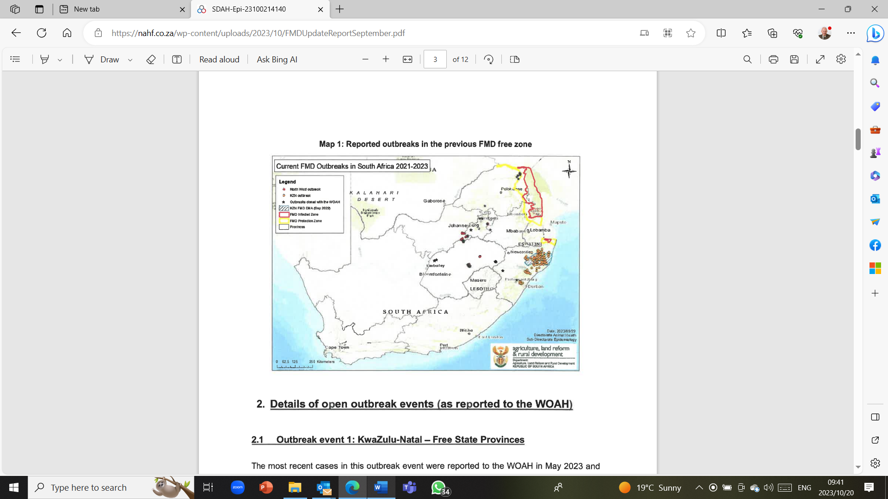
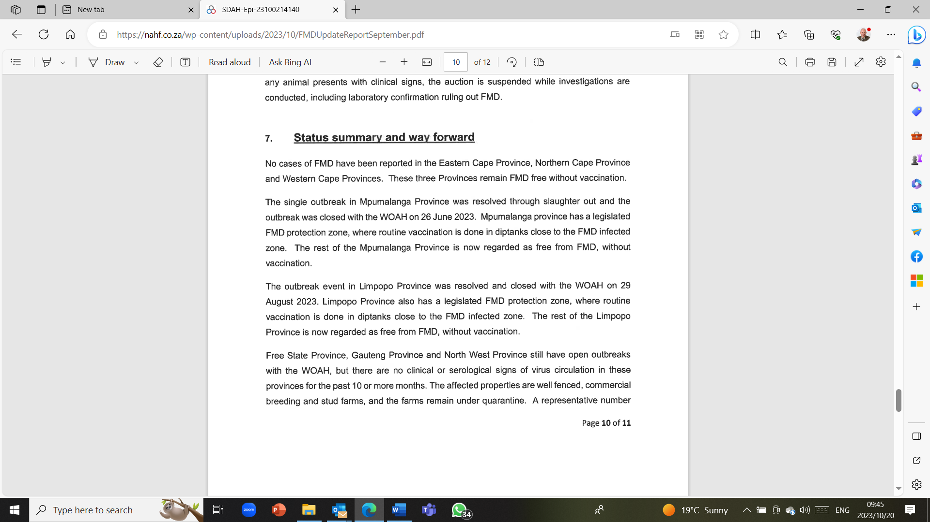
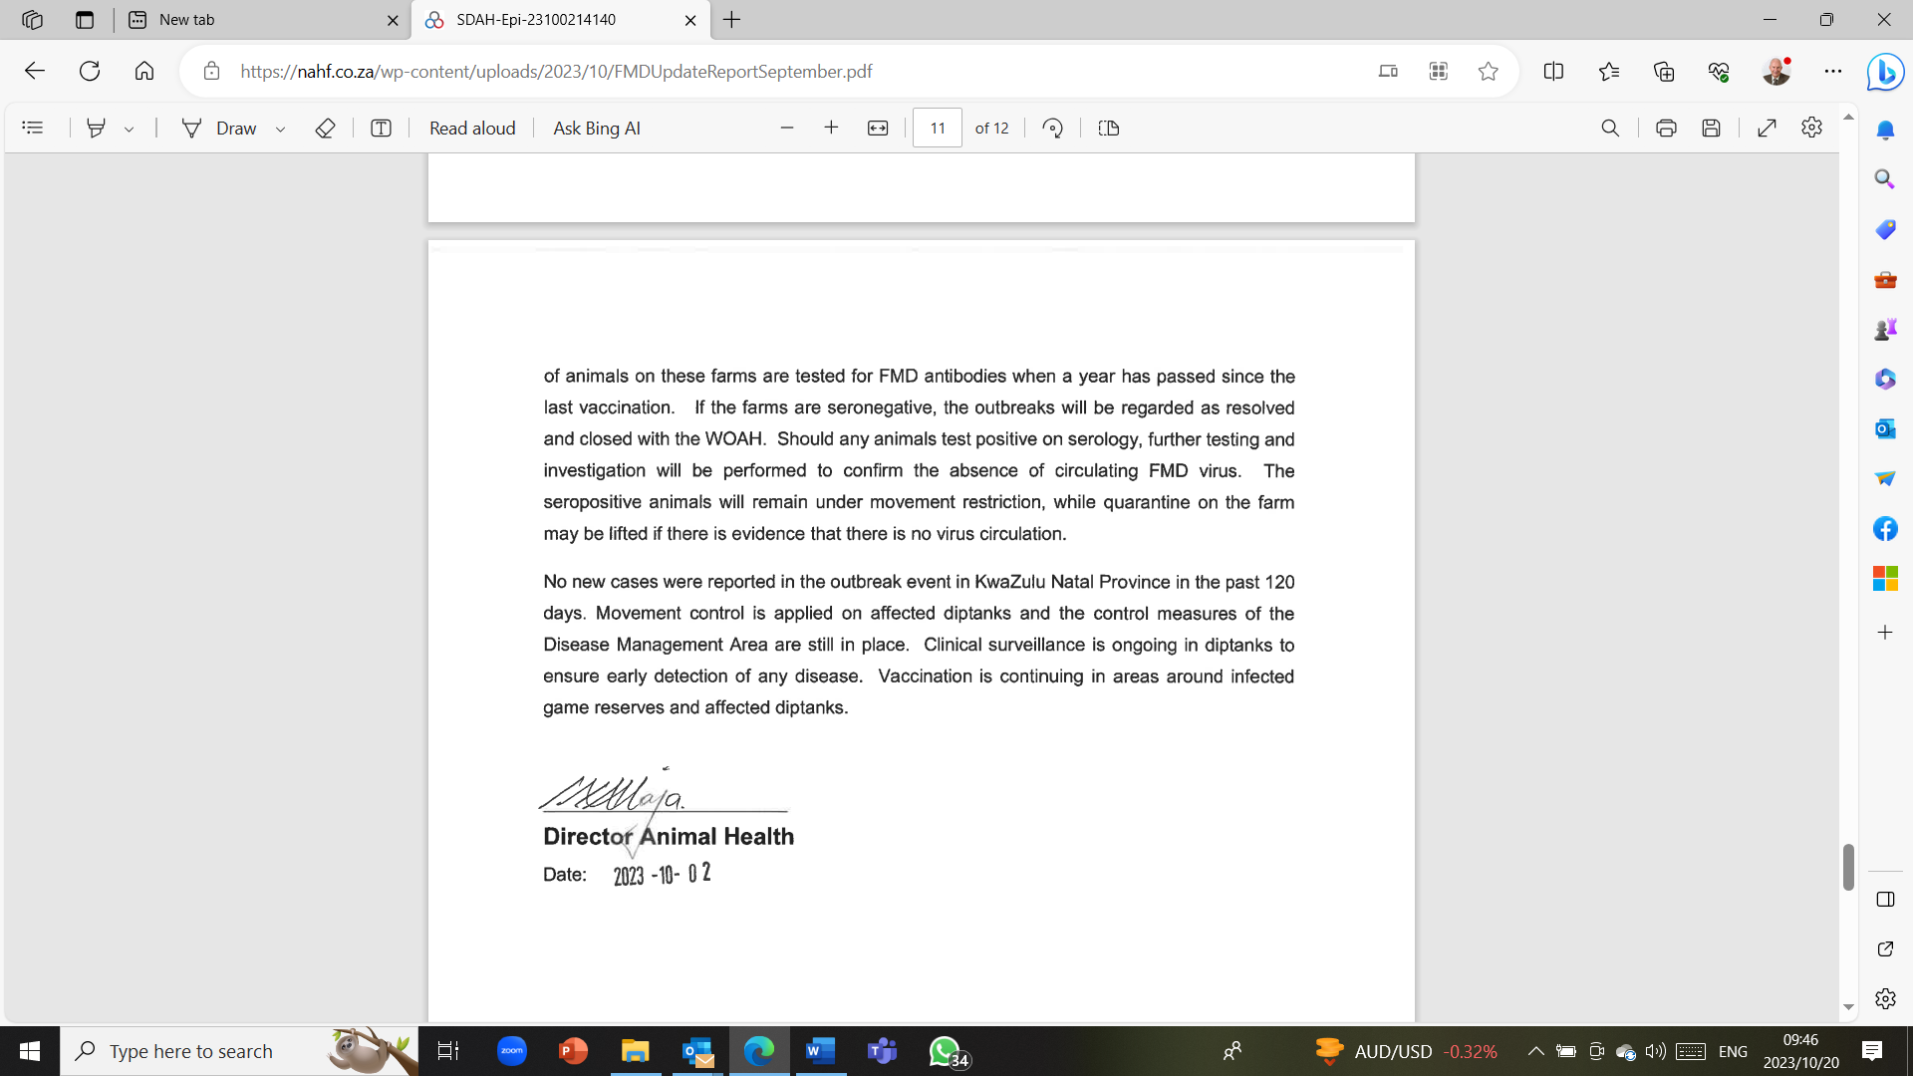
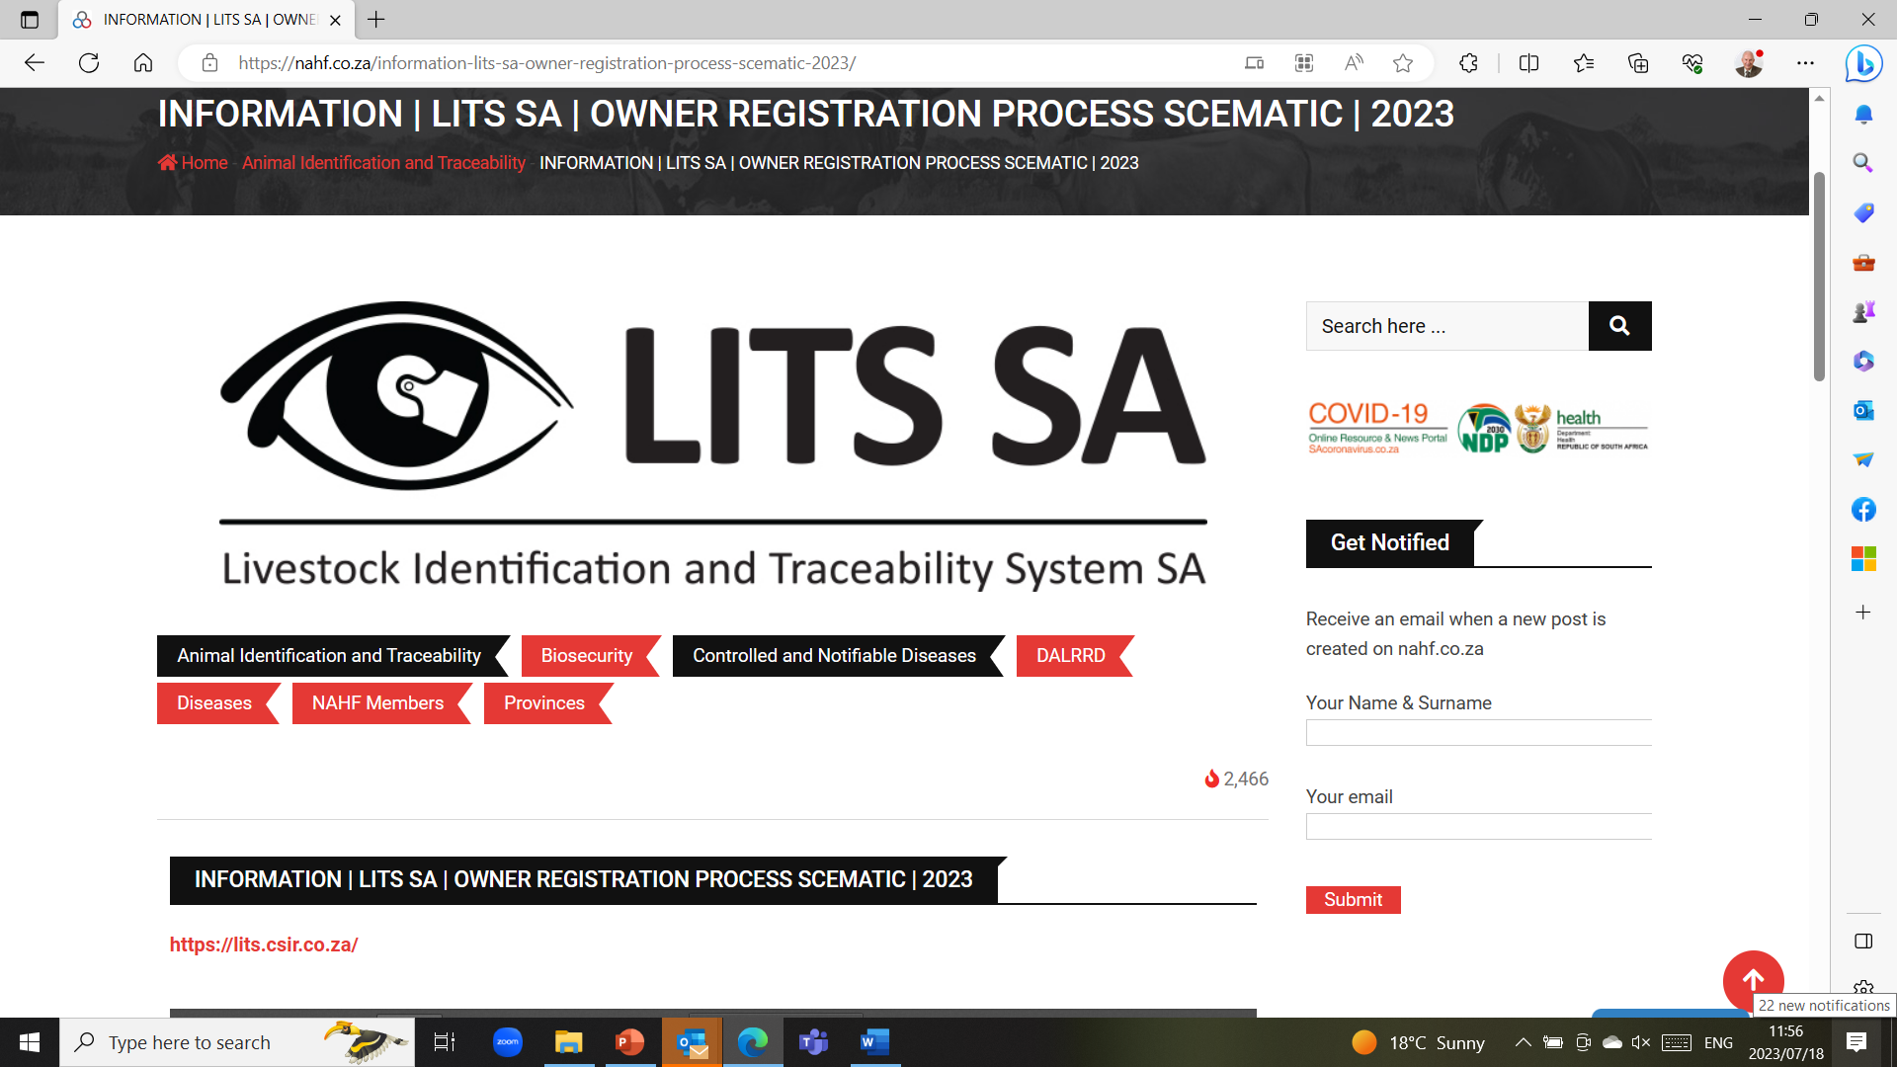

Start registering for the Livestock Identification and Traceability System (LITS SA)!!!
INFORMATION | LITS SA | OWNER REGISTRATION PROCESS SCEMATIC | 2023 – NAHF
https://lits.csir.co.za/
Livestock Identification and Traceability System for South Africa
The government, in collaboration with the industry, has been in the process of developing a livestock
identification and traceability system for the past few years. It encompasses the entire industry,
from emerging to commercial producers, and aims to:
• Improve livestock disease control programs.
• To reduce the disruption of livestock marketing following disease outbreaks.
• Meet sanitary requirements of high-value export markets.
• Improve the competitiveness of the livestock sector.
• Increase equity for all players in the value chain.
• Improve confidence in South African livestock products.
• Accelerate access to accurate information to solve livestock theft cases.
• Improve the quality of livestock data.
• Improve the quality and reliability of genetic selection programs.
The aim is to phase in the system in stages:
• Phase 1 – registration of commercial producers (producers with a VAT number).
• Phase 2 – registration of all livestock owners per province.
• Phase 3 – registration of all other role players in the value chain.
Only commercial livestock producers will be allowed to register on the system for the first three
weeks, after which the system will open to livestock owners and small farmers. It will take producers
approximately 5 to 8 minutes to register, and the system can handle up to 4,500 registrations at a
time.
1. Proof of address as the system will work on a FICA basis.
2. Company registration, trust registration, or ID document.
3. Brand Registration Certificate.
4. GPS coordinates of the farm.
5. Registration number of property with a land surveyor.
6. Your vet's information if you use one
7. Average number of animals on the farm - all sexes and ages
Get these documents ready, so that if registration opens, you have these documents in hand!

Compartementalization
Compartmentalization is a concept developed by the World Organization for Animal Health (OIE) to enable international trade to continue in the event of a notifiable disease outbreak. Compartmentalization is separation by common management and biosecurity measurements while regionalization or zones are based on geography.
When supply is disrupted by trade barriers such as disease, the ability to meet demand becomes challenging. Keeping trade open through strategies such as Regionalization/Zones and Compartmentalization enables primary poultry breeders to provide notifiable disease assurances and maintain continuous supply of breeding stock required to help feed a growing global population.
An example in Poultry farming

Aviagen Leads the Way in Compartmentalization
As a result of excellent biosecurity standards, Aviagen has achieved compartment status for its facilities in the UK, US, Brazil, India, Colombia and Turkey. This means in the event of a disease outbreak, chicks and eggs can be exported from approved locations to countries that recognize compartmentalization.
Compartmentalization is a concept developed by the World Organization for Animal Health (OIE) to enable international trade to continue in the event of a notifiable disease outbreak. Compartmentalization is separation by common management and biosecurity measurements while regionalization or zones are based on geography. Both have strictly controlled biosecurity and are important for international trade purposes.
Aviagen’s facilities have been independently assessed and accredited by the Department for the Environment, Food and Rural Affairs (DEFRA) in the UK, the United States Department of Agriculture (USDA) in the US, the Ministry of Agriculture, Livestock and Supply (MAPA) in Brazil, The Turkish Ministry of Agriculture and Forestry in Turkey, Central Indian Government and State Government of Tamil Nadu in India and the Colombian Agricultural and Livestock Institute (ICA) in Colombia.
Identification of every bovine (LITS or ICAR approved ID tag)
https://www.icar.org/
The International Committee for Animal Recording (ICAR) is an International Non-Governmental Organization (INGO) which was formed on March 9th, 1951, in Rome. Presently it is composed of 128 Members from 57 countries. ICAR strives to be the leading global provider of Guidelines, Standards and Certification for animal identification, animal recording and animal evaluation. ICAR wants to improve the profitability and sustainability of farm animal production by:
Establishing and maintaining guidelines and standards for best practice in all aspects of animal identification and recording.
Certifying equipment, and processes used in animal identification, recording and genetic evaluations.
Stimulating and leading continuous improvement, innovation, research, knowledge development and knowledge exchange.
Providing services essential to achieving international collaboration in key aspects of animal recording and animal breeding.

2022 © OIE - Terrestrial Animal Health Code - 10/08/2022 1
C H A P T E R 4 . 4 .
Z O N I N G A N D C O M P A R T M E N T A L I S A T I O N
Article 4.4.1.
Introduction
The purpose of this chapter is to provide recommendations on the principles of zoning and compartmentalisation to
Member Countries wishing to establish and maintain different subpopulations with specific health status within their
territory. These principles should be applied in accordance with the relevant chapters of the Terrestrial Code. This
chapter also outlines a process by which trading partners may recognise such subpopulations.
Establishing and maintaining a disease-free status throughout the country should be the final goal for Member
Countries. However, given the difficulty of achieving this goal, there may be benefits to a Member Country in
establishing and maintaining a subpopulation with a specific health status within its territory for the purposes of
international trade or disease prevention or control. Subpopulations may be separated by natural or artificial
geographical barriers or by the application of appropriate biosecurity management.
While zoning applies to an animal subpopulation defined primarily on a geographical basis, compartmentalisation
applies to an animal subpopulation defined primarily by management and husbandry practices related to biosecurity. In
practice, spatial considerations and appropriate management, including biosecurity plans, play important roles in the
application of both concepts.
Zoning may encourage the more efficient use of resources within certain parts of a country. Compartmentalisation may
allow the functional separation of a subpopulation from other domestic or wild animals through biosecurity, which would
not be achieved through geographical separation. In a country where a disease is endemic, establishment of free
zones may assist in the progressive control and eradication of the disease. To facilitate disease control and the
continuation of trade following a disease outbreak in a previously free country or zone, zoning may allow a Member
Country to limit the extension of the disease to a defined restricted area, while preserving the status of the remaining
territory. For the same reasons, the use of compartmentalisation may allow a Member Country to take advantage of
epidemiological links among subpopulations or common practices relating to biosecurity, despite diverse geographical
locations.
A Member Country may thus have more than one zone or compartment within its territory.
Article 4.4.2.
General considerations
The Veterinary Services of a Member Country that is establishing a zone or compartment within its territory should
clearly define the subpopulation in accordance with the recommendations in the relevant chapters of the Terrestrial
Code, including those on surveillance, on animal identification and animal traceability and on official control
programmes.
The procedures used to establish and maintain the specific animal health status of a zone or compartment depend on
the epidemiology of the disease, including the presence and role of vectors and susceptible wildlife and environmental
factors, on the animal production systems as well as on the application of biosecurity and sanitary measures, including
movement control.
Biosecurity and surveillance are essential components of zoning and compartmentalisation, and should be developed
through active cooperation between industry and Veterinary Services.
The Veterinary Services, including laboratories, should be established and should operate in accordance with
Chapters 3.2. and 3.3., to provide confidence in the integrity of the zone or compartment. The final authority over the
zone or compartment, for the purposes of domestic and international trade, lies with the Veterinary Authority. The
Veterinary Authority should conduct an assessment of the resources needed and available to establish and maintain a
zone or compartment. These include the human and financial resources and the technical capability of the Veterinary
2 2022 © OIE - Terrestrial Animal Health Code - 10/08/2022
Chapter 4.4.- Zoning and compartmentalisation
Services and of the relevant industry and production system (especially in the case of a compartment), including for
surveillance, diagnosis and, when appropriate, vaccination, treatment and protection against vectors.
In the context of maintaining the animal health status of a population or subpopulation of a country, zone or
compartment, importations into the country as well as movements of animals and their products, and fomites, into the
zones or compartments should be the subject of appropriate sanitary measures and biosecurity.
The Veterinary Services should provide movement certification, when necessary, and carry out documented periodic
inspections of facilities, biosecurity, records and surveillance procedures. Veterinary Services should conduct or audit
surveillance, reporting, laboratory diagnostic examinations and, when relevant, vaccination.
The production sector's responsibilities include, in consultation with the Veterinary Services if appropriate, the
application of biosecurity, documenting and recording movements of commodities and personnel, managing quality
assurance schemes, documenting the implementation of corrective actions, conducting surveillance, rapid reporting
and maintenance of records in a readily accessible form.
Article 4.4.3.
Principles for defining and establishing a zone or compartment
The following principles apply when Member Countries define a zone or a compartment.
1) The extent of a zone and its geographical limits should be established by the Veterinary Authority on the basis of
natural, artificial or legal boundaries, and made public through official channels.
2) The factors defining a compartment should be established by the Veterinary Authority on the basis of relevant
criteria such as management and husbandry practices related to biosecurity, and communicated to the relevant
operators through official channels.
3) Animals and herds or flocks belonging to subpopulations of zones or compartments should be recognisable as
such through a clear epidemiological separation from other animals and all factors presenting a risk. The measures
taken to ensure the identification of the subpopulation and to establish and maintain its health status through a
biosecurity plan should be documented in detail. These measures should be appropriate to the particular
circumstances, and depend on the epidemiology of the disease, environmental factors, the health status of animals
in adjacent areas, applicable biosecurity (including movement controls, use of natural, artificial or legal boundaries,
spatial separation of animals, control of fomites, and commercial management and husbandry practices), and
surveillance.
4) Relevant commodities within the zone or compartment should be identified in such a way that their movements are
traceable. Depending on the system of production, identification may be done at the herd or flock or individual
animal level. Relevant movements of commodities into and out of the zone or compartment should be well
documented and controlled. The existence of an animal identification system is a prerequisite to assess the
integrity of the zone or compartment.
5) For a compartment, the biosecurity plan should describe the partnership between the relevant industry and the
Veterinary Authority, and their respective responsibilities. It should also describe the standard operating
procedures to provide clear evidence that the surveillance conducted, the animal identification and traceability
system, and the management and husbandry practices are adequate to meet the definition of the compartment. In
addition to information on controls of movements of relevant commodities, the plan should include herd or flock
production records, feed, water and bedding sources, surveillance results, birth and death records, visitor logbook,
morbidity and mortality history and investigations, medications, vaccinations, documentation of training of relevant
personnel and any other criteria necessary for evaluation of risk management. The information required may vary
in accordance with the species and diseases under consideration. The biosecurity plan should also describe how
the measures will be audited to ensure that the risks are being managed and regularly reassessed, and the
measures adjusted accordingly.
Articles 4.4.4. to 4.4.7. describe different types of zones that can be established by Member Countries. However, other
types of zones may be established for the purposes of disease control or trade.
Article 4.4.4.
Free zone
A free zone is one in which the absence of a specific infection or infestation in an animal population has been
demonstrated in accordance with the relevant requirements of the Terrestrial Code.
Chapter 4.4.- Zoning and compartmentalisation
2022 © OIE - Terrestrial Animal Health Code - 10/08/2022 3
In conjunction with Articles 4.4.2. and 4.4.3., and depending on the prevailing epidemiological situation, the attainment
or maintenance of free status may require past or ongoing specific surveillance and vector surveillance, as well as
appropriate biosecurity and sanitary measures, within the zone and at its borders. The surveillance should be
conducted in accordance with Chapter 1.4. and the relevant chapters of the Terrestrial Code.
The free status can apply to one or more susceptible animal species populations, domestic or wild.
So long as an ongoing surveillance demonstrates there is no occurrence of the specific infection or infestation, and
principles determined for its definition and establishment are respected, the zone maintains its free status.
Article 4.4.5.
Infected zone
An infected zone is one either in which an infection or infestation has been confirmed, or that is defined as such in the
relevant chapters of the Terrestrial Code.
An infected zone in which an infection or infestation has been confirmed may be:
1) a zone of a country where the infection or infestation is present and has not yet been eradicated, while other zones
of the country may be free; or
2) a zone of a previously free country or zone, in which the infection or infestation has been introduced or
reintroduced, while the rest of the country or zone remains unaffected.
To gain free status in an infected zone, or regain free status following an outbreak in a previously free zone, Member
Countries should follow the recommendations in the relevant chapters of the Terrestrial Code.
Article 4.4.6.
Protection zone
A protection zone may be established to preserve the animal health status of an animal population in a free country or
a free zone by preventing the introduction of a pathogenic agent of a specific infection or infestation from neighbouring
countries or zones of different animal health status.
A protection zone may be established as a temporary measure in response to an increased risk of disease. In such
case, it may be maintained up to 24 months.
The protection zone can be established within or outside a free zone or within a free country. Based on the results of a
risk assessment, more than one protection zone may be established.
Biosecurity and sanitary measures should be implemented in the protection zone on the basis of the animal
management systems, the epidemiology of the disease under consideration and the epidemiological situation
prevailing in the neighbouring infected countries or zones.
In addition to the general considerations in Article 4.4.2. and the principles in Article 4.4.3., these measures should
include intensified movement control, animal identification and animal traceability to ensure that animals in the
protection zone are clearly distinguishable from other populations. Vaccination of susceptible animals in accordance
with Chapter 4.18. may also be applied.
Increased surveillance, in accordance with Chapter 1.4. and the relevant disease-specific chapter, should be
implemented in the protection zone and the rest of the country or zone, including surveillance of wildlife and vectors as
relevant.
If the animal health status of an established protection zone changes owing to the occurrence of a case, the animal
health status of the rest of the country or zone is not affected, provided the measures in place prevent the spread of
disease and allow the subsequent establishment of a containment zone in accordance with the criteria in Article 4.4.7.
Unless otherwise specified in the relevant disease-specific chapters of the Terrestrial Code, if the animal health status
of an established protection zone changes because of vaccination, the animal health status of the rest of the country or
zone is not affected.
4 2022 © OIE - Terrestrial Animal Health Code - 10/08/2022
Chapter 4.4.- Zoning and compartmentalisation
Regarding diseases for which the OIE grants official recognition of animal health status:
– a protection zone is considered as effectively established when the conditions described in this article and in the
relevant disease-specific chapters have been applied and documented evidence has been submitted to and
accepted by the OIE;
– if a Member wishes to make the protection zone permanent, the process for official recognition by the OIE should
be followed in accordance with Chapter 1.6. and the relevant disease-specific chapters.
Article 4.4.7.
Containment zone
1) In the event of outbreaks in a country or zone previously free from a disease, a containment zone, which includes
all epidemiologically linked outbreaks, may be established to minimise the impact on the rest of the country or zone.
2) A containment zone is an infected zone that should be managed in such a way that commodities for international
trade can be shown to have originated from either inside or outside the containment zone.
3) Establishment of a containment zone should be based on a rapid response, prepared in a contingency plan, that
includes:
– appropriate control of movement of animals and other commodities upon declaration of suspicion of the
specified disease;
– epidemiological investigation (trace-back, trace-forward) after confirmation of infection or infestation,
demonstrating that the outbreaks are epidemiologically related and all are contained within the defined
boundaries of the containment zone;
– a stamping-out policy or another effective emergency control strategy aimed at eradicating the disease;
– animal identification of the susceptible population within the containment zone, enabling its recognition as
belonging to the containment zone;
– increased passive and targeted surveillance in accordance with Chapter 1.4. in the rest of the country or zone,
demonstrating no occurrence of infection or infestation;
– biosecurity and sanitary measures, including ongoing surveillance and control of the movement of animals,
other commodities and fomites within and from the containment zone, consistent with the listed
disease-specific chapter, when there is one, to prevent spread of the infection or infestation from the
containment zone to the rest of the country or zone.
4) A containment zone is considered to be effectively established when the following is demonstrated, unless
otherwise specified in the disease-specific chapter:
EITHER
a) there have been no new cases in the containment zone within a minimum of two incubation periods from the
disposal of the last detected case;
OR
b) it comprises an inner zone where cases may continue to occur and an outer zone where no outbreaks have
occurred for at least two incubation periods after the control measures above have been put in place and
which separates the inner zone from the rest of the country or zone.
5) The free status of the areas outside the containment zone is suspended pending the effective establishment of the
containment zone. Once the containment zone has been established, the areas outside the containment zone
regain free status.
6) The free status of the containment zone should be regained in accordance with the relevant listed disease-specific
chapters or, if there are none, with Article 1.4.6.
7) In the event of an occurrence of a case of the infection or infestation for which the containment zone was
established, either in the containment zone described in point 4(a) or in the outer zone where no outbreaks had
occurred as described in point 4(b), the rest of the country or zone loses its free status.
Article 4.4.8.
Bilateral recognition of country or zone status by trading countries
While the OIE has procedures for official recognition of status for a number of infections (refer to Chapter 1.6.), for other
infections or infestations, countries may recognise each other's status through a bilateral process. Trading partners
should exchange information allowing the recognition of different subpopulations within their respective territories. This
Chapter 4.4.- Zoning and compartmentalisation
2022 © OIE - Terrestrial Animal Health Code - 10/08/2022 5
recognition process is best implemented through establishing parameters and gaining agreement on the necessary
measures prior to outbreaks of disease.
The Veterinary Services of an exporting country should be able to explain to the Veterinary Services of an importing
country the basis for claiming a specific animal health status for a given zone or compartment under consideration.
The exporting country should be able to demonstrate, through detailed documentation provided to the importing
country, that it has implemented the recommendations in the Terrestrial Code for establishing and maintaining such a
zone or compartment.
In accordance with Chapter 5.3., an importing country should recognise the existence of this zone or compartment
when the appropriate measures recommended in the Terrestrial Code are applied and the Veterinary Authority of the
exporting country is able to demonstrate that this is the case.
NB: FIRST ADOPTED IN 1998; MOST RECENT UPDATE ADOPTED IN 2021.
6 2022 © OIE - Terrestrial Animal Health Code - 10/08/2022
Chapter 4.4.- Zoning and compartmentalisation
Movement control
Identification of clinical disease signs
Isolation of diseased animals
Demand a vendor’s declaration when animals are bought
Quarantine animals that are bought for 28 days
Strictly follow your herd management programme that is regularly updated in consultation with your veterinarian
The ultimate goal is to form a disease free (Brucellosis, Foot and mouth disease, Trichomonas) compartment of your farm
See what the pig farmers have achieved regarding African Swine Fever
https://www.woah.org/app/uploads/2021/10/asf-compartmentalisationguidelines-en.pdf

FOOT AND MOUTH DISEASE
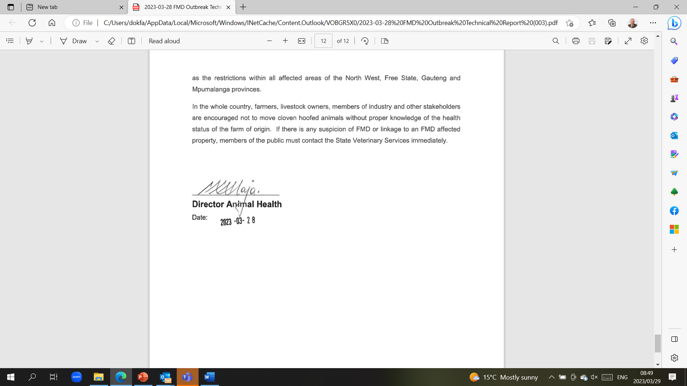
Foot and Mouth Disease Emergency Plan
Health management actions to be taken if a case of foot and mouth disease is suspected on your farm. This Emergency Plan must be discussed with your herd veterinarian and adapted for the situation on your farm.

Foot and Mouth Disease Emergency Plan:
Health management actions to be taken if a case of foot and mouth disease is suspected on your farm. This Emergency Plan must be discussed with your herd veterinarian and adapted for the situation on your farm.
Phases | Description | Timeline | Outcome
Phase 1 | Trained herdsman observes suspicious signs of FMD during structured daily observation | Day 1 | Animal/s must be brought to the closest handling facility within that camp.
Phase 2 | Trained herdsman examines affected animal/s and send findings and photos to the manager and veterinarian | Day 1 | Two possible outcomes based on the results of the observation and subsequent examination:  The absence of lesions consistent with FMD – the herd will be monitored daily.  A possible case of FMD is confirmed based on the visible lesions and the State veterinarian must immediately be informed to collect samples for laboratory confirmation
Phase 3 | If a possible case of FMD is suspected during examination of the herd, the animal must be isolated (quarantined) and other herds on the farm or adjacent farms must be moved at least 1km away from this isolated herd. | Day 2 to 7 | Can take 1 day or more to get a veterinarian to take the samples and then also up to 1 week before the results of the tests are available.
Phase 4 | If a possible case of FMD is confirmed by laboratory results this herd must now be managed over the long term (plan for up to a maximum of 3 months) in such a way that the disease is not transmitted to other herds on the same or adjacent farms. | < than 30 days | Two possible outcomes based on the laboratory confirmation tests:  Tests are negative and the isolated herd is closely monitored for another 3 weeks until the quarantine is lifted.  Tests are positive confirming the case of FMD and the herd is kept as an isolated herd on a longer term basis – the follow up action (vaccination to slaughter or direct slaughter after recovery from the disease under a red cross permit at the closest approved abbatoir)

Procedures:
Phase 1:
Observation of signs of disease consistent with Foot and Mouth (FMD) disease by the herdsman.
In case where a herdsman observes signs of disease that is consistent with a suspected case of FMD he must report it immediately to the manager.
The manager must identify the location of the herds and other herds in the vicinity on a map for further fast reaction (e g moving other herds away from the possible infected herd) if needed.
The herdsman stays with the animal/s and gets it to the closest handling facility for examination.

Phase 2:
Examination of suspected FMD case after observation of typical signs of disease.
The herdsman then proceeds to examine the feet and the inside of the mouth of the affected animal as per training.
If there are any lesions, the herdsman must take photos and a video to send to the manager.
If the herdsman can't manage the taking of the photos and/or don’t have a cell phone with a camera, he must be assisted by a manager.
The manager that arrives must stop at a place well away of the kraal, wear an overall and gumboots and must not physically handle the animal/s but just observe the examination by the herdsman and take photos that must be send to the consulting veterinarian with the history of the case and the number of animals affected.
If lesions are found during the examination that is consisted with the lesions caused by FMD, the herd must be handled as a positive FMD herd.
The affected animal/s must stay separated from the herd until feedback by the consulting veterinarian.
The herdsman must not handle other healthy animals in this herd after examination of the affected animal/s
Depending on the findings of the examination, the consulting veterinarian will give advice on further actions to be taken.
If the lesions observed are not consistent with FMD, the herd will be managed as normal with increased focus on daily observation and reporting.
If the lesions are consistent with FMD, all precautions described will be taken as this herd is now treated as positive for FMD until the results from laboratory testing are available.
The person that came to assist must then go back to the vehicle and before getting into the vehicle pour disinfectant in a bucket with water at the right dilution (or use a 5-liter container with already made-up disinfectant). Disinfect hands and take the boots and overall off and put normal clothes on. Wash (scrub with a hard brush to remove dung and dirt) and disinfect the boots, put the overall in a bucket and wet it with disinfectant, and then wash and disinfect hands and arms. This person can then go straight home and shower. Overalls can be washed as usual.
The herdsman, that examined the affected cattle can wash and disinfect his boots (not at or in the watering trough) before leaving the camp to go to his house.
The outside of rubber boots can be washed (scrubbed) and disinfected again at home and overall can be put in a bucket with diluted disinfectant for 1 hour before washing it.
Although the carrier state of the FMD disease virus is not transferrable to other people, it is advisable that the herdsman must not come into close contact with any other person that also works with animals on the same or other farms.

Phase 3:
After informing the state veterinarian to come and take samples for laboratory testing for FMD.
The state veterinarian/technician must immediately be contacted (the contact numbers must be ready and available in order for the manager to call immediately).
Ensure that the state veterinarian/technician come to collect the samples within a maximum period of 2 days after reporting the possible case.
Manager to follow up on the results of the laboratory tests on a daily basis – it can be expected that the test results will be available in a maximum period of 5 days.
Herds within 1 km from the possible affected herd on the farm and adjacent farms must be moved away to be at least 1km away from the herd that is now isolated (quarantined).
Only the herdsman that examined the animals initially, will tend to and handle animals in the herd and follow the procedure as described above when leaving the herd every day.
The first function of the herdsman will be to check the fences of the camp in which the cattle are to ensure that no cattle can get out of this camp and that all gates leading to or through this camp are locked.
The herdsman must also assess the grazing and give feedback to the manager regarding the grazing days left in this camp for future planning during Phase 4.

Phase 4:
Manage the herd that test positive on the laboratory confirmation tests.

If a possible case of FMD is confirmed by laboratory results, this herd must now be managed over the long term (plan for up to maximum 3 months) in such a way that the disease is not transmitted to other herds on the same or adjacent farms.
The herd is kept as an isolated herd and the management during the next 3-4 weeks is of utmost importance because that will be the period when most animals in the same herd will be infected and then they will also recover when immunity develop. The highest risk of transmission is when the animals start showing signs of FMD until they recover 2-3 weeks later.
The follow up action will be determined and directed by the State veterinarian (vaccination to slaughter or direct slaughter after recovery from the disease under a Red Cross permit at the closest approved abattoir).
Compiled by Dr. Danie Odendaal
STOP ILLEGAL MOVEMENT OF CATTLE!!!!!!!!!!!
The reason for the foot and mouth outbreaks in South Africa all had to do with the illegal movement of cattle out of the FMD controlled zones in Limpopo.
Owners of motor vehicles are legally bound to have number plates on their vehicles, similarly all cattle have to be branded with a registered mark to prove ownership and in future cattle will be identified with a ICAR approved RFID ear tag.
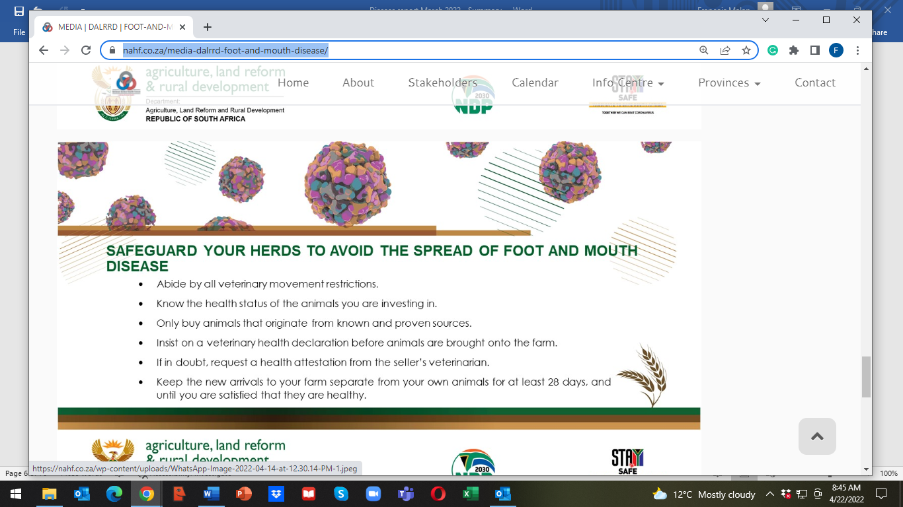
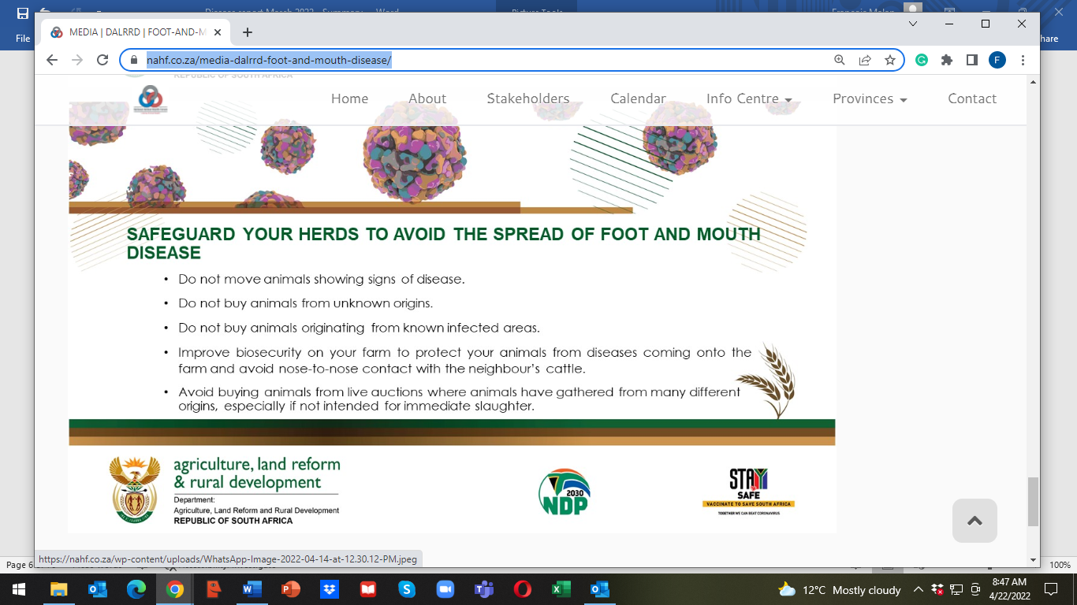

Important development in the beef industry
PRESS RELEASE
LIVESTOCK PRODUCERS DO GROUNDWORK FOR A TRACEABILITY SYSTEM IN THE INDUSTRY
“International trade partners and consumers increasingly insist on a traceability system in the
livestock industries and it has also become necessary in terms of market access, whether
locally or internationally,” says Mr James Faber, chairman of the national RPO.
“The need for traceability systems has now become imperative because of the outbreak of
Foot and Mouth Disease (FMD),” Faber said.
The Department of Agriculture, Land Reform and Rural Development (DALRRD), in
cooperation with the livestock industries already made significant progress with the
development of a LITS system (Livestock Identification and Traceability system).
The CSIR developed the system and the testing phase is currently taking place in the FMD
endemic areas.
Although work is continuously being done in terms of the LITS system with the involvement
of the industries, it will take a long time to implement it comprehensively.
“The need to kickstart with a practical voluntary system has become of critical importance,”
according to Mr Faber.
On the initiative of the RPO, representatives of the livestock industries and private service
providers recently convened with the aim of commencing with a practical voluntary system.
The initiative will initially focus on individual animal identification with unique ear tag numbers
and will be urgently implemented in the cattle- and small stock industries. The numbers will
also be linked with the detail of the owner and the farm. Producers will make use of private
service providers who are already delivering services and will also pay for the services
themselves.
It is envisaged that commercial producers will participate on a voluntary basis and the state
will take responsibility for the implementation of a system in the developing sector. The
livestock industries will in collaboration with the private service providers establish criteria
which must be adhered to in order to render the system functional.
It will be imperative that the information systems of the private service providers be integrable
with the LITS system.
However, producers must ensure that service providers comply with ICAR (International
Centre of Animal Registration). Criteria which service providers will have to fulfil will soon be
finalised and announced.
“The implementing of the systems will pave the way for the establishment of a complete
traceability system in collaboration with the state in the future. Producers participating in the
system, should insist on a premium,” says Mr Faber.
The implementing of the system enjoys the full support of the state and will most likely lead
to a private/public partnership (PPP). The initiative will be driven by the primary red meat
cluster consisting of the RPO, NERPO, SA Feedlot Association and the Red Meat Abattoir
Association.
DATE : 21 April 2022
ENQUIRIES :
Mr Dewald Olivier Mr Gerhard Schutte
SA Feedlot Association Red Meat Producers’ Organisation
Cell: 082 800 3737 Cell: 082 556 7296
Email: exec@safeedlot.co.za Email: gerhard@rpo.co.za
Dr Gerhard Neethling Mr James Faber
Red Meat Abattoir Association Red Meat Producers’ Organisation
cell: 082 551 7232 Cell: 083 292 2556
Email: manager@rmaa.co.za Email: james@glenross.co.za

For detailed reports and maps visit www.ruvasa.co.za and on the toolbar click on Disease reporting

Bovine Brucellosis
Brucellosis is still a huge problem!!!!!! Vaccinate your heifers between the age of 4 to 8 months with Strain 19 and RB 51 in non-pregnant animals. Contact your veterinarian to test your herd.
Strain 19 vaccine manufactured by Onderstepoort Biological Products and Design Biologix
RB 51 is available through MSD
Visit www.nahf.co.za and click on Info-centre for details on this HERD disease!
Bovine brucellosis is a herd disease, if one animal tests positive in a herd, the herd is regarded as being positive for bovine brucellosis
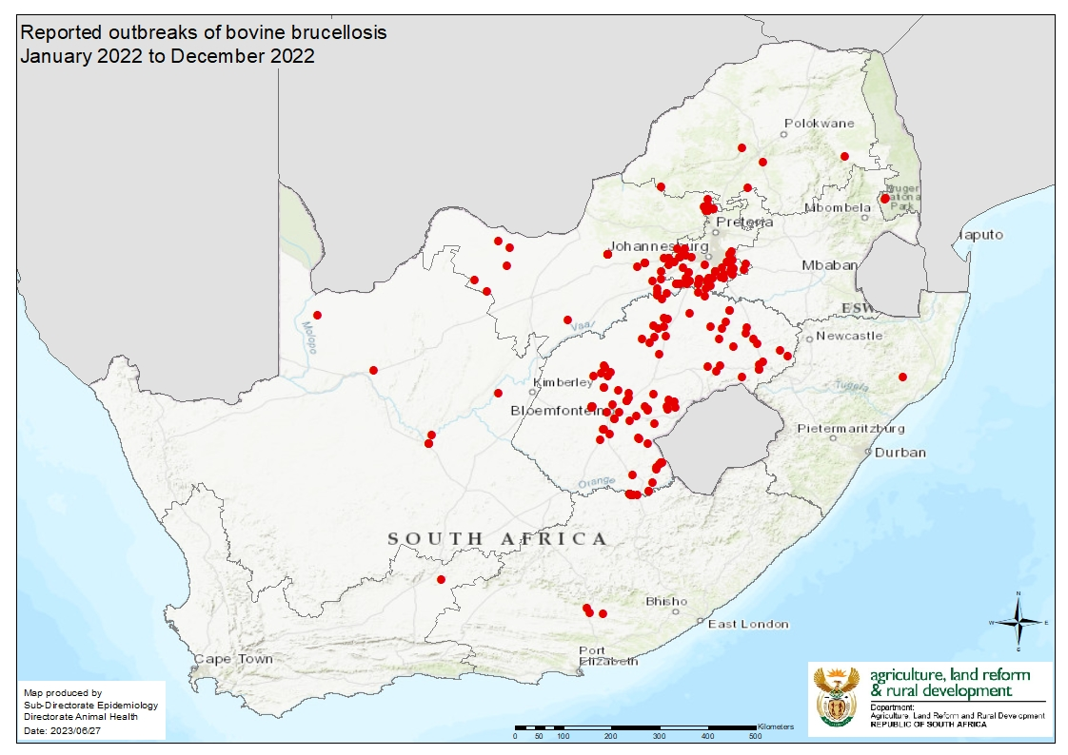
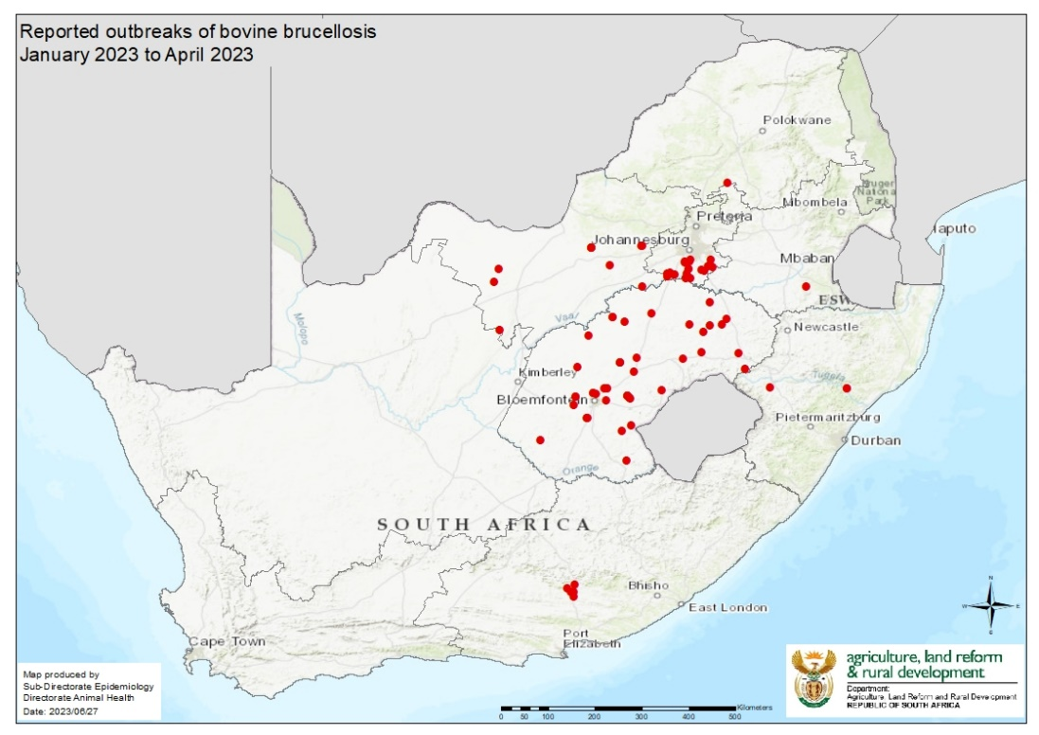
Test your bulls for Trichomonosis and Vibriosis as these two venereal diseases can ruin your future!
HAVE YOU ORDERED YOUR VACCINES? Discuss your management program with your veterinarian!
Visit the link for all the disease maps and detailed reports www.ruvasa.co,za
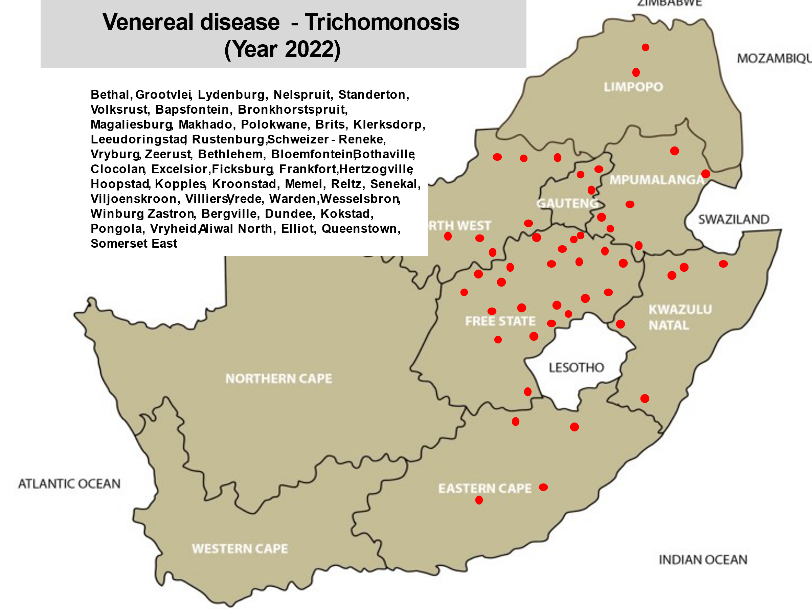
https://ruvasa.co.za/disease-report-2022/
To assess your risk, talk to your local veterinarian and update your vaccination and holistic parasite management program. It is important to study what diseases are prevalent in your area and to determine your risk. Take the necessary steps in time, as from experience it is seen that vaccine availability during an outbreak could be a huge problem. If vaccines are not available, insect and tick control are even more of importance.
Shows have been opened again after the COVID epidemic and due to the presence of diseases in South Africa, strict biosecurity protocols should be practiced at all times! If animals are taken back to the farm from shows, quarantine these animals for 28 days and observe them twice daily before allowing them into the herd again
Visit the National Animal Health Forum’s website regularly where updates on animal health are posted (www.nahf.co.za).
www.nahf.co.za
Click on Info centre
Click on Diseases
When last did you study the Veterinary Strategy??
https://nahf.co.za/wp-content/uploads/Vet-strategy-final-signed.pdf
“Bovine Brucellosis – Outbreaks are mostly due to our own fault”
Again, new outbreaks of brucellosis are reported! When will we be able to say that we are winning the battle?
Brucellosis destroyed my life and this could happen to you too!

Dr. Frans Banting, a veterinarian who was infected with brucellosis nearly 40 years ago, tells his story and hopefully this will help all of us realize how devastating this disease is; and that we all have to stand together to eradicate brucellosis. It is each farmers responsibility to stop the spread of this disease.

Dr. Banting’s story:

Disease in cattle

The disease Bovine Brucellosis is also known as Contagious Abortion (CA) and in Afrikaans as “Besmetlike Misgeboorte (BM)”. Brucellosis is a herd disease, if an animal is tested positive in a herd, the whole herd is considered to be infected.

The disease is caused by a bacterium (pathogen) Brucella abortus bovis. Infected cows and pregnant heifers usually remain life-long carriers of the bacteria; spreading (excreting) the bacteria over many years. The udder and uterus are the most important organs that are infected. Blood and muscle tissue can also be infectious for a short period. Transmission by this means is very rare in humans.

Production losses occur as animals that test positive for brucellosis are slaughtered. Additional financial losses are due to:
Cost of an abortion
Cost of perinatal mortality
Cost of temporary infertility
Increased calving intervals
Cost of replacement of dairy cows
Cost of replacement of bulls
Cost due to mortality of sero-positive cows
Milk and meat production loss
Veterinary costs

(Information provided by Dr. Chris van Dijk, dairyvetza@outlook.com)

Clinical signs of infected cattle

Pregnant cows and heifers which are infected for the first time, having no resistance (immunity) to the disease, usually abort at 4 to 7 months of pregnancy. Such a fetus is usually hairless and about 30 to 40 cm in length. Calves that are stillborn may also be found in a herd. Weak calves can be born. Infected cows may abort for a second time. Retained afterbirths usually occur.

Temporary infertility after an abortion as well as mastitis may occur. Chronic cases may develop a swelling of the knee (hygroma). Cows that are carriers of the Brucella bacteria may show no clinical signs of the disease and could still calf annually and spread the disease to the rest of the herd. Bulls may also become infected.

Brucellosis in humans

In humans, brucellosis, is a zoonotic disease i.e., a disease spread from animals to humans. The disease is known as Undulant fever or Malta fever. Undulant fever is caused by Brucella abortus bovis and Malta fever by Brucella melitensis which occurs in goats.

Transmission

Humans are infected through one of the following ways:
Intake of infected raw milk, ice cream, butter or cheese
Ingestion or handling of infected raw or underdone meat, biltong or meat products. The risk is very small as the Brucella bacteria dislike dry, warm conditions. If an animal is slaughtered at an abattoir and hung (pH drop), then the risk is negligible.
Through contact or handling of an infected still born or infected calf, uterine fluid, afterbirth or bull string. The chance of infection when helping a cow during a difficult calving or removing a dead calf, is a reality!
Through pricking yourself with a syringe needle when vaccinating animals with Strain 19 or RB 51. Accidental contact of mucous membranes (eyes and mouth and open wounds) with the vaccine through aerosol transmission or breakages, could be disastrous to the farmer and personnel.

To summarize, if infected material is consumed (unpasteurised milk, meat, meat products, biltong) or if the bacteria/live vaccine comes into contact with mucous membranes (uterine fluid or fluid from infected calf) a person may become infected with brucellosis. Such an infection may enter the body through the eye, mouth, nasal cavity or skin.

Symptoms
The writer of this article was infected with brucellosis about 40 years ago. About two weeks after the infection took place, the first acute attack started.

Fever
A very high fever with profuse sweating occurred especially during the night. It felt as though his whole body was glowing. The worst attacks occurred from 22h00 to 01h00 the next morning. During the period from 07h00 to 14h00, the fever usually subsided.

Muscular pain
The pain was due to infection and was prominent in calf and thigh muscles

Arthritis and painful, swollen joints especially of the knees and hands.

Headaches
This is not a normal headache, but a sudden and serious stabbing headache within a localized area. It does not remain for a long period, but feels as if a long nail is driven into your skull. It disappears usually within a minute or might only last a few seconds.

Fatigue
An indescribable fatigue is often present. It often lasts for long periods -anything from one week to 6 months.

Weakness and muscular weakness. This weakness may be so bad that a person may not be able to work.

Weight loss and chronic diarrhoea
An affected person could lose 3 to 10 kg body weight within weeks.

Depression
Loss of interest in life. Such an attack can last for a few days or up to months.

Insomnia:
Waking during the night (especially between 22h00 and 24h00), one cannot sleep or one has a poor sleeping pattern.

Appetite
Strangely, appetite is not affected

The above listed symptoms are often confused with flu and therefore a correct diagnosis, in many cases, is not made in time. Most acute cases disappear within a month or two, A large percentage of cases develop a chronic (long lasting) infection with roughly the following symptoms:

Muscle and joint pain
Severe fatigue develops with a typical pattern. During the morning and early afternoon, the person feels normal. From about 15h00 to late at night fatigue sets in. This pattern repeats itself and may last for months or years.
Muscular weakness. A normal life is often not possible.

Treatment
If the disease is diagnosed and treated at an early stage, the patient could recover from the disease. Diagnosis is confirmed by means of a positive blood test. Unfortunately, many physicians do not recognize this disease or have insufficient knowledge of the disease and a correct diagnosis is not made.
Brucellosis is treated by giving numerous antibiotics as well as anti-inflammatory drugs, pain killers and multi-vitamins to patients. Antibiotics are given per mouth for 3 to 4 months while intra-venous drugs are given for five successive days with a drip containing nutrients.
In chronic cases the treatment is repeated if typical symptoms of the disease are seen. If infection is due to contact with the RB 51 vaccine, the infection cannot be discovered with the ordinary blood-test and the infection does not react to the ordinary treatment. Contact your medical doctor if you suspect you got infected through contact with the RB 51 vaccine.

Consequences
In serious cases it might be necessary to give the patient sick leave for an extended period. It may even be the best for the patient to retire or change his/her occupation. Brucellosis has its consequence and could change a person’s entire life!

Prevention
Brucellosis is a State Controlled Disease. Cattle are tested by taking a blood sample from an animal and sending the samples to an accredited laboratory. If it is suspected that brucellosis is present in a herd, the following procedure is followed:
Test all animals on the farm over 18 months of age. All positive animals have to be branded with a C on the neck, isolated and sent for slaughter as soon as possible (under cover of a Red Cross Permit) to an accredited abattoir. The farm will be quarantined. The herd is tested every two months until two negative tests are obtained. The test is repeated after six months and then annually thereafter.
If adult cows are bought, they should be tested before they are introduced into the herd.
Use the available registered brucellosis vaccines, Strain 19 or RB 51, according to prescribed instructions on the packet insert.
When buying animals, get a vendor’s declaration that these animals are from a brucellosis negative accredited herd. Quarantine them and test them again. Heifers should be kept separate until they have calved. Heifers should be tested from 4-5 months pregnancy and then again after calving.

Humans
Never handle suspected infectious material such as fetuses, dead calves, live weak calves or afterbirths without gloves or eye protection.
Do not drink raw milk from an unknown, untested source.

Remember: A brucellosis infected heifer, cow, dead calf or raw milk from a positive herd is a TIME BOMB which can alter your life dramatically or destroy it totally!

Written by: Dr. Frans Banting, Veterinarian and translated by Drs. Faffa Malan, Veterinarian (dokfaffa@nashuaisp.co.za) and Sewellyn Davey (sewellynd@gmail.com)

Summary of disease report for September 2023

142 Reports from veterinary practices and laboratories were received from Mpumalanga (MP) 15; Gauteng (G) 12; Limpopo (L) 7; Northwest (NW) 12; Free State (FS) 25; KwaZulu-Natal (KZN) 12; Eastern Cape (EC) 12; Western Cape (WC) 22; Northern Cape (NC) 11; Feedlots (FL) 2; Biosecurity (BC) 1 and Laboratories and others (Lab) 11
Study this list – these are the most widely spread diseases as well as other conditions as reported by veterinarians, and determine your risk in collaboration with your veterinarian.
A list of diseases and conditions reported by veterinarians in 5 or more provinces

Diseases and other conditions | Provinces
Wireworm | 9
Blue ticks | 9
Abortions | 9
Abscesses | 9
Diarrhoea | 9
Dystocia | 9
Warts | 9
Coccidiosis | 8
Bont-legged ticks | 8
African red water | 8
Anaplasmosis | 8
Ringworm | 8
Energy deficiency | 8
Protein deficiency | 8
Eye infections | 8
Lameness/foot problems | 8
Eye infections | 8
Downer | 8
Uterine prolapse | 8
Liver fluke worms | 7
Red-legged ticks | 7
Biting lice | 7
Asiatic red water | 7
Blackquarter | 7
Pulpy kidney | 7
Orf | 7
Eye cancer | 7
Joint ill | 7
Pneumonia | 7
Mastitis | 7
Navell ill | 7
Retained afterbirth | 7
Vaginal prolapse | 7
Conical fluke | 6
Cryptosporidiosis | 6
Heartwater | 6
Pasteurellosis | 6
Selenium deficiency | 6
Bloat | 6
Blue udder | 6
Ketosis | 6
Endometritis | 6
Poor conception | 6
Parafilaria | 5
Tapeworms | 5
Bont ticks (heartwater ticks) | 5
Trichomonosis | 5
Vibriosis | 5
Red gut (cattle) | 5
Blood gut (sheep) | 5
Enzootic abortion | 5
Tulip | 5
Calcium deficiency | 5
Stillbirths | 5
Metritis | 5
Theft | 5
Trauma (fractures etc) | 5

Study the table above and determine your risk with your veterinarian and take the necessary preventative measures!

There was still a huge difference between day and night temperatures and this resulted in an increase in lung diseases. Excellent vaccines against organisms causing pneumonia are available and your veterinarian can advise you on the use of these vaccines.

Tick numbers were still high and therefore the occurrence of tick transmitted diseases such as African and Asiatic red water, Anaplasmosis and Heartwater were still recorded.

Internal parasites, causing production loss and mortalities to production animals were reported from most areas where good rainfall occurred in previous months. Wireworm infestations, resistant to most anthelmintic groups, caused great losses to small stock!

Insect transmitted diseases such as Lumpy skin disease, Three Day Stiff Sickness, Blue Tongue, African Horse Sickness declined. Unavailability of strategic vaccines, Blue tongue and African Horse Sickness, contributed to losses. A new vaccine against Blue tongue is registered and is available.

Bull testing reports were received and Trichomonosis and Vibriosis are still a huge problem, leading to poor conception rates.

Losses due to protein and energy deficiencies were reported. Veld fires destroyed huge grazing areas and animal losses were reported. Decisions should be taken to sell animals in time, should there be insufficient grazing during the coming months.

Make sure that sufficient protein and energy sources are supplemented.

Biosecurity measures should be kept in place at all times! Foot and Mouth disease, Bovine Brucellosis, Trichomonosis, Crypyosporidiosis and BMC (snotsiekte) are some of the diseases that farmers should constantly be aware of.

Now is the time that farmers should sit down with their veterinarian to update management programmes – vaccinations, breeding, biosecurity and nutrition.

Make farmers aware of the LITS system and assist them with the registration of their farms.

LEKKER BOER!!!!

Bovine Brucellosis

Although we have made positive steps in controlling Bovine brucellosis, the model disease stated in the Veterinary Strategy, we as a country is far from achieving our goal!

If farmers will just comply by vaccinating their animals against brucellosis, according to law, the incidence of brucellosis will drop dramatically as shedding of bacteria will drop!

Many farmers are still shrugging their shoulders and saying: “Why should I test my animals as it will only cost me money and what if there are positive animals? My farm will be placed under quarantine, so I am not going to test my animals!”

Dr Trudie Prinsloo a veterinarian and legal advisor has compiled legal aspects regarding brucellosis control and it is VERY IMPORTANT that you should avail yourself with the content of this document.

It is available in English and Afrikaans.

http://nahf.co.za/brucellosis-legal-aspects-2018-12-11/

When buying cattle, this Vendor declaration can assist you to minimize your risk!
Article | Be careful of what you buy-check the animal health history first | Prof Gareth Bath – NAHF

VENDOR DECLARATION BOVINE BRUCELLOSIS
I hereby declare that I am the legal owner or authorised representative of the cattle on sale and am competent to make this declaration

1 | The cattle for sale are clearly and permanently identified |  | Yes | No
2 | The cattle for sale/slaughter were born on my farm |  | Yes | No
3 | The farm has a closed herd policy i.e. I do not buy in cattle, rent out grazing or speculate with cattle |  | Yes | No
4 | I practice bio-security on my farm to a level that is ** | Poor | Moderate | Good
5 | I vaccinate my heifer calves against Bovine Brucellosis once between the ages of 4 – 8 months |  | Yes | No
6 | In addition, I vaccinate my cattle older than 8 months with RB51 |  | Yes | No
7 | I have all the cattle on my farm tested for Bovine Brucellosis |  | Yes (date) | No
8 | My herd has been tested negative within the past year |  | Yes | No
9 | I did not buy in cattle since my last negative brucellosis test |  | Yes | No
10 | I/my vet investigates any abortions on my farm |  | Yes | No
11 | To the best of my knowledge, my immediate neighbours and farms in my area are free of Bovine Brucellosis |  | Yes | No
12 | I use a veterinarian to advise me on my cattle’s herd health |  | Yes | No
13 | The cattle handling facilities on my farm are | Poor | Average | Good

Note: Vaccination does not mean freedom from Bovine Brucellosis as cattle can still be carriers
Please attach the most recent Brucella blood test certificate

Owner or authorised representative: ………………………………………………

Signature: ………………………………………………

Date: ……………………………………….

** * Biosecurity
Poor – speculates with cattle, does not vaccinate, poor fences, cattle come into contact with other cattle
Medium – Vaccinates heifers, does not buy in cattle of unknown health status

Good – closed herd/never buys in cattle, vaccinates heifers and no contact with other cattle, follows a herd health plan as advised by his veterinarian, does not allow transport trucks onto property, washes and disinfects truck after returning from the abattoir or auction grounds.
Compiled by: Dr. Sewellyn Davey, Past Chairman of the Brucellosis Steering committee of the National Animal Health Forum

BOVINE BRUCELLOSIS IS A HERD DISEASE
If one animal is found to be positive for bovine brucellosis, the entire herd is regarded as being positive. The State Veterinarian should take responsibility for controlling and eradicating the disease from the farm.

SOP for the control of Bovine Brucellosis
Audit date:____________________________
Authorised person:__________________________

 |  | Y/N | Comment
1 | Fences and gates in good condition
2 | Gate control - log in
3 | Disinfection of vehicles coming onto the farm
4 | Protective clothing and boots given to people visiting the farm (cattle area) coming from high- risk areas eg. veterinarians, nutritionists, representatives, truck drivers, workers, etc.
5 | Sterilizing equipment coming in contact with cattle
6 | Run off water/ streams from neighboring farms
7 | All animals identified with a brand mark and ear tag
8 | Data base of all animals
9 | Closed herd
10 | When last were animals bought in or moved from another farm?
11 | Only buy in animals from a farm which has a recent negative tested brucellosis herd certificate
12 | Origin(s) of acquired cattle? Bought at an auction?
13 | Keep heifers separate from herd until they have calved and tested negative for brucellosis
14 | Quarantine camp available
15 | Separate calving camps
16 | Were all heifers vaccinated between 4 and 8 months vaccinated with Strain 19 or RB51?
17 | Any cattle vaccinated with Strain 19 over 8 months of age? History over last few years.
18 | Were there any abortions on the farm – samples taken, diagnosis?
19 | All sexually mature cattle in herd tested for bovine brucellosis (provide proof)
20 | Bovine brucellosis is a State controlled disease. Positive cattle are branded with a C on the right side of the neck.
21 | Isolation of infected animals & separate handling facilities
22 | Prohibition of movement of animals off quarantined property except under cover of a Red cross permit for slaughter at an abattoir
23 | Prohibition of use and on-farm disposal of un-boiled, un-pasteurised or un-sterilised milk on quarantined property
24 | Disinfection of places where infection is a possibility.
25 | Neighbors/ recent buyers informed of infected herd status
26 | Fly, crow and predator control
27 | Destruction of afterbirths/abortions in a responsible manner
28 | Beware of livestock, game interface

VENDOR DECLARATION FOR OVINE JOHNE’S DISEASE:
SEE BELOW AND HERE:
https://nahf.co.za/ojd-vendor-declaration/

Websites that are there to assist you with information regarding animal health:

National Animal Health Forum

www.nahf.co.za

Read what the Forum is all about:
http://nahf.co.za/about/

This website will become the information centre of animal health in Southern Africa.
On the toolbar click on Stakeholders and you will find links to producer organizations and other organizations who are participating in the NAHF
http://nahf.co.za/stakeholders/

Provincial Animal Health Forums have their own site – click on Provinces http://nahf.co.za/provinces/

Important is to study the Veterinary Strategy (2016 -2026) as it gives direction to where we are going with Animal Health in South Africa.
http://nahf.co.za/wp-content/uploads/Vet-strategy-final-signed.pdf

Click on Info centre for more information on the “war” we have against Bovine Brucellosis. Please be up to date on the role all have to play to control this zoonotic disease.
http://nahf.co.za/category/diseases/brucellosis/

Information on other controlled diseases (Foot and Mouth Disease, Ovine Johne’s Disease, Pest of small stock – PPR, and African Horse Sickness) is available.

This link will continuously be updated.

Information on antibiotic resistance is also available at this address: http://nahf.co.za/category/antibiotic-resistance/

Rural Veterinary Association of South Africa
www.ruvasa.co.za
Click on Disease reporting where maps and information can be sourced on the prevalence of diseases in all provinces. Abattoir reports are available. Use the information available to update management programmes

Internal parasite control
www.wormx.info

Farm gates, Fences and Foresight, the 3 F’s!
Bear this in mind as this is where most disease-causing organisms enter or exit farms!
Major examples are: Foot and mouth disease, brucellosis, Johne’s disease, TB, cryptosporidiosis, trichomonosis, vibriosis, sheep scab, resistant parasites such as red lice, blue ticks and internal parasites (Buyer beware programmes).
Insist on VENDOR’S DECLARATIONS when buying animals.
Quarantine
Immunization programmes
Speak to your veterinarian
Abide the law- vaccinate cattle against anthrax and heifers against brucellosis!
For the detailed report and previous reports go to www.ruvasa.co.za and click on Disease reporting

Internal parasites:
The following reports were received from practices regarding internal parasite infestations:
Internal parasites | MP | G | L | NW | FS | KZN | EC | WC | NC
Roundworms | x | x | x | x | x | x | x | x
Resistant roundworms |  | x | x |  |  |  |  | x
Wireworm | x | x | x | x | x | x | x | x | x
Brown stomach-worm |  |  |  |  |  |  |  | x
Bankruptworm
Long-necked bankruptworm
White bankruptworm
Large-mouthed bowelworm
Nodularworm |  |  |  |  |  | x
White bankrupt worm
Lungworm
Eyeworm
Parafilaria | x | x |  |  | x | x |  | x
Stephanofilaria
Tapeworms | x | x |  |  | x | x |  | x
Liver fluke | x | x |  | x | x | x | x | x
Conical fluke | x | x |  |  | x | x | x | x
Cysticercosis (measles) |  |  |  |  |  |  |  | x
Schistosomiasis (bilharzia)
Coccidiosis | x |  | x | x | x | x | x | x | x
Cryptosporidiosis | x |  |  | x | x | x | x | x
Sarcosporidium
Giardia

Wireworm outbreaks were reported from 9 provinces.
BEWARE
A farm has been found where the wireworm strain on the farm is resistant to ALL active de-wormer groups
Check the eye mucous membrane colour of a group of sheep in all flocks weekly! Bottle jaws and pale eye mucous membranes are indications that deaths are just around the corner!
Get advice from your veterinarian to ascertain which de-wormer group(s) are still effective on your farm by doing a faecal egg count resistance test (FECRT). Visit www.wormx.info for training material.
The following table was received from Dr. Camilla Paterson (CamillaP@dalrrd.gov.za) from Act 36 of 1947 on 20 October 2022.

THE CODING OF ANTHELMINTICS
GROUP CODE | GENERIC CLASS OF ACTIVES | EXAMPLES OF ACTIVE INGREDIENTS
1. | Macrocyclic lactones | Avermectins
 |  | Ivermectin
 |  | Abamectin
 |  | Doramectin
 |  | Eprinomectin
 |  | Selamectin
 |  | Milbemycins
 |  | Moxidectin
 |  | Milbemycin oxime
2. | Benzimidazoles | Fenbendazole
 |  | Flubendazole
 |  | Albendazole
 |  | Mebendazole
 |  | Oxfendazole
 |  | Oxibendazole
 |  | Netobimin
 |  | Triclabendazole
 |  | Ricobendazole
3. | Imidothiazoles | Levamisole
4. | Salicylanilides | Closantel
 |  | Niclosamide
 |  | Oxyclosanide
 |  | Rafoxanide
 |  | Brationide
 |  | Clioxanide
5. | Nitrophenols | Nitroxinyl
 |  | Disophenol
 |  | Hexachlorophene
 |  | Meniclofolan
 |  | Niclofolan
6. | Sulphonamides | Clorsulon
7. | Organophosphors | Trichlorfon
 |  | Dichlorvos
8. | Isoquinolones | Praziquantel
9. | Spiroindole | Derquantel (added after table compiled)
10. | Amino-acetonitrile | Monepantel (added after table compiled)
11. | Others | Piperazines companion animals
 |  | Bunamidine
 |  | Epsiprantel
 |  | Nitroscanate companion animals

Check the number(s), codes on the labels of the worm remedies. Faecal egg count reduction tests (FECRT) should be done to determine which actives should be used on your farm for worm control. Worm resistance is a huge problem on many farms in South Africa.
Visit www.wormx.info for valuable information on parasite control!
Beware of liver fluke and conical fluke outbreaks when animals are grazing in wet areas where the intermediate hosts, water snails, are abundant.
Coccidiosis outbreaks were reported from 8 provinces. Young animals are most susceptible.
Cryptosporidiosis outbreaks, causing huge losses were reported from 7 provinces. This deadly condition has now spread to the Western Cape. Good colostrum protects new born animals. Biosecurity should be practised at all levels on the farm.
https://www.google.co.za/search?hl=en&tbm=isch&source=hp&biw=1344&bih=608&ei=PyxyXOO7OcutkwXinK3oCA&q=cryptosporidium+parvum&oq=Cryptosporidium&gs_l=img.1.1.0l10.2885.9850..16402...0.0..0.708.5719.2-4j4j3j2j1......0....1..gws-wiz-img.....0.o66yefU7Ric
Prevention of Cryptosporidiosis
Prevention is the best control method.
Animals with a well-developed immune system will generally overcome Cryptosporidium thus this should be the main aim in controlling Cryptosporidium.
A consistent, vet approved and farm appropriate vaccination program for other diseases.
Ensure no nutritional deficiencies especially vitamin A and Selenium
Excellent bio-security management
Ensure clean pathogen free water sources
Hygiene training of personnel
Consult your veterinarian

SOLUTION:
HOLISTIC INTERNAL PARASITE MANAGEMENT FOR SHEEP AND GOATS

Gareth Bath, Jan van Wyk and Faffa Malan

INTRODUCTION
Over the past ten to fifteen years there has been a radical rethink on our previous worm control strategies and assumptions due to the ever-accelerating failure of anthelmintics globally. This has caused a quiet but drastic revolution in many of the “received wisdoms” which governed advice to farmers for close to a century.

For a start, we have to abandon the underlying philosophy that internal parasites are an evil plague which should be maximally suppressed, or preferably eradicated. We have to learn to live with parasites, and prevent only the unacceptable production losses, while simultaneously breeding animals fit for the environment, rather than making the environment fit for existing animals. By regarding parasites as part of the natural order of things, we will be able to see them simply as potential problems to be managed in order to achieve optimum productivity and profitability.

Only well integrated, holistic planning has a long-term chance of success, and unless all elements of our potential armamentarium are harnessed, the results will not match the expectations.

While this paper applies to helminths, and mainly nematodes, the parallels and inferences which can be made for ectoparasites, and indeed other organisms, should be obvious.

WORM MANAGEMENT PRINCIPLES

A FLOCK MANAGEMENT REQUIREMENTS

Separation of Groups
Since different classes of animals vary in their susceptibility to worm infection and its effects, they should be separated into groups, which are grazed, treated and managed as distinct entities. If these distinctions are not made one may be forced to treat the flock according to the most susceptible group. The most susceptible groups can still be managed and treated more intensively in a mixed flock, but this becomes more difficult.

Identify the groups most at risk
Research has shown that the more susceptible animals are lambs/weanlings; and pregnant/lactating ewes. The former is susceptible because they cannot yet mount an effective immune response to infection, the latter are prone to infection because of a temporary suppression of immunity. (PPRR). These groups must get special attention.
Separation of pastures
Unless pastures can be divided by fencing or herding, all sheep will be exposed to a similar challenge, regardless of whether they are susceptible or resistant to infection and its effects. This will prevent any differentiation in management and treatment. Diversion of pastures is not only good for internal parasite control; it also aids pasture management. Electric fences can be used as temporary pasturage dividers. In communally farmed areas, herding or tethering can achieve the same result without fencing.

Resting of pastures
If pastures can be separated, it is then possible to rest them effectively, which has decided advantages to pasture management and improvement. If such pastures can be rested long enough, this will also have a significant effect on the survival of worm larvae and therefore the infection rate of the flock. Although the time needed for effective resting of pastures will vary with the climate, weather and worm species, a useful rule of thumb for effective resting is at least 3 months in subtropical for temperate climates, but as little as 1 month in the tropics. The longer the rest, the better it is for worm management.

Alternation of host species
Sheep and goats share the same worm species and alternation with one another is ineffective for worm management. However, other species like cattle, horses and ostriches are generally not susceptible to the worms of sheep and goats. If they are used to graze pastures before or after sheep or goats, they act as "vacuum cleaners" on the pasture, as they ingest many larvae which cannot develop further into egg-laying adults. The other advantage is that the pasture can still be utilised in its growing season, which prevents the grass from becoming senescent, and optimises its usefulness. This aids in maintaining the profitability of the farm.

Mend water leaks
Water points (troughs, windmills) should not be allowed to leak, as this encourages the growth of grass. Since this is where sheep concentrate, the area can become lethally contaminated by larvae.

Avoid grass in pens
Where sheep or goats have to be penned for lengthy periods (usually at night, to combat theft or predation) there can be a fatal buildup of larvae on the grass growing there. Sheep become hungry overnight and will eat these morsels of food. In consequence they will ingest massive numbers of larvae. It is therefore necessary to remove all grass from such pens.

Fence off moist areas
Areas particularly prone to high moisture and therefore the survival of worm larvae, like streams and marshes, should be separated to reduce the challenge of the flock.

Strategic movement of flocks
The aim should be to create "safe" (not necessarily "worm free") pastures. By planning changes in camps or paddocks, stock will be subject to lower challenges and need less chemical treatment. Any grazing system where a significant proportion of the pasture is rested for a full growing season will be particularly effective.

Quarantine and treatment
Do not simply introduce purchased animals into the flock or herd. They must be quarantined in a worm-unfriendly pen (bare earth or concrete) and treated intensively using the best drugs and schedule. If financially feasible, do an FECRT to ensure minimum carry-over of drug-resistant parasites. Then place them on infected pasture if there is no multiple resistance.

B GENETIC SELECTION

Selection for resistance
Resistance (the acquired or innate ability to prevent or minimize infection by parasites) is heritable and can be selected for, by measuring the faecal egg counts and using only those sheep with the lowest FEC's for breeding. For practical and economic reasons, this is usually only done for rams. Some successful breeding programs have been undertaken but they require good organisation and meticulous record keeping. Culling of bad ewes and their offspring is also practical and recommended.

Selection for resilience
Resilience (the ability to withstand the effects of infection and produce satisfactorily in spite of it) is also heritable. At present, only two proven methods, FAMACHA© and Haematocrit determination exist, although preliminary results suggest that Body Condition Scoring may also be useful. The FAMACHA© System can be used only where wireworm is the major parasite. By treating according to clinical anaemia (an indicator of poor resilience), only those sheep unable to cope with wireworm are treated. This reduces selection pressure for anthelmintic resistance and at the same time allows the farmer to cull the non-copers, in the long term thus being able to breed an animal better adapted to the environment.

It is also possible to select rams by a system of allocation of selection indexes. This is currently under investigation and will require measuring individual ram FECs and FAMACHA© scores (or haematocrits) to make the measurement more accurate.

C MONITORING SYSTEMS

FEC
Regular (monthly or 2 - monthly) monitoring of faecal egg counts on a group or flock basis will help to indicate when dosing is really needed, and equally important, when it can be delayed or even omitted. A bulk (composite) FEC comprising a single count of faeces pooled from equal samples from 10 to 20 sheep is certainly cheaper than dosing the whole flock unnecessarily. Keep graphs or tables of changes to indicate when parasite buildup is likely.

FECRT
Every farmer should have the flock tested for drug resistance in the worm population on his farm, at regular intervals of not less than two years. Only by knowing exactly what the state of anthelmintic resistance on a farm is, can appropriate action be taken. Generalisation such as "benzimidazole resistance is found on most farms" are not much use since they cannot tell us what the situation is on a particular farm. Just as important, we must know not only that resistance is present, but also how bad it is. Can we still use the drug group at all? Separate bulk faecal samples from each drug group will reduce the cost to acceptable levels.

FAMACHA© evaluation
Apart from selection and culling, this system also allows frequent, cheap and easy monitoring of the current situation as regards worm infection, but applies only to haemonchosis.

D OPTIMISE ANTHELMINTIC USE

Establish the important parasites species present
Unless the prevalence and importance of worm species is known, worm management becomes dangerous and unpredictable guesswork. It can also be ineffective and very costly.

Use the most suitable drug
If the parasites are ranked in order of economic importance and their susceptibility to groups of anthelmintics is known and combined with knowledge on the anthelmintic resistance situation on the farm, it is then possible to decide which drug(s) and formulations will be the most suitable in each situation. This includes their cost and a cost/benefit analysis. Neither the cheapest nor the most expensive drug is necessarily the best one to use. Beware of generic drugs sold by an unknown company.

Avoid too frequent treatment
The old approach of "dosing clean" must be completely abandoned, although not by reducing the dosage rate per animal. The aim has to be to treat only sufficient times and enough individual animals to maintain the equilibrium between parasite, host and environment (that is, worm management). Overtreatment ensures that only resistant parasites can survive. Minimal treatment programs must be the new watchword, but is must be ensured that every treatment is effective.

Treat all and stay
This is a major departure from the recommendations made for close to a century. If all sheep are to be treated, they should remain in the camp (paddock) where they were grazing before treatment. This will prevent sheep from contaminating a new pasture with only those resistant parasites which survived treatment, thus in the process unwittingly causing the selection for resistance parasites. In most cases they should remain in the paddock for at least 2-3 weeks after treatment to pick up unselected larvae for propagation of the susceptible worms in the new camp/paddock. However, should a long-acting anthelmintic be used, this period will have to be longer (2 to 3 weeks after the effective residual action ends). Particularly bolus (slow release) formulations should be used with great caution.

Treat selectively
It is preferable to treat only those sheep or goats unable to cope with the current infection challenge, provided the percentage of non-copers remains below 20%. This can be done with the FAMACHA© system for haemonchosis, or possibly with Body Condition Scoring for other parasites. If clinically unaffected animals are left untreated, an immediate move to new pasture will not be detrimental. In the absence of such selective treatment, just leaving a small percentage (10-25%) of the flock intentionally untreated can be beneficial to slow AR development.

Move then treat

Another way of achieving the same result as “treat all and stay” is to move the flock to a new “safe” pasture and delay treatment for 2-3 weeks, to allow the seeding of the new pasture with unselected worms, before treating the flock.

Herbal Remedies
These are often touted as the answer to worm control. However, unless they have been properly tested and proven by an independent body, they may be useless or even harmful.

E IMPROVED ANTHELMINTIC EFFICACY

Dose over the tongue
By placing the tip of the gun towards the back of the mouth, over the tongue, closure of the oesophageal groove does not occur and thus the full dose lands in the rumen where it is absorbed more slowly - this is particularly important for anthelmintic groups which rely on prolonged blood levels for their effect, like the benzimidazoles and macrocyclic lactones.
This prolonged level of activity (a long so-called "killing zone") means that the drug against which worms have developed a moderate degree of resistance can be made more effective, although of course the resistance of the worms is not reduced, but rather partially overcome. However, dosing (drenching) over the tongue, if done carelessly, can result in two very severe consequences:
the dose can land up the lungs, and cause pneumonia
the nozzle of the dosing gun can penetrate he pharynx and cause severe, fatal infection.
If the sheep jumps forward, the operator must let the gun ‘ride’ with the sheep, and not oppose it, and the dose must be delivered by a measured, steady pressure rather than a single squeeze.

Reduce feed intake
It has been shown in the case of benzimidazoles and closantel that reducing feed intake (i.e. starvation) for 24 hours prior to treatment will improve the absorption of the remedy because of the lower rate of flow of ingesta. As in the previous case, this results in a more effective exposure of the parasite to the drug.
In turn, this means that the drug is clinically more effective and can partially overcome drug resistance.

Repeat the dose
This only applies to benzimidazoles and macrocyclic lactones. Two doses given 12 hours apart will again increase the “killing zone” of these drugs, allowing more time for a cumulative killing effect. Thus, resistant worms can still be killed, although this is achieved at a cost since two normal doses rather than one are needed. A double dose, given at one time, will have no beneficial effect with these two groups of anthelmintics.

Increase the dose
This only applies to drugs which rely mainly on peak concentrations for their effect. In this case, a double amount of drug given at one time can overcome drug resistance in worms. This is useful for the imidasothiazoles (levamisole). There is however a relatively low safety margin, only 2x – 3x the therapeutic dose may sometimes cause problems of toxicity.

Correct dosage
It may seem too obvious, but a lot of problems are caused by not weighing sheep, not calibrating and checking the dosing gun for accuracy and repeatability, and not reconciling the amount of drug used with the number of sheep treated. Underdosing may be a factor leading to anthelmintic resistance, but it is more likely to be the cause of ineffective treatment.

Drug combinations
Combining drugs from different activity groups in one dose may temporarily improve the effective clinical action of these drugs, but only if each drug concerned is unaffected by resistance. However, many authorities believe that this will not slow the development of resistance and could even enhance it. If drugs are mixed, this can only be done if the formulation has been fully tested and carried by experts, in registered products. Home-made combinations are dangerous and illegal. Such combinations often just give temporary relief and disguise the emergence of AR until it is severe and multiple.

Sustained delivery
Medicated blocks or controlled release capsules will increase the clinical efficacy of those drugs which rely on prolonged action for their effectiveness. However, we have to bear in mind that prolonged exposure to a drug at low levels will increase selection for resistance. This approach will therefore not be permanent, and should only be used for very specific, limited purposes (e.g., weaners on green pasture) and not the entire flock in all circumstances.

Goats are different
Because of differences in the rate of metabolising drugs, goats must be treated as different to sheep. This means that goats must often be given a higher dosage rate than sheep except where there is a possibility of toxicity. Note that many anthelmintics may not be registered for use in goats, or that the recommended dose given is the same as for sheep. Unfortunately, therefore if the product is not registered for use in goats, or the dosage rate is increases, the user has no legal redress if the product is used and fails, or causes losses.

F EFFECTIVE PLANNING

Use the expert
Knowledgeable veterinarians, who know the area, farming systems and risks can construct a simple, practical, economic and effective holistic worm management strategy. They can consult helminthologists where necessary.

Use a program
Unless a basic planned system is in place and is used, actions will inevitably be largely reactive and based on ad hoc or panic decisions. But this does not imply a rigid adherence to the basic plan.

Flexibility
The program must be flexible to allow for changes in weather, management and farming systems, drug costs or other factors.

Treatment strategy
It is probably true that on most farms animals are either dosed too often, or with inappropriate drugs, or at the wrong times, or with no coherent plan. By setting up a well thought out dosing plan, we can cut out ineffective doses which only add to the selection pressure for parasite resistance. This is one of the areas in which the knowledge and skills of the local vet are vital for success.

II OTHER MEASURES AND FACTORS

Protein supplementation
Since resistance and resilience are dependent on adequate nutrition, and the most important factor identified is protein, it is possible to ameliorate the effects of parasites by feeding animals better. We need to know when and how much of what supplement must be supplied to which class of animal, and what the cost / benefit ratio would be before this aspect can be fully integrated into our overall approach.

Condition scoring
The early indications are that this may be useful for identifying individual animals for treatment against some non-haematophagous worm species. The principle is that animals with a condition score which is more than half a score below the flock or herd average are treated. If the animals have a condition score below 2 and the risk of worm infestation is high, then treatment should be given.

Weather monitoring
Factors which affect the survival, development and infectivity of larvae on pastures must be considered. Temperature, rainfall, rainfall pattern, humidity and could cover will all have an effect and must be considered when making worm management decisions.

Flock/Herd history
Without knowing details of numbers, types, ages, reproductive stages, treatment, stocking rates, grazing pressures and livestock movements, decision making is at best arbitrary and at worst potentially disastrous.

Veld/pasture assessment and history
Coupled with livestock data, the advisor has to consider details of the veld or pasture type, its condition, growth stage, the soil cover, soil moisture, slope land the grazing history.

Assessment and decision support computer programmes
A few of these are available internationally, others are under development. Using computer power, they evaluate all the known risk factors and advocate alternative actions based on the given situation and data provided. The evaluation is of course only as good as the inputs given and these programmes cannot substitute entirely for the skills, knowledge and assessment of the advisor or the farmer.

III CONTROL MEASURES UNDER DEVELOPMENT

Predacious fungi
Nematophagous fungi in the soil can severely constrain larval survival by immobilizing and killing them. Practical implementation is, however, still a long way off.

Dilution of resistance
By the re-introduction of susceptible strains to a farm where a parasite strain has become resistant to anthelmintics, it is possible to significantly reduce the degree of resistance by a dilution effect. There is some indication that this can be effective on severely affected farms, by the process is slow, labour-intensive and costly.

Vaccination
A vaccine against wireworm is now available, discuss its use with your veterinarian
Condensed Tannins

Plants containing higher levels of tannins suppress worm egg counts, but also have problems with palatability and digestibility.

Cupric oxide
Needles of oxidised copper wire dosed into the rumen will reduce worm egg counts, but the long-term toxic effects (especially with sheep) have to be considered, especially if the diet is high in copper.

Change in body weight
Lack of satisfactory weights gain, or even weight loss, can be considered as indicators for the treatment of individual animals in a flock. However, weighing is time consuming and may not be applicable in a given situation.

IV INTEGRATED PARASITE MANAGEMENT

If any of the foregoing principles are used exclusively, failure will be certain. It is only by using a prudent mix of strategies that sustainable, cost-effective measures can be established. The decision on which measures are to be used in a given situation can only be made by an expert who is conversant with local conditions. This programme will of course have to be drawn up in close consultation with the livestock owner(s).

Whether the farming system is based on communal ownership, subsistence farming, small-scale farming, commercial farming or stud farming, the principles remain the same. Only the mixture and weighting of measures used to manage parasites will vary according to circumstances.

V ACTION CHECKLIST

To implement the holistic use of all the available worm control strategies and principles, the veterinary advisor needs to go about setting up a sustainable programme methodically. The starting point is always the basic management programme, although even this may need to be modified to accommodate sustainable parasite control. Once the key activities like lambing, mating and shearing have been established, and the basic grazing programme has been decided, the requirements of effective parasite management may be superimposed. Planning is a dynamic and never-ending activity, and plans need to be revised each year as necessary.

By following the checklist, advisors can ensure that all appropriate measures have been considered and used:

- Make sure that the farmer understands and supports the need for change
- Ensure that all measures are practical, integrated and financially defensible
- Use an incremented approach, do not try to do everything at once
- Evaluate and use knowledge in stock flow, reproductive programme, grazing systems, pasture or veld conditions and weather to decide on appropriate and integrated worm management actions.
- Are the groups/classes of animals properly separated? If not, implement this if possible.
- Give weanlings and late pregnant/lactating ewes most attention and the best circumstances
- Are the pastures properly fenced, and are there enough camps for effective management?
- Implement a satisfactory pasture resting program. Keep well rested pastures for susceptible groups
- Graze camps sequentially by cattle, small stock and other host species if available
- Make sure that animals are getting the right nutrition, especially protein, and avoid putting animals in poor condition onto high- risk pastures
- Mend water leaks and fence off moist areas
- Remove all grass from pens where animals are routinely held for long periods
- Buy rams selected for resistance (FEC) and/or resilience (FAMACHA©/haematocrit)
- Cull the minority of ewes which are unable to cope with prevailing parasite burdens
- Institute a planned program for FECs to monitor the parasite situation
- Ensure that the FECRT is done every second year
- Introduce TST and Institute the FAMACHA© system for haemonchosis or BCS for other worm species
- Ensure that the types and relative importance of parasites have been established on each farm as well as when they are likely to occur
- Select and use the best drug for each situation
- If all animals are treated, do not move to new pastures for 2-3 weeks or longer depending on the drug and formulation used
- Ensure that the drug used is given in the most effective way
- Quarantine and treat all introductions and put them onto infected pasture
- Stick to what is possible in a given situation

FAMACHA cards can be obtained through your veterinarian (famachasystem@gmail.com)
Serious problems due to diarrhoea in lambs and calves were received from many areas. In many instances Cryptosporidium and pathogenic strains of E. coli were involved. Consult your veterinarian for help!
https://www.google.co.za/search?hl=en&tbm=isch&source=hp&biw=1344&bih=608&ei=PyxyXOO7OcutkwXinK3oCA&q=cryptosporidium+parvum&oq=Cryptosporidium&gs_l=img.1.1.0l10.2885.9850..16402...0.0..0.708.5719.2-4j4j3j2j1......0....1..gws-wiz-img.....0.o66yefU7Ric

External parasites:
The following reports were received from practices regarding external parasite infestations:
External parasites | MP | G | L | NW | FS | KZN | EC | WC | NC
Blue ticks | x | x | x | x | x | x | x | x | x
Resistant blue ticks | x |  |  |  | x
Heartwater ticks | x | x | x |  |  | x |  | x
Brown ear-ticks |  |  |  |  |  |  |  |  | x
Bont-legged ticks | x | x | x | x | x |  | x | x | x
Red-legged ticks | x | x | x | x | x | x |  |  | x
Paralysis ticks |  |  |  |  | x | x | x
Tampans
Biting lice | x | x |  | x | x | x | x | x
Sucking lice |  |  |  |  | x |  | x
Fleas
Itch mites |  |  |  |  |  |  |  | x
Sheep scab |  | x |  |  | x |  |  |  | x
Mange mites |  | x |  | x | x |  |  |  | x
Nuisance flies | x |  |  |  |  | x |  | x
Midges |  | x |  |  |  |  |  | x | x
Mosquitoes |  | x
Blowflies |  |  |  |  |  |  |  | x
Tsetse flies |  |  |  |  |  | x
Screw-worm |  | x
Gedoelstia (uitpeuloogsiekte)
Nasal bot |  | x |  |  | x

Blue ticks were reported from all 9 provinces. Blue ticks (African and Asiatic blue ticks) are able to transmit African and Asiatic red water, anaplasmosis and lumpy skin disease.
Make sure to assess the blue tick resistance status on your farm before buying tickicides. Your veterinarian will be able to collect engorged blue ticks to be tested for resistance.
Heartwater parasites, are transmitted by bont-ticks.
Ticks also cause anaemia, udder, ear and hide damage.
Most important is to prevent udder damage. Ticks with long mouth parts such as bont and bont-legged ticks, may cause irreparable damage to teats and the udder.
Screw-worm infestation is rife after tick damage.
Actives to be tested for resistance are: organophosphates, pyrethroids, amidines and fipronil. Actives, only registered for controlling blue ticks are: macrocyclic lactones, fluazuron (acaracide growth regulator).
Discuss your tick control programme with your veterinarian.

Tick borne diseases:
The following tick-borne diseases were reported by practices in the provinces:
Tick borne diseases | MP | G | L | NW | FS | KZN | EC | WC | NC
African red water | x | x | x | x | x | x | x | x
Asiatic red water | x | x | x |  | x | x | x | x
Anaplasmosis | x | x |  | x | x | x | x | x | x
Heartwater | x | x | x | x |  | x | x
Lumpy skin disease |  |  |  |  |  | x | x
Corridor disease
Theileriosis

Asiatic red water is spreading and is one of the deadliest diseases in cattle.
Deaths occur when introducing susceptible animals into areas where tick borne diseases are present!
Numerous mortalities were reported.
Vaccinate your animals before 8 months of age. Contact your veterinarian for advice!!
Anaplasmosis outbreaks were reported from 8 provinces! Biting flies are the main transmitters of this disease.
Using the same needle when vaccinating cattle may also be the reason for an anaplasmosis outbreak!
Red water and anaplasmosis can be confirmed by examining blood smears under a microscope.
The keyword is: vaccinate your animals! Contact your veterinarian.
Beware of moving susceptible animals into areas where infected ticks are present or moving animals with infected ticks to disease free areas! Before deciding to buy animals speak to both veterinarians – from the area moving the animals and the area where they are moving to.
Tick toxicosis
Tick toxicosis | MP | G | L | NW | FS | KZN | EC | WC | NC
Sweating sickness |  |  |  | x

Sweating sickness is caused by a toxin injected into calves by females of the bont-legged tick specie.
Insect transmittable diseases:
The following insect transmittable diseases were reported by practices in the provinces:
Insect transmittable diseases | MP | G | L | NW | FS | KZN | EC | WC | NC
Lumpy skin disease |  |  |  |  |  | x | x
Pseudo Lumpy skin disease (Allerton virus)
Ephemeral fever (Three-day-stiff sickness) |  | x |  |  |  |  |  | x
Blue tongue |  |  |  |  |  |  |  | x
Rift Valley Fever
Wesselsbron disease
Nagana |  |  |  |  |  | x

Seasonal forcast for Southern and Eastern Africa
Attached is the seasonal outlook report with notable observations below:
Page 1. The Ocean Nino Index is currently at +1.1 (The ONI is the rolling 3-month average temperature anomaly—difference from average—in the surface waters of the east-central tropical Pacific, near the International Dateline). The ONI indicates that El Niño conditions are already present (Index values of +0.5 or higher indicate El Niño; values of -0.5 or lower indicate La Niña). Forecasts of the ONI project that we are going to max out at +2.0 during the period November – February 2023/2024, though this is likely to be higher.

Page 2 and Page 3. Consequences are shown in forecasted continental rainfall anomalies for SON2023 with Eastern Africa expected to receive an excess of 40mm or more while Southern Africa is expected to have a deficit of between 10 and 35mm, with the center of the deficit over Free State and Lesotho (This is the so-called continental dipole pattern)

Page 4. The dry/deficit pattern will be enhanced and expanded over the Southern Africa region during OND 2023 except in Mozambique and Angola.

Implications : If these patterns hold as expected, we are going to have dramatic reduction in flood water mosquito collections and consequences for other sectors including agricultural production.
Compiled by: nyamba, ASSAF <anyambaa@ornl.gov>
Made available by Dr. Claudia Cordel (execuvet26@gmail.com)
Due to cold weather setting in the insect numbers dropped and therefore a drop in the reporting of insect transmittable diseases.
Make sure your animals are vaccinated before the rainy season!!!!!!!!!! Do not vaccinate your animals during an outbreak on your farm.
Lumpy skin disease is transmitted by biting flies and insects and some ticks. When an outbreak occurs on a farm, needle transmission of the virus is possible.
Three day stiff-sickness cases dropped. Reports of low conception rates were reported in herds where these diseases were rife.
Blue tongue caused dropped.
A new inactivated blue tongue vaccine was registered.
An abortion storm may indicate an outbreak of Rift Valley Fever. This viral disease is a zoonosis. Do not come into contact with infected material such as afterbirths and blood.
Immediately contact your veterinarian when having an abortion storm in your animals
Venerial diseases:
The following venereal diseases were reported by practices in the provinces:
Venereal diseases | MP | G | L | NW | FS | KZN | EC | WC | NC
Trichomonosis | x |  |  | x | x | x |  |  | x
Vibriosis | x |  |  | x | x | x | x
Pizzle disease
Actinobacillus seminis plus HPA |  |  |  |  | x

BEWARE
New cases of trichomonosis are reported every month and this disease is out of control.

Make sure to buy bulls from farmers where biosecurity measures are in place and bulls are tested for these diseases at regular intervals. Trichomonosis were reported from 5 provinces.
Venerial diseases are HERD diseases! Calculate your losses if these diseases are not eradicated on your farm!
Make sure that fences are in good order and gates closed so that bulls cannot escape to neighbouring cows that may be infected with Tritrichomonas and become infected or infected neighbouring bulls are jumping fences to your farm.
Cattle study groups should discuss preventative and control measures with their veterinarians. Be sure to test bulls regularly for these diseases.
Beware when buying in or sharing bulls! Remember female animals may also be infected.
Study the Good management SOP’s for cattle farmers on the RPO website
Consider Trichomonosis as an area disease, farmers should work together to keep areas free from diseases such as trichomonosis, brucellosis, tuberculosis, Johne’s disease and sheep scab.

Bacterial diseases:
The following bacterial diseases were reported by practices in the provinces:
Bacterial diseases | MP | G | L | NW | FS | KZN | EC | WC | NC
Anthrax
Blackquarter | x |  |  | x | x | x | x | x | x
Clostridium sordelii
Clostridial diseases |  |  |  |  | x
Botulism |  | x |  | x | x | x
Pulpy kidney | x | x |  | x | x | x | x | x
Lamb dysentery | x
Swelled head | x |  | x |  |  | x | x
Red gut (cattle) | x |  |  |  | x | x | x | x
Blood gut (sheep) | x | x |  | x | x |  |  | x
Tetanus |  | x |  |  | x
Salmonellosis |  |  |  |  |  | x
Klebsiella
Bovine brucellosis | x |  |  | x | x |  |  |  | x
Brucella melitensis (goats)
Ovine brucellosis (Ram’s disease) |  |  |  |  |  |  | x | x
Bovine tuberculosis
Johne’s disease |  |  |  |  |  | x
Leptospirosis
Listeriosis
Pseudomonas |  |  |  |  |  | x
Pasteurellosis (see pneumonia -lungs) | x | x |  | x | x | x |  | x
Pasteurlla multocida
Fusibacterium necrophorum |  | x |  |  |  | x |  | x
Septicaemia | x
E. coli |  |  |  | x |  | x |  | x | x
Klebsiella
Coxiella (Q-fever) |  |  |  |  |  |  |  | x
Mycoplasma
Histophilus somni
Enzootic abortion | x |  |  |  | x | x |  | x | x
Lumpy wool (Dermatophilus) |  |  |  |  |  | x |  | x | x
Bovine dermatophilosis (Senkobo disease) |  |  | x | x
Uterine gangrene | x | x |  |  |  |  |  | x
Wooden tongue (Actinobaillus lignieresii)
Lumpy jaw (Actinomycosis bovis) |  |  |  |  |  |  |  | x
Interdigital dermatitis
Most of the bacterial diseases can be prevented by vaccination! Discuss and update your programme regularly in consultation with your local veterinarian!
Multi-clostridial vaccines should be used if blackquarter outbreaks still occur when only using a vaccine containing Clostridium chauvoei. Remember to give a booster vaccine when using an inactivated vaccine for the first time. Read the packet insert!! Study the table above and determine the risk for animals getting infected from bacterial and viral diseases on your farm.
Get advice from your veterinarian on Cryptosporidium/E. coli/Rota and Corona virus outbreaks in your area and what to do to prevent losses in lambs and calves. Biosecurity!!!!!!!!
Enzootic abortion contributes to the disappearance (verdwyning siekte) of foetuses in sheep and goats scanned pregnant. Vaccinate replacement ewes with the live vaccine before putting them to the ram!
Pulpy kidney (Clostridium perfringens type D – epsilon toxin) is still the biggest killer of sheep. There are various factors that could lead to pulpy kidney such as: the intestinal tract stops functioning (stasis), sudden change from poor veld to lush artificial pastures; sudden change in diet; grazing of fodder crops such as lucerne, green wheat and green oats, diet high in protein, overeating of concentrates or fertile pastures, deworming and coccidiosis infection. Sudden changes in the weather and grazing in wilted pastures, may also play a predisposing role.
Be sure to vaccinate animals against botulism especially if chicken litter is going to be fed to animals. Make sure that there are no carcasses in the water troughs and bales. Prevent pica by giving licks containing phosphorous.
Q-fever, a zoonosis, seems to be more prevalent, beware! An abortion storm in sheep should make farmers aware of Q-fever!
Challenging farmer’s unions and study groups to eradicate brucellosis in their area!! Many success stories are received! Brucellosis is a herd disease!!!
Ask for vendor’s declarations before buying in animals and quarantine them before releasing them onto the farm!!!!
Calves may become infected when drinking infected colostrum!
A positive heifer is a TROJAN HORSE!!! This latent carrier of brucellosis may only test positive after calving!!!!!
Use a dedicated syringe just for using Strain 19 vaccine. Paint it red! When administering Strain 19 vaccine in adult cattle, these animals may test positive for brucellosis. A few Strain 19 bacteria may remain in a syringe to be used for other vaccines.
PREVENTION IS BETTER AND CHEAPER THAN TREATMENT!
Do not save yourself bankrupt!
Q-fever, enzootic abortion, brucellosis, are all zoonotic diseases and should be handled with utmost care!

Viral diseases:
The following viral diseases were reported by practices in the provinces:
Viral diseases | MP | G | L | NW | FS | KZN | EC | WC | NC
BMC (snotsiekte) | x |  | x | x |  |  | x
Rabies (cattle and sheep) |  |  |  |  |  | x |  |  | x
BVD |  |  |  |  | x
IBR |  |  |  | x | x | x
BRSV
PI3
Maedi visna virus
Rotavirus | x |  |  |  |  |  |  | x
Coronavirus | x |  |  |  |  |  |  | x
Enzootic bovine leucosis (EBL) |  |  |  |  | x |  |  | x
Foot and Mouth Disease
Sheep leucosis
Jaagsiekte
Orf | x | x |  | x | x | x | x | x
Warts | x | x | x | x | x | x | x | x | x
Herpes mammillitis - goats

There is no treatment for viral diseases with the result that the animal’s immune system has to be stimulated by vaccinations (if vaccines are available).
Preventative vaccinations are the best way to protect animals against viruses and bacteria causing pneumonia.
Keep cattle and wildebeest well separated especially when wildebeest are under stress to prevent snotsiekte outbreaks! There is also a sheep associated form of the disease.
Have a dialogue with your neighbour if wildebeest are in the area.
BMC (snotsiekte) is a notifiable disease and have to be reported to the State Veterinarian.
http://nahf.co.za/controlled-and-notifiable-diseases/
Discuss vaccination programmes and biosecurity measures with your veterinarian.
Orf (vuilbek) is a zoonosis.
Enzootic bovine leucosis virus is transmitted by blood (vaccinations, rectal examinations, certain procedures, etc.) This disease, EBL, can be latent in your herd. As there is no vaccine available, be extra careful not to introduce the disease into your herd. More information is received warning us that this disease is also a zoonosis. Talk to your veterinarian as to take necessary precautionary measures.
Fungal diseases:
The following fungal disease was reported by practices in the provinces:
Fungal diseases | MP | G | L | NW | FS | KZN | EC | WC | NC
Ringworm | x | x |  | x | x | x | x | x | x

Protozoal diseases:
Protozoal diseases | MP | G | L | NW | FS | KZN | EC | WC | NC
Besnoitiosis (olifantsvelsiekte) |  |  | x

Toxicities:
All plants and chemicals that have been responsible for toxicity in the past are listed. The following toxicities were reported by practices in the provinces during September 2023:
Toxicities | MP | G | L | NW | FS | KZN | EC | WC | NC
Cardiac glycoside |  | x |  |  | x |  |  | x | x
Slangkop
Gifblaar |  | x |  | x
Gousiekte
Wilde dadel
Cestrum (ink berry) | x | x |  | x | x
Tulip | x | x |  |  | x | x |  | x
Cynanchum (bobbejaantou) |  |  |  |  | x |  |  | x
Facial eczema |  |  |  |  | x
Lantana | x |  |  |  |  | x
Prussic acid | x |  |  |  | x |  |  | x
Damkweek (cyanide)
Acacia nilotica
Senecio |  |  |  |  | x |  | x | x
Cotula nigellifolia (stagger wood)
Geeldikkop (duwweltjies) and dikoor |  |  |  |  |  |  |  | x
Vermeersiekte |  |  |  |  |  |  |  | x | x
Misbek (plant poisoning)
Hertia pallens (Nenta, krimpsiekte)
Chrysocoma ciliata (bitterbos)
Crotalaria (stywesiekte bossie)
Solanum incanum (maldronksiekte)
Dipcadi glaucum (wild-onion, malkop ui)
Gnidia burchelli (Januariebos, besembossie, harpuisbos))
Gomphocarpus (Asclepias) fruticosus (milkweed)
Heliotropium (potato weed)
Bracken fern
January bush (Gnidia polycephalatus)
Chinkerinchee
Ceylons rose
Datura
Sarcostemme viminale (melktou, caustic bush)
Malva parviflora (kiesieblaar)
Bitou
Cotula nigellifolia (Stagger weed, stootsiektebossie)
Eucalyptus (bloekom) bark/leaves
Black locust tree (Robinia pseudoacacia)
Nerium oleander (Ceylons rose)
Kikuyu
Ryegrass | x
Grass staggers
Lush pastures (Dikkop)
Lasiospermum (Ganskweek)
Solanum incanum
Paspalum staggers
Phalaris aquaticum (Phalaris staggers)
Photosensitivity (Turksnaald, Erodium moschatum)
Photosensitivity (Stellenbosch)
Photosensitivity
Swelled head (Dikkop) toxicity)
Sporodesmin toxicity
Lusern
Mycotoxicosis |  |  |  |  |  | x |  | x
Apergillus
Aflatoxin
Diplodiosis |  |  |  |  | x
Lupins
Soya | x
Syringa berries
Acorn
Cycad
Alium cepa
Kraalbos, Geelbos (Galenia africana)
Radish
Carrot poisoning
Onion poisoning
Bracken fern
Pollen beetle (Astylus atromaculatus)
Senna toxicity
Water contamination
Oxalates
Nitrate
Amaranthus
Tannins
Urea |  |  |  |  |  | x |  |  | x
Excessive protein
Salt
Snake bite
Bee stings
Moth cocoons (impaction)
Blue green algae
Microcystis aeruginosa
Copper |  |  |  | x | x |  |  | x
Selenium
Zinc
Zinc sulphite
Fluoride
Lead
Arsenic
Alcohol poisoning
Chemical products
Paraquat
Phosamine
Aldicarb
Organophosphate
Zinc phosphide
Xanthium
Pyrethroid
Amitraz
Levamisole
Macrocyclic Lactone/Ivermectin
Moxidectin
Oxytetracycline
Tilmicosin
Bromoxynil nitrate
Ionophor
Monensin
Hypo
Diazinon
Carbofuran (carbamate)
Glutaraldehyde
Glyphosate
Chemical products
Chicken litter
Medicated maize seed

Keep all chemical products locked!
Beware when buying animals or moving them into rested grazing camps as they are the animals which usually eat toxic plants such as gifblaar, tulip, gousiekte, and ink berries (Cestrum).
Do have activated charcoal on the farm as charcoal is the antidote for tulip (5 provinces) poisoning! Dosage: 2 gram per Kg body weight, 1 Kg charcoal for 500kg animal. Toxic plants are sometimes eaten by young animals that do not know these plants are toxic. Be aware of this situation and know where these plants are growing on the farm.
Urea poisoning occurs every now and then on farms. Make sure that licks containing urea are mixed and formulated properly. Many mortalities were reported where mixing instructions and calculations were not followed correctly! Make sure that licks containing urea do not get wet during the rainy season.
Every now and then goats die when they are injected in the neck area, rather inject them in the tail fold.
Nutritional deficiencies:
The following nutritional deficiencies were reported by practices in the provinces:
Deficiencies | MP | G | L | NW | FS | KZN | EC | WC | NC
Energy | x | x | x | x | x | x | x | x
Protein | x | x | x | x | x | x | x |  | x
Phosphate |  |  | x | x |  | x |  |  | x
Calcium |  | x |  |  | x | x |  | x | x

It is important that ewes and cows receive sufficient supplementation so as to have optimal colostrum quality for their offspring! Reports of downer animals were recorded.
Reports of fires destroying grazing were received. Animals in poor condition are not going to survive due to lack of protein and energy!!!!

Micro-nutritional and vitamin deficiencies:
The following micro-nutritional deficiencies and vitamins were reported by practices in the provinces:
Deficiencies | MP | G | L | NW | FS | KZN | EC | WC | NC
Iodine
Copper |  |  |  | x |  | x |  | x
Zinc |  |  |  |  |  | x | x | x
Selenium |  | x |  | x |  | x | x | x | x
Magnesium |  |  |  |  |  |  | x | x
Manganese
Vitamin A |  | x |  | x | x
Vitamin B 1 |  |  |  |  |  |  |  | x

There are antagonists such as calcium, iron and sulphur which hamper the uptake of micro-minerals. Have water and soil samples analysed to see what the levels of these antagonists are. Arrange with your veterinarian to have liver samples analysed to determine the status of these micro-minerals in your herd or flock.
Selenium is a powerful anti-oxidant and necessary for immunity. Check the selenium status of the herd.
Beware of fluoride poisoning as borehole water levels drop.
Supplement animals with vitamin A and Zinc during winter and drought conditions.
Multifactorial diseases and other conditions:
The following conditions were reported by practices in the provinces
Multifactorial diseases and other conditions | MP | G | L | NW | FS | KZN | EC | WC | NC
Abortions | x | x | x | x | x | x | x | x | x
Stillbirths | x |  |  |  | x | x | x | x
Abscesses | x | x | x | x | x | x | x | x | x
Intestinal ulcers
Intestinal perforation
Peritonitis
Bladder stones –urolithiasis |  |  |  |  | x | x |  | x | x
Blindness | x |  |  |  | x |  |  | x | x
Bloat | x | x |  | x | x | x |  | x
Oesophageal obstruction
Blue udder | x | x |  |  | x |  | x | x | x
Diarrhoea | x | x | x | x | x | x | x | x | x
Epididymitis | x |  |  |  | x |  |  | x | x
Eye cancer | x |  | x | x | x | x |  | x | x
Eye infections | x | x |  | x | x | x | x | x | x
Skin lymphoma
Allergic insect bites
Joint ill | x |  | x | x | x |  |  | x | x
Cystitis
Icterus
Lameness/foot problems | x | x |  | x | x | x | x | x | x
Lung infection | x | x |  | x | x | x | x | x
Mastitis | x | x |  | x | x | x | x | x
Navel ill |  | x |  | x | x | x | x | x | x
Abdominal hernia
Umbilical hernia
Red gut (sheep, torsion of gut) |  |  |  |  |  |  |  | x
Rectal prolapse
Rumen stasis
Peritonitis
Abdominal impaction
Abdominal hernia
Intussusception |  |  |  |  |  |  |  | x
Floppy kid syndrome
Swelsiekte
Traumatic reticulo-peritonitis |  |  |  | x | x | x | x
Trauma | x | x |  |  | x |  |  | x
Teeth wear
Plastic bags (ingestion)
Sand impaction
Downer | x | x |  | x | x | x | x | x | x
Obturator nerve paralysis
Anorexia
Poor condition
Anaphylactic shock
Immune incompetence
Vestibular syndrome (middle ear infection) |  |  |  |  | x
Hernia
Deformaties
Wet carcases at abattoir | x |  |  |  | x |  |  | x | x
Yellow carcases at abattoir | x |  |  |  |  |  |  | x | x
Pseudomonolysis
Mismothering |  |  |  | x | x |  | x
Neonatal deaths

Discuss the origin, treatment and prevention of these diseases with your veterinarian.
Lameness and eye conditions are a huge problem in most parts of the country.
Downer animals, due to lack of food, protein and energy is of great concern!
The cause of abortions should be established: brucellosis, enzootic abortion, Q-fever, leptospirosis, Rift valley fever, infectious disease causing a fever, etc. The necessary preventative measures can then be taken.
Metabolic diseases:
The following diseases were reported by practices in the provinces:
Metabolic diseases | MP | G | L | NW | FS | KZN | EC | WC | NC
Acidosis | x | x | x |  | x | x | x | x
Displaced abomasum |  | x |  |  | x | x |  | x
Ketosis (domsiekte) | x | x |  | x | x |  | x | x
Milk fever |  | x |  |  | x |  | x | x

Make sure that you adapt animals to feed containing concentrates as more and more cases of acidosis are reported when grazing animals on harvested maize fields. Overeating of soya leads to an alkalosis.
Discuss the aetiology, treatment and prevention of these diseases with your veterinarian.
Reproductive diseases:
Reproductive diseases | MP | G | L | NW | FS | KZN | EC | WC | NC
Dystocia (difficult births) | x | x | x | x | x | x | x | x | x
Endometritis | x |  |  | x | x | x | x | x
Metritis |  |  |  | x | x | x | x | x
Hydrops
Foetal maceration
Poor conception | x | x |  | x | x |  | x |  | x
Retained afterbirth | x | x |  | x | x | x | x | x
Uterine rupture
Sheath prolapse | x |  |  | x | x | x
Uterine prolapse | x | x |  | x | x | x | x | x | x
Vaginal prolapse | x | x |  | x | x | x | x | x
Penis injury
Orchitis
Sub-fertile rams
Sub-fertile bulls
Vesiculitis in bull
Hypogonadism (testes hypotrophy)
Ruptured tunica albuginea

Secret of making money is to have an offspring of EACH heifer, cow, ewe or doe on the farm and wean that calf, lamb or kid EVERY YEAR!!

A poor conception rate on many farms is a huge issue. Consult your veterinarian to rectify this problem.
Environmental conditions:
 | MP | G | L | NW | FS | KZN | EC | WC | NC
Exposure to cold |  |  |  |  |  |  | x | x
Frozen to death |  |  |  |  |  |  | x
Heat stress |  |  |  |  | x
Lightning |  |  |  |  | x
Electrocution
Drought

Other conditions:
 | MP | G | L | NW | FS | KZN | EC | WC | NC
Dermatosparaxis |  |  |  |  | x
Genetic disorders | x |  |  |  |  |  | x
Drug residues (milk, meat, liver, kidney etc)
Preditors | x | x |  |  | x
Theft/Sabotage | x | x |  | x | x | x
Trauma (fractures etc) | x | x | x |  | x |  |  | x
Trauma (veldfires) |  |  |  | x | x | x | x
Cause of death not established |  |  |  |  | x

In the CODE OF CONDUCT of the RPO the following standard operating procedures are documented. The local veterinarian should be your partner to help you achieve the necessary standards. http://www.rpo.co.za/BestPractices/English.aspx
PRECAUTIONARY MEASURES TO SUPPORT BIO-SECURITY.

Precautionary measures are required to protect the herd against diseases acquired because of external contact. The following categories are of concern:

1. DIRECT LIVESTOCK PURCHASES (and own animals returning):
The following should be verified before importing new animals into the herd:
How long animals have resided at the purchase or previous location?
Have there been any recent disease outbreaks in the location?
Do brand marks clearly confirm ownership?
Was a vaccination program followed (need paper or veterinarian proof). What are the local prevalent external parasites and the routinely implemented control program?
Is a veterinarian supported control program against transmittable diseases followed?
Dates and sufficient number of tests for reproductive diseases of both male and female
Dates and tests for zoonotic diseases
The above should also be verified with the purchaser’s own veterinarian.

2. PURCHASES FROM SALES OR SPECULATORS
Purchase only in areas which are not in close proximity to scheduled areas
Visually inspect the animals before purchasing for:
* brand marks
* parasite infestation

3. TRANSPORT TO THE FARM
Use only reputable transporters
Has the truck been cleaned and disinfected?
Truck to follow the shortest uninterrupted route
Truck to take the shortest route to the handling facilities
Do not allow the truck personnel to get in contact with the farm herd

4. ARRIVAL ON THE FARM
Off-load the livestock to limit stress and to be visually evaluated for any unnatural
conditions.
Isolate them from the farm herd and shared facilities for at least 21 days (quarantine)
Retest for diseases of concern if needed, before mixing with the rest of the herd
Process new arrivals within 24 hrs after arrival (unique ID tag brand, dip, dose, vaccinate)
Inspect regularly

5. FEED PURCHASES
Ensure bales of hay are sourced from areas that are not bordering scheduled areas
Purchase feed from reputable dealers only
Avoid buying feed in second hand bags
Ensure feed trucks are also disinfected and cleaned, especially if also used to transport animals to abattoirs

6. VISITORS
Do not allow strangers or their vehicles amongst the livestock
Ensure fences are well maintained and preferably jackal and warthog proof

7. EMPLOYEES
Do not allow the employees to eat in feed stores
Supply employees with sufficient ablution facilities
Regularly arrange to let employees be medicated for tape worm and have health check-ups
Keep record of all employee livestock on the property
Treat employee livestock with separate but dedicated health programs
Ensure employees understand the reason behind the implemented bio-security measures to help ensure compliance.

GENERAL AND REPRODUCTION MANAGEMENT

Record keeping: All animals are individually identified and recorded.
To prove ownership: All animals are marked with the registered brand mark according to the Animal Identification Act, No 6 of 2002.
A defined breeding season is the basis of effective management: The breeding season coincides with the rainy season, i.e. the period when nutritive value of the pasture is at its best.
Sufficient energy reserves in the herd as measured by condition scoring are vital, especially for effective breeding, and when inadequate the herd is supplemented in consultation with a nutritionist: Condition scoring of bulls and cows are regularly done, particularly at the onset of the breeding season and supplemented if necessary.
Bull - cow ratios are maintained: A ratio of 1 to 25 is maintained in every separate herd.
Fertility of breeding bulls: All breeding bulls are tested for mating ability and semen quality before the breeding season.
Sexually transferable diseases: Sheath washes or scrapes on bulls are performed annually.
Diseases that can cause poor conception, abortion or weak calves: Cows are vaccinated against such diseases in consultation with the veterinarian.
Breeding success monitored by a veterinarian: Rectal pregnancy or scan diagnosis is done by the veterinarian 8 weeks after the breeding season.
Twenty percent of cows or more not pregnant: Further tests are done to determine cause of low pregnancy rate.
Culling of non-pregnant cows: Non-pregnant cows are removed from the herd and considered a necessary bonus to supporting herd income.

HERD HEALTH AND BIO-SECURITY
Maintenance of herd health is key to a successful enterprise: A veterinarian should visit the farm bi-annually at least.
Calf mortality before 3 months of age is an important reason for poor weaning percentage: Good management practices are applied to limit early calf deaths.
Some diseases and parasites (internal and external) are more often encountered in specific areas: Annual vaccinations and a parasite control program should be applied according to regional requirements and in liaison with the veterinarian.
Farmers selling weaned calves to feedlots may want to have a market advantage compared to others: A specific vaccination program is applied before weaning for that purpose.
Herds may be at risk of being exposed to CA and TB: The herd is tested annually for CA and all heifers are vaccinated against CA between 4 and 8 months of age with an efficient, approved remedy. The herd is tested at least every 5 years for TB
Precautionary measures are required to prevent diseases being imported into the herd: A quarantine program to keep incoming animals separate is followed. All incoming animals have a suitable certificate of negative test results or are of a certified clean, closed herd.
Stock remedies and medicines should be registered, correctly stored and used before the transpire date: All medicines and stock remedies are registered, stored and applied according to prescription.
Prescribed medicines with a specific application are under the control of the veterinary profession: All prescription medicines are obtained and applied under prescription from a veterinarian.

Practices that had nothing to report

Alexandria – Dr. Johan Olivier
Beestekraal – Dr. Alwyn Venter
Elsenburg – Dr. Annelie Cloete
Hendrina – Dr. Anja Steinberg
Malalane – Drs.Van Sittert and Van Sittert
Malmesbury – Dr. N J Heyns
Middelburg – Dr. Neil Fourie
Nigel – Dr. Cindy van der Westhuizen
Nigel – Dr. Henry Labuschagne
Postmasburg – Dr. Boeta van der Merwe
Stutterheim – Dr. Dave Waterman
Swellendam – Drs. De Wet, Smit and Venter
Vanderbijlpark – Dr. Kobus Kok

Equines

Gauteng
Magaliesburg – 2 Several Theilerias/Biliary fever

Northern Cape
Colesberg
Strongylus spp. (roundworms)
Rhodococcus in foals

Game

Limpopo
Bela-Bela
Poor condition and mortalities: A few game animals arrived from game auctions who were in very poor condition. Animals must have been captured in very poor condition.
Dystocia: Blue duiker died during the lambing process, the foetus was lying in the birth canal in the wrong position. It was noticed this year that many game animals giving birth, had similar problems. Was this per chance or not? Client said calf was one of a twin but it is often seen that a calf would drink milk from another mother.
Kudu bull in very poor condition – upper respiratory infection, tame animal underfed, did not eat enough food at the feed trough, died.
Abscesses – Kudu cow with abscesses on head. May be caused by a bullet. Cleaned wound and treated the animal.
Swine
Gauteng
Pretoria
Lameness – 2
Pneumonia - 2

Oudtshoorn – Report from Dr. Adriaan Olivier (South African Ostrich Business Chamber) for September 2023

E. coli | 3 – Chicks, resistance to antibiotics after iappropiate use of antibiotics in necrotictyphlocolitis of clostridial origin
Clostridial enterotoxaemia | 3 – Necrotic typhlocolitis in chicks 5 to 14 days of age
Pneumonia | 3 – Ostrich chicks, large temperature fluctuations with severe climatic changes – heavy rains

Monthly report on Livestock and Wildlife isolations for September 2023 from Vetdiagnostix – Microbiology Laboratory, supplied by dr. Marijke Henton (henton@vetdx.co.za)
Vetdiagnostix microbiology
Bacteriology
Bovine Respiratory Disease yielded Pasteurella multocida [3 cases], Mannheimia haemolytica [3], Trueperella pyogenes [2] and Histophilus somni.
Gangrenous myositis cases were Clostridium novyi [4], C. chauvoei [3], C. sordellii and C. septicum.
Septicaemia was due to Salmonella Dublin in one case, and E. coli in two cases, one of which yielded an ESBL [Extended Spectrum Beta Lactamase] isolate, resistant to many antibiotics.
E. coli was also associated with 5 calf enteritis cases, and two other bovine cases were due to Clostridium perfringens.
Bovine mastitis was due to Staphylococcus aureus, E. coli and Streptococcus uberis on one farm each.
Sheep yielded M. haemolytica and T. pyogenes from cases of respiratory disease, Staphylococcus pseudintermedius [2] from Blue Udder, and E. coli from enteritis in 3 cases, also C. perfringens in two others.
Pneumonia in goats yielded both T. pyogenes and Prevotella from a single case. Caprine abscessation was due to Corynebacterium pseudotuberculosis on two farms. Enteritis in a goat yielded C. perfringens.
Salmonella Typhimurium caused enteritis and deaths on one pig farm, and E. coli on another.
A case of Aero chocolate liver in pigs was positive for C. novyi.
An abscess in an elephant yielded Streptococcus agalactiae, which is common in elephants.
Abscesses in white rhino yielded Streptococcus zooepidemicus in one and Streptococcus suis in another.
A septicaemic roan antelope yielded T. pyogenes and the anaerobe, Prevotella.

Monthly report on Livestock and Wildlife isolations for August 2023 from Vetdiagnostix – Supplied by Dr. Rick Last- BVSc; M.Med.Vet (Pathology)
Specialist Veterinary Pathologist, Vetdiagnostix - Veterinary Pathology Services, South Africa
Livestock.
Bovine Adult, Dermatophilus. Tzaneen, Far North
Bovine Foetus, Bovine Herpesvirus abortion. Bethlehem, Free State.
Ovine Adult, Lungworm. Bosberg, E. Cape.
Bovine yearlings. Coccidiosis. Bosberg, E. Cape.
Bovine calf. Cryptosporidiosis and rumen indigestion. Howick, KZN.
Bovine Angus calf. Hepatic hemosiderosis. Wellington, W. Cape.
Bovine neonate. Hydrocephalus. Bosberg, E. Cape.
Bovine calves. Mannheimia hemolytica with underlying Salmonella. Bosberg, E.Cape.
Bovine adult. Abomasal lymphoma EBL. Jeffreys Bay, E.Cape
Wildlife.
Impala adult. Lungworm. Nelspruit, Mpumulanga.
Monthly report on livestock and wildlife isolations for September 2023 by Department Veterinary Tropical Diseases Bacteriology Laboratory, University of Pretoria, supplied by Dr Annelize Jonker
Livestock
Gemella morbillorum was isolated from a bovine placenta.
Aeromonas hydrophila was isolated from stomach content from an aborted bovine foetus.
Mannheimia haemolytica was isolated from a lung sample from a goat carcase.
Escherichia coli was isolated from a goat placenta, stomach content and spleen.

Monthly report on Livestock and Wildlife isolations for September 2023 from Pathcare Vet Lab supplied by Dr. Liza du Plessis (Elizabet.duplessis@pathcare.co.za)
Condition | Comments and Specie
Intestinal roundworms | O 1, G 1
Heartwater tick | E 1
Red legged -tick | E 1
Heartwater | B 2, 0 2
Coccidiosis | B 1, G 1
Blood gut | C 1
Pasteurella multocida pneumonia | B 1, C 1
E. coli enteritis | C 1
Septicaemia | O 1
Jaagsiekte | O 1
Cardiac glycoside toxicity | B 2
Copper deficiency | C 1
Abortion | B 1,O 1, C 1
Infectious abortion | O 1
Mastitis – E. coli | O 1
Mastitis - Staphylococcus | O 1
Mastitis - Streptococcus | B 1
Diarrhoea (calves – E.coli) | B 1
Pneumonia | C 1
Tracheitis | B 1
Abortions – Various non infections, Brucellosis (B), Chlamydiosis (O) | B, O, C

University of Stellenbosch, Animal Science Department – Dr. Bennie Grobler September 2023
Condition | Specie and Numbers
Wireworm | O 3
Bladder stones (urolithiasis) | O 2
Eye infection | O 3
Lameness | O3
Trauma (dog bites) | O 1

Monthly report September 2023: Dr. Mark Chimes -Dairy Standard Agency
Lameness – Dairy 3 in Western Cape and Eastern Cape
Mastitis – Dairy 3

Monthly report September 2023: Dr Theo Kotzé – One Health Consultancy and Vet Lab
U77365845@vodamail.co.za
0827849706
No new State controlled disease or Notifiable disease to be reported during August
Recorded the following diseases
Diverse mastitis pathogens
Thoughts on Foot and Mouth Disease control
International and Disease Management Area: protocol needed
Farm gate: Self-regulation through entrance control
Veterinary certification – 28 days quarantine
Traceability at auctions
Traceability at abattoirs
Strict quarantine control
Strategic vaccination
Strategic surveillance
Feedlot report received from Dr. Eben du Preez for August 2023 (edupreez1@telkomsa.net)
Condition | Comments and Specie
Liver fluke worms | B 3
Conical fluke | B 3
Parafilaria | B 2
Blue ticks | B 3
Red-legged ticks | B 3
Itch mite | O 3
African red water | B 1
Anaplasmosis | B 2
Heartwater | B 2
Theileriosis | B 1
Blackquarter | B 2
Red gut | B 3
Ringworm | B 3
Histophilus somni | B 3
Acute haemorrhagic pasteurellosis  Pasteurella multocida Type B | B 1
E. coli | B 2
BVD | B 1
IBR | B 3
Warts | B 3
Orf | G 3
Energy excess | B 3
Phosphate deficiency | B 3
Vitamin B1 deficiency | B 2
Zinc deficiency | B 3
Selenium deficciency | B 2
Vitamin A deficiency | B 3
Ink berry toxicity | B 1
Abortion | B 1
Dystocia | B 1
Metritis | B 2
Mastitis | B 2
Navell ill | B 2
Joint ill | B 2
Lameness | B 3
Pneumonia | B 3
Diarrhoea | B 3
Eye infections | B 3
Abscesses (Trueperella pyogenes) | B 3
Heat stroke | B 1
Trauma | B 3, O 3
Pericarditis | B 3
Farmers reporting | B. Pneumonia, Clostridial diseases, Ringworm, E. coli, Warts

Feedlot report received from Drs. Morris, Morris and Barnard, September 2023 (shaun@octavoscene.co.za)

Condition | Comments and Specie
Bovine popular stomatitis (two farms) | B 2
Salmonella Typhimurium in lambs | O 2
E. coli in calves | B 3
Cryptosporidiosis | B 3, O 3
Chronic pneumonia | B 3
Parafilaria (seen at abattoir) | B 3
Animals pulled due to digestive problems | B 3

Dr. Clara Blaeser -Queenstown Provincial laboratory – September 2023

Area | Sample | History | PM findings | Other tests/outcome
Thornhill | Ovine carcass | Seen straining if it had back pain | Thin, moderate hydro-thorax and ascites, maize in GIT, rumen pH 4,5 | Suspect acidosis
Whittlesea | Ovine carcass | Started feeding pellets 2 days ago. 4 died showing signs of rapid breathing | Rotten | Suspect acidosis from history
Queenstown | Caprine carcass | Boer goats, bought in Upington. Fed pellets. There is plenty of browse on the farm.. Manager had reduced pellet allowance. Goats might not know what trees are. | Poor body condition score. Diarrhoea, . Fluid in body cavities and subcutaneous oedema. Coccidia abundant on faecal flotation. (worm eggs not detected) | Malnutrition

